About Our LHD: Here you can include some information on the location of your public health department, the size of the population you serve, and the demographics of your community. [This can be done in 2-3 sentences.]
Top Priorities:
Three key issues

What we do:
Emergency Preparedness
Vital Records
Active Living
Asthma
Tobacco Control
Immunization
Maternal and Child Health
Food Safety
Food Service Inspections
Teen Pregnancy Prevention
Communicable Disease Prevention
LHD Logo
NAME OF PUBLIC HEALTH DEPARTMENT
“Motto or mission statement”
For example:
All health departments serve to protect, promote, and improve the health of all people in their community, contributing to economic productivity and competitiveness.
Public Health Funding: In 5-6 sentences you can include your budget and identify your sources of funding.
This can be done by public health issue categories or by specific programs (WIC, CRI, PHEP, etc.). Including graphs is very useful. Make sure the graph is representative of funding issues on its own.
A comparison of funding sources in proportion to total funding is a great visual. Click on the graph to reflect your health departments funding.

Priority Issues/Success Stories:
Indicating success stories and challenges and concerns in your community is key to support for funding. This differs from the public health funding section because can reflect the impact of budget cuts. In 2-3 bullet points this information can be provided in a minimum 11 point font. You can also use the back side of the paper.
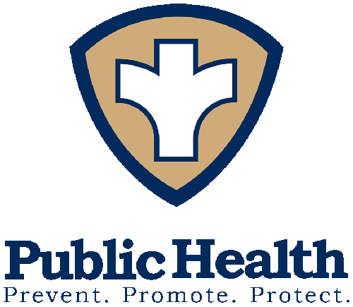
Please add your local priorities to support the NACCHO funding priorities)
For example:
Emergency Preparedness:
Epidemiology capacity to track disease outbreaks has been reduced by 50%
from 22 to 11, resulting in reduced surge capacity and ability to respond to emergencies. Epidemiology capacity to track disease outbreaks has been reduced by 50% from 22 to 11, resulting in reduced surge capacity and ability to respond to emergencies. The Public Health Emergency Preparedness program and Epidemiology and Lab Capacity programs at the Centers for Disease Control and Prevention (CDC) are critical to maintaining the ability to protect people in our community.

Section 317 Immunization Program:
The Section 317 Immunization Program at CDC enables the local health department to vaccinate an average of 25 children a day. However, to fully protect our population, we should be vaccinating at least 40 children a day. CDC funding is critical to ensuring that as many residents as possible in our communities are protected from infectious disease.
Important Accomplishments: Here you can add more details about success stories or challenges.
For example:
Cities Readiness Initiative (CRI):
- Allowed the health department to host a regional public health emergency response exercise, improving readiness for severe weather/flu pandemic/other emergency. Recruited businesses/organizations to serve as Point-of-Dispensing (POD) sites for their employees/members.
It is useful to include a graph about the department’s top priorities or a specific public health issue that has had significant impact, whether positive or negative. Click on the graph to enter your data.
The factsheet can extend to a second sheet of paper,
but should be no more than 1 page, double-sided.

