 | Community Health Assessment
2016 | Loup Basin Public Health Department
 | Healthier People, Healthier Communities, Healthier Tomorrows.

Community Health Assessment

Loup Basin Public Health Department

Introduction
Loup Basin Public Health Department (LBPHD), Jeannie Melham Memorial Medical Center (JMMMC), Valley County Health System (VCHS), Howard County Medical Center (HCMC), and Callaway District Hospital began collaborations in September 2015 to conduct a comprehensive central Nebraska Community Health Needs Assessment (CHNA). Due to the IRS regulations which require tax-exempt hospitals to conduct a CHNA every 3 years, LBPHD facilitated a joint community health needs assessment and planning process with the four hospitals in the Loup Basin health district. LBPHD is transitioning into conducting the CHNA every three years instead of every five to align with the timeline required of tax-exempt hospital organizations by the Internal Revenue service according to the Patient Protection and Affordable Care Act.
The purpose of the CHNA process is to describe the current health status of the community, identify and prioritize health issues, better understand the range of factors that can impact health and identify assets and resources that can be mobilized to improve the health of the community.
The priority health areas identified in the 2016 Loup Basin Public Health Department Community Health Assessment and addressed in the 2016-2021 Loup Basin Public Health Department Community Health Improvement Plan (CHIP) are:
To be established when CHIP is completed in August 2016

Mobilizing for action through planning and partnership (MAPP)
Mobilizing for Action through Planning and Partnerships (MAPP), a partnership-based framework, was again used to conduct this round of the Community Health Needs Assessment and Community Health Improvement Plan development. MAPP emphasizes the partnership with all sectors of the public health system to evaluate the health status of the region it serves, identify priority areas, and develop plans for implementation.
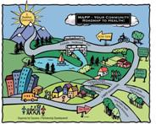
The MAPP process includes two preliminary steps – organization and vision.

Organization
LBPHD was charged with the leadership of the project. This role included establishing timely schedules, allocation of personnel resources, contracting for additional services, and promotion and media relations. Loup Basin Public Health Department’s leadership team provided oversight and quality assurance to the process.
A MAPP Steering Committee was formed with representatives from each of the four Loup Basin hospitals and members of the Custer County Health Coalition. Committee members provided guidance throughout the process and were charged with reviewing data a progress on the chosen priorities, using quality improvement to modify implementation plans as needed, and sharing results with stakeholders.

Local Public Health System Collaborative Infrastructure
The region enjoys a vigorous, well-established collaborative infrastructure which provided the foundation for the local public health system communication and engagement process. This infrastructure includes:
- Loup Basin Public Health Department Board of Health comprised of twenty members. The twenty-member board is composed of a physician and dentist as well as a County Commissioner and a spirited citizen from each of LBPHD’s nine counties.
- The already existing Custer County Health Coalition provided a significant platform for LBPHD to utilize through the MAPP process. The Coalition had representatives from every aspect of the local public health system and provided services from all of the 10 essential services.

MAPP Assessments
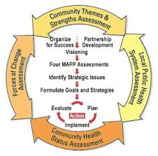
- Community Themes and Strengths
Assembles focus groups that address the community concerns about what is important, how quality of life is perceived, and the assets that exist and can be used to improve community health.
- Local Public Health System Assessment
Identifies the components, activities, competencies, and capacities of the public health system and how the essential services are being provided through area organizations and entities.
- Forces of Changes Assessment
Identifies what is occurring, or might occur, that affects the health of the community. Looks at the opportunities and threats that are currently facing the region.
- Community Health Status Assessment
Identifies priority community health and quality of life issues. Health data provided by Loup Basin Public Health Department.

Community Health status assessment

Economic and Demographic Data

Overview

Social and Economic Factors in Population Health
Some of the biggest predictors of health in and individual’s life come from social and economic factors. This section addresses what social and economic factors of health (education, income, social support, etc.) look like in central Nebraska and what the data indicates about the health of the involved citizens.

key trends and patterns
To be established when CHIP is completed in August 2016

Loup Basin Public Health Department Region
Loup Basin Public Health Department is situated in the heart of Nebraska. The area has a rich agricultural background, including farmland, prairie meadows and cattle-grazing. Population remains steady, wages remain lower than the state and national averages, and the median age continues to increase.
LBPHD proudly services the counties of Blaine, Custer, Garfield, Greeley, Howard, Loup, Sherman, Valley and Wheeler.

Quick Facts from US Census Bureau
Population (2014 estimate) 30,711
Population Change in LBPHD District (2010-2014) -1.4%*
Unemployment Rate (October 2015) 2.7%**
Total Land Area 7272.7 sq. miles
*Loup Basin CHA Data, Nebraska DHHS
**Bureau of Labor Statistics

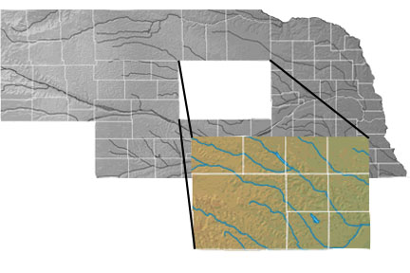
CUSTER
BLAINE
LOUP
GARFIELD
WHEELER
VALLEY
GREELEY
SHERMAN
HOWARD

Population
While the population of Nebraska has been slowly increasing over the past 75years, central Nebraska’s population has been declining. Much of Nebraska’s growth is seen in the urban areas.

Figure 1: Nebraska Urban and Rural Populations, 1870-2010
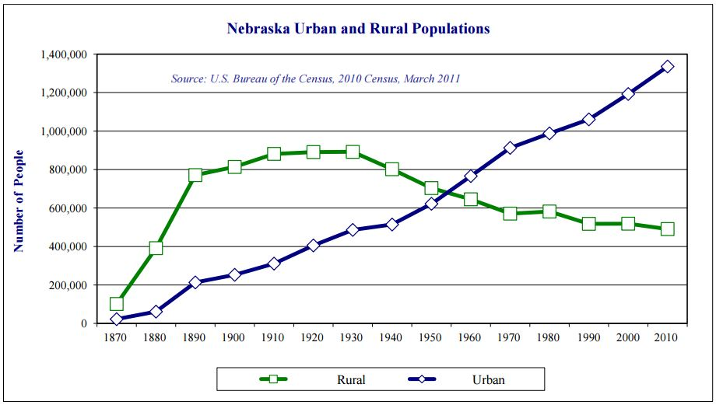

Figure 2: Loup Basin Public Health Department District Population, 1960-2010

Source: US Census Bureau
Figure 1 shows how Nebraska’s population growth has been concentrated in the urban areas (including the counties of Douglas, Sarpy, and Lancaster). These counties are home to the Omaha metropolitan area and the state capital, Lincoln.
What does a declining population mean for our region?
- Decreased resources
- Threat of decreased vitality
Population consolidation away from the rural areas is not a new trend, as seen in Figure 1 this has been occurring in Nebraska since the 1950s and is also a global occurrence. Figure 2 echoes that Loup Basin Public Health Department’s population, which is primarily rural, has been declining and following the consolidation trend to urban areas. Due to this trend, communities should not focus on ways to halt population loss but rather strategies to improve quality of life and opportunities for their citizens. What central Nebraska lacks in resources must be combated with creative solutions and strengthening of partnerships.

Figure 3: Loup Basin Public Health Department
Population Distribution, 2014 Census
As Figure 3 emphasizes, sixty-five percent of Loup Basin Public Health Department district’s population is concentrated in the three counties that have more amenities to offer (Custer, Howard and Valley counties). All four hospitals within LBPHD’s district are also located in these three counties. Out of the remaining six counties, three (Garfield, Greeley, and Sherman) offer medical services through satellite clinics. Blaine, Loup and Wheeler counties currently do not have any medical services provided through satellite clinics.
Travel time and lower annual income post obstacles to the citizens of these counties in terms of healthcare, economic growth, and community vitality.
Source: US Census Bureau, 2014 population estimate

Figure 4: Overall Birth and Death Rates in Nebraska and Loup Basin Public Health Department, 2005-2014
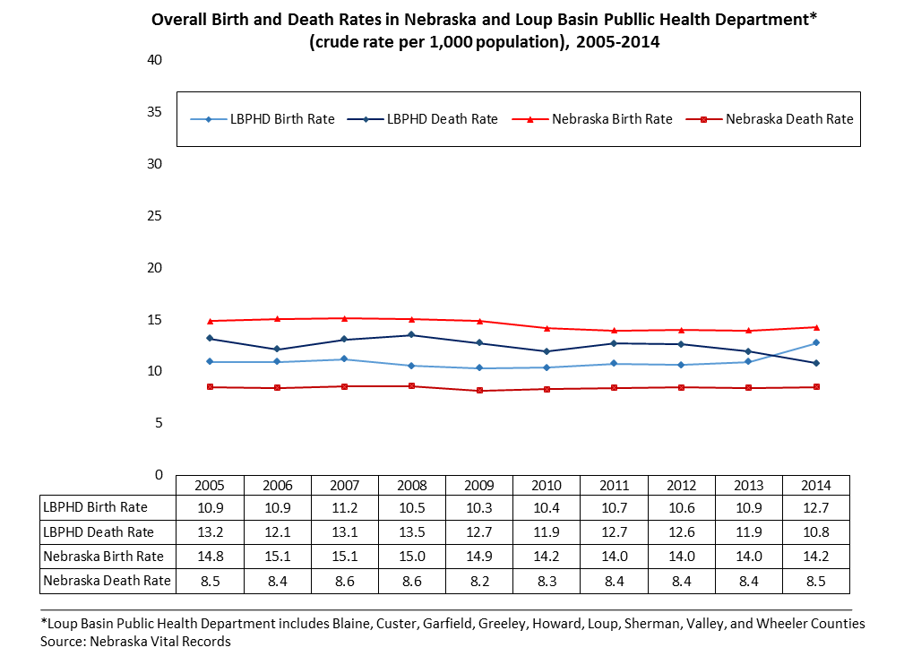

Table 1: Loup Basin Public Health Department Population Characteristics, 2000-2014

Age | 2000 |  | 2010 |  |  | 2014
 | Population | % of Total | Population | % of Total | % Change (2000-2010) | Population | % of Total | % Change (2010-2014)
Under 5 years | 1,890 | 5.7% | 1,881 | 6.0% | -0.5% | 1,724 | 5.6% | -8.3%
5 - 14 years | 5,089 | 15.4% | 4,007 | 12.9% | -21.3% | 4,010 | 13.1% | 0.1%
15 - 24 years | 3,532 | 10.7% | 3,105 | 10.0% | -12.1% | 3,365 | 11.0% | 8.4%
25 - 44 years | 7,755 | 23.4% | 6,212 | 19.9% | -19.9% | 6,109 | 19.9% | -1.7%
45 - 64 years | 7,877 | 23.8% | 9,208 | 29.6% | 16.9% | 8,623 | 28.1% | -6.4%
65 - 84 years | 5,819 | 17.6% | 5,668 | 18.2% | -2.6% | 5,753 | 18.7% | 1.5%
85 and older | 1,160 | 3.5% | 1,059 | 3.4% | -8.7% | 1,127 | 3.7% | 6.4%
Source: Loup Basin CHA Data, prepared by Nebraska DHHS
The graph in Figure 4 depicts a change in the trend of the death rate outweighing the birth rate for the first time in 2014. According to the Loup Basin Public Health Department Community Health Assessment Data (Table 1), the population under 5 years old has shown an 8.3% decrease from 2010 to 2014. By examining these two data sources together, we can anticipate in 2015 or 2016 the death rate will again exceed the birth rate and LBPHD’s population totals will continue to decline without a change to in-migration.
The trend identified within Loup Basin Public Health Department’s district is not echoed throughout the state of Nebraska (Figure 4) where the birth rate has exceed the death rate by at least 5.7 since 2005.

Race
Race patterns in a population are important to assess because they reveal social patterns. Social issues tend to follow the lines of certain social classes and families, and families have tended to follow race lines. With this understanding we can see social and economic patterns for certain segments of the population.

Figure 5: Race Composition of 9 Loup Basin Public Health Department Counties, 2014 Census estimate
Source: US Census Bureau
In the nine counties that are included in Loup Basin Public Health Department’s district the majority race is white, non-Hispanic (Figure 5). The second largest race includes the Hispanic population. Custer County has a Hispanic rate of 2.5%, but this is also the county with the largest overall population within the district.

Table 2: Nebraska Health Disparities Profile

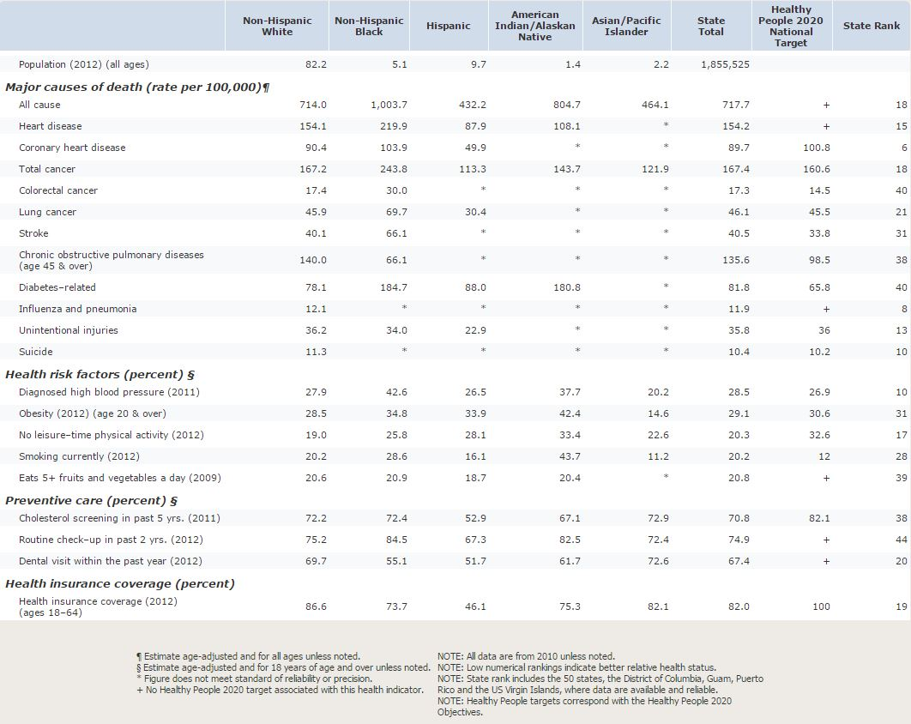
Source: Health Status 2020

Trends identified by Health Status 2020 (Table 2) for the state of Nebraska correlate with LBPHD population characteristics of predominant Non-Hispanic White being the majority population followed by Hispanic. The table depicts a disparity of low health insurance coverage amongst the Hispanic population. The Hispanic population also has the highest cancer rate among the races.

Economy
Economic health is the driving force for opportunities and prosperity in a region or community. While it is not the only indicator of wellbeing, quality economic opportunities contribute heavily to the quality of income and the access to education and health care. Thriving local economies also contribute to the vitality of communities and provide a base for shared investments in infrastructure, law enforcement, public spaces, positive neighborhood environments, etc.
The Loup Basin Public Health Department district has its roots in a strong agricultural economy that has endured the rise and fall of markets. Throughout economic ups and downs the unemployment rate has maintained lower than the national average. Professional opportunities and wages do lag behind the state and nation.

Employment and Workforce
LBPHD’s district typically has a similar unemployment rate (2.7%) when compared to Nebraska (2.9%). Historically, Nebraska’s rate is lower when compared to the national average (5.0%).

Table 3: Unemployment Rates, October 2015

County | Unemployment Rate (%)
Blaine | 4.9  Interpreting Unemployment  While unemployment can give us a quick glance as to how the economy of an area is doing, it also does not account for the rate of people who are underemployed or who are working multiple jobs to make ends meet. In an economic downturn, someone who is self-employed or working multiple jobs could lose a significant amount of their work and still not technically be unemployed.
Custer | 2.0
Garfield | 1.8
Greeley | 2.5
Howard | 2.7
Loup | 3.1
Sherman | 2.6
Valley | 2.6
Wheeler | 1.9
Average in Region | 2.7%
Nebraska | 2.9%
National | 5.0%
Source: Bureau of Labor Statistics

educational achievement
Lower levels of educational achievement in LBPHD’s district reflect the job force available. Most jobs in the nine county area are in agriculture, manufacturing, etc. and do not require a Bachelor’s degree. For the most recent data (Table 4) our district is 11.9 and 15.3 percent below the state and national achievement, respectively.

Table 4: Educational Achievement, 2009-2013

County | High School graduate or higher (% of persons 25+) | Bachelor’s degree or higher (% of persons 25+)
Blaine | 99.0 | 16.0
Custer | 92.6 | 21.0
Garfield | 94.0 | 13.8
Greeley | 92.8 | 15.0
Howard | 92.4 | 17.8
Loup | 93.0 | 12.6
Sherman | 90.1 | 17.7
Valley | 93.9 | 17.8
Wheeler | 95.2 | 17.5
LBPHD District | 93.7 | 16.6
Nebraska | 90.5 | 28.5
National (2014) | 88.3 | 31.9
Source: US Census Bureau, Quick Facts

income and poverty
Table 5 displays the median household incomes across the district displaying that are all within a $4,000 difference except for a few outlying counties. Howard County ranks the highest with a median household income of $49,088. Loup and Wheeler counties rank the lowest with $38,125 and $38,807 respectively.

Table 5: Median Household Income, 2009-2013

County | Median Household Income
Blaine | $42,917
Custer | $44,873
Garfield | $41,892
Greeley | $44,950
Howard | $49,088
Loup | $38,125
Sherman | $41,835
Valley | $40,445
Wheeler | $38,807
LBPHD District | $42,548
Nebraska | $51,672
National (2014) | $51,939
Source: US Census Bureau, Quick Facts

According to the US Census Bureau, the 2009-2013 poverty level of Nebraska was 12.8%. Nebraska’s poverty level falls below the United States which from the same data source was reported to be 15.4%. Figure 6 represents the poverty trend of Nebraska in comparison to LBPHD’s district. For all persons, LBPHD’s rate was higher in the 2000 Census but lower in the 2009-2013 American Community Survey (ACS). The trend reverses for those under 18 years old; Nebraska is lower in the 2000 Census and has a higher percentage below the poverty level in the 2009-2013 ACS. Overall the trend is that poverty levels are higher in those under 18 years of age.

Figure 6: Poverty Trends in Nebraska and Loup Basin Public Health Department

Source: Loup Basin CHA Data, prepared by Nebraska DHHS

family type
The majority of households throughout Loup Basin Public Health Department’s district are family households (Figure 7). Loup County ranks highest with 70% family households; Wheeler County ranks highest in nonfamily households at 40.7%. Both counties are primarily rural, farming communities. The average household size across the district is relatively equal (Figure 8) with the exception of Blaine County. The average amongst the eight other counties is 2.28 and Blaine County reports 2.81 per household.

Figure 7: Family versus Nonfamily Households by County

Source: US Census Bureau, American Community Survey2010-2014

Figure 8: Average Household Size by County

Source: US Census Bureau, American Community Survey 2010-2014

Health Data
Moving Forward
An individual’s economic and social well-being directly affects his or her health. While the Loup Basin Public Health Department district has many social and economic indicators that are worse than those of the entire state of Nebraska, the positive is that many of the issues, while complex, can be strategically addressed to have a positive impact. Strong partnerships among educational, governmental, non-profit and business communities that promote financial and social stability for all citizens of central Nebraska will drive sustainable, regional wellness.

Overview
According to Loup Basin’s Community Health Assessment Data, prepared by Nebraska DHHS from Vital Records, the leading cause of death within the district during 2014 was heart disease followed closely by cancer (Figure 9). According to Nebraska’s 2013 Vital Statistics Report, the leading cause of death for the state was cancer representing 22% of all deaths. For the state this was the 5th consecutive year in which cancer has surpassed heart disease as the leading cause of death.

Figure 9: Seven Leading Causes of Death in Loup Basin Public Health Department, 2014

Behavioral Risk Factors Surveillance System
Each year, Loup Basin Public Health Department, working with the State of Nebraska, contracts the University of Nebraska Medical Center (UNMC) to conduct a telephonic survey to gather self-reported health data. This survey, the Behavioral Risk Factor Surveillance System (BRFSS), is done nationally and is coordinated with each of the states through the Centers for Disease Control and Prevention. BRFSS data is not available on a county-by-county basis but rather paints a picture of the entire Loup Basin Public Health Department District.
This survey can be used to identify emerging health problems; establish and track health objectives; develop, implement, and evaluate a broad array of disease prevention activities; and support health-related legislative efforts.
The number of those who self-reported having healthcare coverage since 2011 within LBPHD’s district has increased by 3.3% to 86.7% in 2014. This result shows no statistical significance in different from Nebraska’s result of 84.7%. The increase in healthcare coverage mimics the 3.1% increase from 2011 to 2014 in LBPHD’s population reporting receiving an annual exam within the past year. In 2011 there was a statistical difference between the number of men and women receiving their annual exam, 62.6% and 47.6% respectively. However, since 2011 there has not been a statistical difference and for the most recent report (2014) 53.6% of men and 62.8% of women report participating in this preventative care.
Self-reporting of those who currently smoke cigarettes has declined from 2011 to a low of 11.0% in 2013, but rebounded in 2014 to 13.1%. Sixty-one percent of current smokers reported trying to quit during 2014. The trend for current smokeless tobacco users is also on the rise from 2011. Alcohol use, binge drinking and heavy drinking in the past 30 days all remain fairly unchanged over the past four years but still remain below Nebraska’s average for 2014.
Unfortunately, the percentage of adults in LBPHD’s district reporting they are overweight or obese (BMI 25 or greater) exceeds the State of Nebraska. Slightly more than one in four of Loup Basin Public Health Department’s population who participated in the survey report no leisure-time physical activity in the past 30 days.
Seat belt use within Loup Basin’s district is significantly less than the State of Nebraska. Forty-eight percent of LBPHD participants reported always wearing a seatbelt, which is about 24% less than the State reported result (72.4%). This number correlates to unintentional injury being the 4th leading cause of death within the district. One factor that can influence this includes the farming/ranching, rural lifestyle that is prevalent through the area.
Under the Affordable Care Act (ACA) preventative immunizations are covered at 100%. According to the BRFSS data, Nebraskan’s and the LBPHD population are not taking advantage of this. In 2014, Nebraska and LBPHD had 43.9% and 39.4%, respectively, receive their annual influenza vaccination. There is a statistical difference reported with more women receiving the vaccination annually. The adherence to this recommendation was better received in the 65+ age group with LBPHD reporting 58.8% and Nebraska reporting 64.8% being vaccinated annually for influenza. Pneumonia vaccination rates within Loup Basin’s district were significantly less than the Nebraska report (LBPHD 63.6%; Nebraska 72.3%). Healthy People 2020 has set the goal of those 60+ who have been vaccinated for shingles at 30%; in 2014 LBPHD’s population reported 28.2% of those 50+ having received the vaccine.
BRFSS data reports those who have visited a dentist or dental clinic for any reason in the past year during the even years only. In both reporting years, 2012 and 2014, Loup Basin Public Health Department’s district reported significantly less than the State of Nebraska participating in this activity. However, the trend for LBPHD from 2012 to 2014 is in an upward direction.

Table 6: BRFSS Health Data, Loup Basin Public Health Department and State, 2011-2014

Indicators | 2011 |  | 2012 |  | 2013 |  | 2014
 | LBPHD | NE | LBPHD | NE | LBPHD | NE | LBPHD | NE
General Health Status
General health fair or poor | 14.8% | 14.3% | 16.9% | 14.4% | 13.3% | 13.9% | 14.4% | 13.2%
Average number of days physical health was not good in past 30 days | 2.9 | 3.2 | 4.0 | 3.2 | 2.6 | 3.1 | 3.0 | 3.0
Health Care Access and Utilization
No health care coverage, 18-64 year olds | 16.6% | 19.1% | 16.1% | 18.0% | 13.5% | 17.6% | 13.3% | 15.3%
Needed to see a doctor but could not due to cost in past year | 8.4% | 12.5% | 11.9% | 12.8% | 7.4% | 13.0% | 8.7% | 11.9%
Had routine checkup in past year | 55.2% | 57.7% | 56.4% | 60.4% | 62.4% | 61.6% | 58.3% | 63.3%
Cardiovascular
Ever told they had a heart attack or coronary heart disease | 8.3% | 5.9% | 9.7% | 6.0% | 7.0% | 5.9% | 6.4% | 5.8%
Ever told they had a stroke | 3.0% | 2.6% | 2.9% | 2.4% | 4.0% | 2.5% | 3.2% | 2.6%
Had blood pressure checked in the past year | - | - | - | - | 87.1% | 84.6% | - | -
Ever told they have high blood pressure, excluding pregnancy | 38.3% | 28.5% | - | - | 36.1% | 30.3% | - | -
Had cholesterol checked in past 5 years | 71.8% | 71.8% | - | - | 74.2% | 74.0% | - | -
Ever told they have high cholesterol, among those who have ever had it checked | 39.6% | 38.3% | - | - | 37.6% | 37.4% | - | -
Cancer
Ever told they have skin cancer | 7.9% | 5.6% | 6.3% | 5.6% | 8.0% | 5.9% | 8.4% | 5.7%
Ever told they have cancer (in any form) | 14.8% | 11.2% | 12% | 10.8% | 15.2% | 11.4% | 16.1% | 10.7%
Up-to-date on colon cancer screening, 50-75 years old | - | - | 56.2% | 61.1% | 57.8% | 62.8% | 52.9% | 64.1%
Up-to-date on breast cancer screening, female 50-74 years old | - | - | 68.9% | 74.9% | - | - | 62.7% | 76.1%
Tobacco
Current cigarette smoker | 16.5% | 20.0% | 16.9% | 19.7% | 11.0% | 18.5% | 13.1% | 17.4%
Attempted to quit smoking in past year, among current cigarette smokers | 51.2% | 55.6% | 54.2% | 57.1% | 34.8% | 57.1% | 61.3% | 58.2%
Current smokeless tobacco use | 8.9% | 5.6% | 8.9% | 5.1% | 9.8% | 5.3% | 9.5% | 4.7%
Nutrition/Physical Activity
Obese (BMI = 30+) | 31.5% | 28.4% | 28.8% | 28.6% | 30.6% | 29.6% | 29.9% | 30.3%
Overweight or Obese (BMI = 25+) | 69.0% | 64.9% | 64.2% | 65.0% | 71.3% | 65.5% | 70.0% | 66.7%
Consumed fruits less than 1 time per day | 39.8% | 40.1% | - | - | 41.4% | 39.7% | - | -
Consumed vegetables less than 1 time per day | 24.3% | 26.2% | - | - | 18.6% | 23.3% | - | -
No leisure-time physical activity in past 30 days | 32.8% | 26.3% | 26.5% | 21.0% | 31.5% | 25.3% | 26.4% | 21.3%
Ever told they have diabetes, excluding pregnancy | 10.3% | 8.4% | 9.0% | 8.1% | 10.4% | 9.2% | 9.5% | 9.2%
Mental Health
Ever told they have depression | 15.3% | 16.8% | 12.1% | 16.7% | 10.1% | 18.2% | 14.8% | 17.7%
Average number of days mental health was not good in past 30 days | 2.2 | 3.1 | 2.8 | 3.0 | 1.3 | 3.0 | 1.8 | 2.8
Alcohol
Any alcohol consumption in past 30 days | 55.5% | 61.8% | 53.1% | 61.3% | 53.8% | 57.5% | 52.4% | 59.2%
Binge drank in past 30 days | 19.5% | 22.7% | 17.7% | 22.1% | 15.1% | 20.0% | 17.5% | 20.3%
Heaving drinking in past 30 days | 6.6% | 7.5% | 5.5% | 7.2% | 4.0% | 6.8% | 5.6% | 6.4%
Immunization and Infectious Disease
Had a flu vaccination in past year, aged 18 and older | 38.2% | 41.1% | 42.6% | 42.2% | 43.9% | 45.2% | 39.4% | 43.9%
Had a flu vaccination in past year, aged 65 and older | 55.3% | 61.8% | 58.2% | 62.9% | 59.5% | 66.2% | 58.8% | 64.8%
Ever had a pneumonia vaccination, aged 65 and older | 68.8% | 70.3% | 67.7% | 70.0% | 67.7% | 71.7% | 63.6% | 72.3%
Ever had a shingles vaccination, aged 50 and older | - | - | - | - | - | - | 28.2% | 27.9%
Oral Health
Visited a dentist or dental clinic for any reason in past year | - | - | 56.8% | 67.6% | - | - | 59.2% | 66.4%
Injury
Always wear a seatbelt when driving or riding in a car | 51.4% | 71.3% | 46.0% | 69.7% | 52.8% | 74.1% | 48.3% | 72.4%
Texted while driving in past 30 days | - | - | 72.2% | 69.1 | - | - | - | -
Talked on cell phone while driving in past 30 days | - | - | 72.2% | 69.1% | - | - | - | -
Injured due to a fall in past year, aged 45 and older | - | - | 12.1% | 9.9% | - | - | 8.7% | 8.8%
Red shaded boxes: LBPHD statistical significance of worse rate than State of Nebraska
Green shaded boxes: LBPHD statistical significance of better rate than State of Nebraska

Youth Risk Factors
The Nebraska Risk and Protective Factors Student Survey (NRPFSS) is a biennial survey of the students in grades 8, 10 and 12. The goal of the survey is to provide schools and communities with local-level data, therefore it is implemented as a census survey meaning every public and non-public school with an eligible grade can choose to participate. The data presented from this report is not intended to be a representative of a statewide sample.
The survey is designed to assess adolescent substance use, delinquent behavior and many of the risk and protective factors that predict adolescent problem behaviors. These risk and protective factors also highly correlate with substance abuse as well as delinquency, teen pregnancy, school dropout and violence.
The report is generally a good indicator of the problem behaviors and protective factors if there was 60% or more participation. If fewer than 60% participated, a review of who participated should be completed prior to generalizing the results. For Loup Basin’s 2014 NRPFSS report, a total of 639 students participated giving a participation percentage of 55.8%. Statewide only 35.4% of the total enrolled in the designated grade levels participated.

Figure 10: Substance Use, 2014

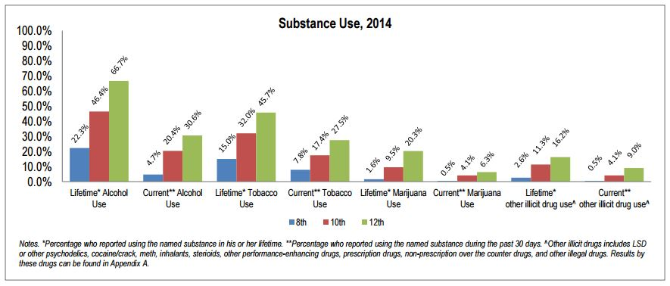
Substance use trends upward in all categories as students enter higher grade levels. When the question was asked, “During the last 30 days did you ride in a car or other vehicle driven by someone who had been drinking alcohol?” 17.6% of 8th graders, 20.5% of 10th graders and 25.2% of 12th graders reported “yes.”

Figure 11: Percentage that were Bullied during the Past 12 Months, 2014

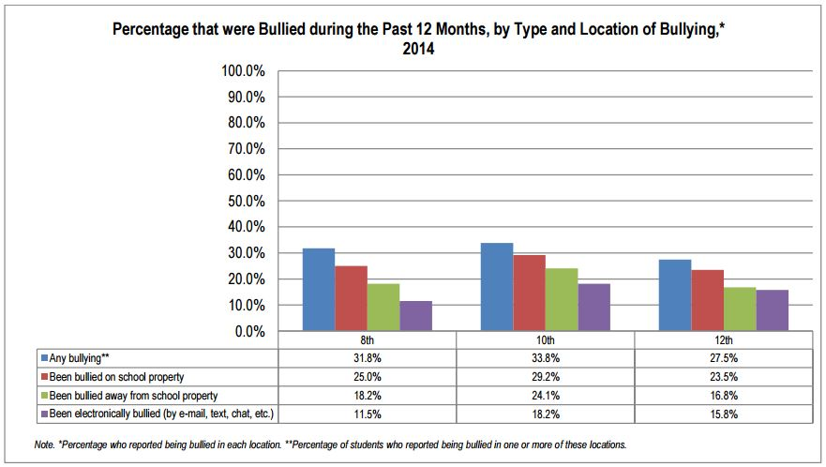
Bullying questions were added to the NRPFSS survey in 2010 in response to interest from school and community leaders. Figure 11 displays the trend that most bullying is occurring in person with the lowest percentage in each grade level occurring electronically.

Unintentional Injury
Unintentional injury is the fourth leading cause of death in Loup Basin Public Health Department’s district. According to the CDC, 31 million emergency department visits occur each year for unintentional injuries. Each year, NE DHHS tracks the following unintentional injuries for LBPHD: motor vehicle crashes and falls.

Figure 12: Motor Vehicle Crashes Death Rate per 100,000 (age-adjusted) in Nebraska and Loup Basin Public Health Department, 2005-2014

Figure 13: Always Wear a Seatbelt when Driving or Riding in a Car, Adults 18+, Nebraska and Loup Basin Public Health Department, 2011-2014

Figure 12 depicts a grim statistic that Loup Basin Public Health Department has a death rate due to motor vehicle crashes that is more than two times the state average. This large difference has been seen since 2012. This statistic coincides with the seatbelt rate (Figure 13) being substantially lower than Nebraska’s rate since 2011.

Figure 14: Unintentional Fall Death Rate per 100,000 (age-adjusted) in Nebraska and Loup Basin Public Health Department, 2005-2014

For the last two years, the district’s unintentional fall death rate (Figure 14) has been lower than Nebraska’s. According to the CDC, the national rate of deaths from unintentional falls was most recently 9.6 in 2013, which is similar to the State of Nebraska and also higher than LBPHD’s rate.

Communicable Diseases

Figure 15: STD Incidence Rates by Type per 100,000 population, Nebraska and Loup Basin Public Health Department, 2005-2009 & 2010-2014 Aggregate

The incidence of sexually transmitted diseases throughout Loup Basin Public Health Department is relatively low (Figure 15) when compared to the State of Nebraska. Chlamydia has the highest per 100,000 population rate for the years presented. Chlamydia can affect both and women, but for women it can cause permanent damage to her reproductive system making it difficult or impossible for her to get pregnant later on.

County Health Rankings

Figure 16: County Health Rankings Model
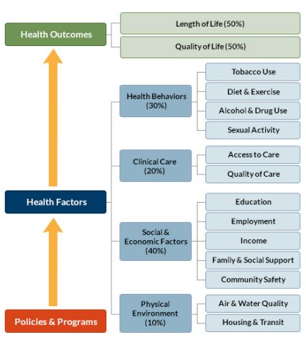

Each year the Robert Wood Johnson Foundation (RWJF) partners with the University of Wisconsin Population Health Institute (UWPHI) to rank the health of nearly every county in the nation. The County Health Rankings illustrate what we know when it comes to what is making people healthy or sick. The Rankings are unique in their ability to measure the current overall health of each county in all 50 states. They also look at variety of measures that affect the future health of communities, such as high school graduation rates, access to healthy foods, rates of smoking, obesity and teen births. Communities can use these rankings to identify and garner support for local health improvement initiatives among government agencies, healthcare providers, community organizations, business leaders, policy makers and the public.
This model, from the 2015 rankings, (Figure 16) shows that one must do more than just exercise and eat well to have good health. Where we live, our environment, education, medical care and the behavioral choices we make all impact healthy outcomes.

Figure 17: Nebraska Health Outcome Rankings, 2015
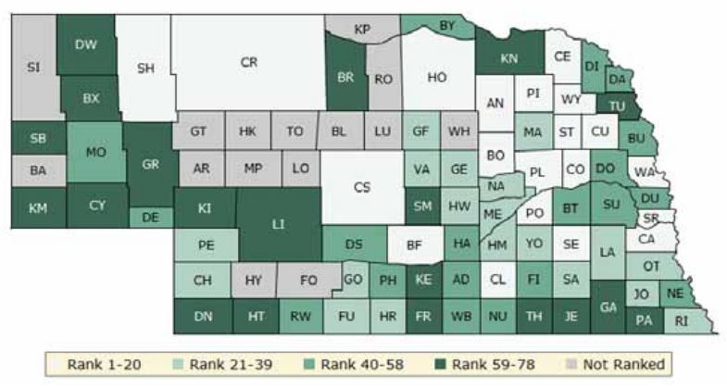
The green map shows the distribution of Nebraska’s health outcomes, based on an equal weighting of length and quality of life. Lighter colors indicate better performance in the rankings.

Figure 18: Nebraska Health Factors, 2015
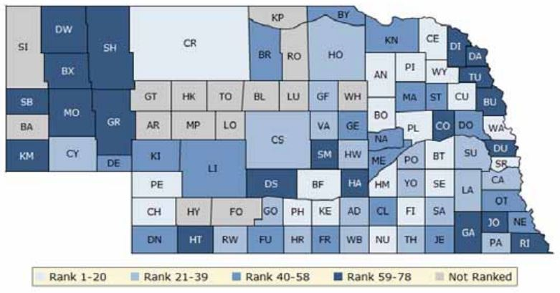
The blue map displays Nebraska’s summary ranks for health factors, based on weighted scores for health behaviors, clinical care, social and economic factors and the physical environment. Lighter colors indicate better performance in the respective rankings.

Table 7: County Health Rankings, Loup Basin Public Health Department district, 2015

County | Health Outcomes Ranking | Health Factors Ranking
Blaine | NR | NR
Custer | 20 | 37
Garfield | 36 | 21
Greeley | 22 | 52
Howard | 35 | 32
Loup | NR | NR
Sherman | 64 | 63
Valley | 37 | 29
Wheeler | NR | NR

Source: County Health Rankings, 2015
Rankings are given to the top 78 counties; those with the smallest populations are not ranked. A ranking of 1st is considered to be the healthiest county and 78th the unhealthiest. In LBPHD’s district, Blaine, Loup and Wheeler counties are not ranked.
With the exception of Sherman, the counties that are ranked within our district fall in the middle of the rankings (Table 7). Sherman County was ranked in the bottom half of counties in Nebraska indicating that the majority of their citizens do not practice healthy behaviors and that their socioeconomic environment along with healthcare and physical infrastructure may not be as conducive to healthy living as it could be.
It is important to note that the County Health Rankings use broad measures that are standardized based on multiple years of data in order to account for counties of all sizes and make them comparable. Therefore, local data must take precedence. Regardless of the limitations of the County Health Rankings, it gives us a snapshot of the health of the county and helps demonstrate how LBPHD’s district is doing in relation to each other and in comparison to the rest of Nebraska.

Forces of Change Assessment
The Forces of Change (FOC) Assessment is aimed at identifying forces – such as trends, factors, or events – that are or will be influencing the health and quality of life of the community and the work of the local public health system.
- Trends – patterns over time
- Factors – circumstance, fact, or influence that contributes to a result or outcome
- Events – one time occurrences

Methodology
Stephanie Gideon led the MAPP Steering Committee through a brainstorming session to identify the forces of change facing the Loup Basin health district in March 2016. During the FOC Assessment, participants answered the following questions: “What is occurring or might occur that affects the health of our community or the local public health system?” and “What specific threats or opportunities are generated by these occurrences?”
Representatives from 8 of the 9 counties that Loup Basin Public Health Department serves were present. Participants included health professionals, school representatives, business owners, farmers and ranchers, and other individuals long-involved in their local communities.
Through a facilitated brainstorming discussion, participants shared their ideas and insights and assembled a comprehensive list of forces that affect the health and quality of life in their community. The identified forces were reviewed and for each force, associated threats and opportunities for the community and the local public health system were identified.

Results
Forces(Trend, Events, Factors) | Threats Posed | Opportunities Created
Legislative hearing on LB1013 tobacco tax that will increase local health department infrastructure funds | (1)Continued and increased burden on health and welfare of residents of NE  (2)Burden on Health care system in state | Increased funding for health departments, tobacco cessation programs, and create tax relief
Housing and economic opportunities | (1)Migration of youth out of rural communities  (2)Lack of quality and affordable housing  (3)Price of land detours youth from becoming involved in agricultural opportunities | (1)LB1013 tax relief may help with future home purchases  (2)Need for housing may create jobs and other economic opportunities
Political agenda that follow cliques | Loss of health professionals, quality workers, and businesses | Encourages people to become involved in political process
Shift in traditional family structure | (1)Increased number of children home alone leads to childhood obesity and increase of STD’s  (2)Creates dependency and abuse of the state welfare system | (1)Two incomes create more stable financial environment  (2)Creates more opportunity for afterschool programs and daycare workers
Aging population | (1)Loss of stable factor in community  (2) Less youth equals loss of economic opportunities | (1)Jobs created because of demand for more assisted living and nursing home facilities
Follow up with care | People slipping through cracks of health care system

Summary
The results of the FOC Assessment will be used both for reporting back to key stakeholders and identifying strategic issues.

Local Public Health SYstem Assessment

Purpose
The Local Public Health System Assessment, designed by National Public Health Performance Standards Program, measures the ten essential public health services. The primary purpose of the NPHPS Local Public Health System Assessment Report is to promote continuous improvement that will result in positive outcomes for system performance. Local health departments and their public health system partners can use the Assessment Report as a working tool to:
• Better understand current system functioning and performance;
• Identify and prioritize areas of strengths, weaknesses, and opportunities for improvement;
• Articulate the value that quality improvement initiatives will bring to the public health system;
• Develop an initial work plan with specific quality improvement strategies to achieve goals;
• Begin taking action for achieving performance and quality improvement in one or more targeted areas; and
• Re-assess the progress of improvement efforts at regular intervals.
This shared frame of reference will help build commitment and focus for setting priorities and improving public health system performance.

Methodology
To conduct the 2016 LPHS Assessment Loup Basin Public Health Department utilized Google Drive. All 10 essential health services were considered and the survey format of google drive was used as the voting method. There were 15 participants in the assessment, representing a wide array of organizations within the local public health system.
Each participant rated the level of activity for each essential service and model standards according to table 1 below.
 | Table 1. Summary of Assessment Response Options
Optimal Activity  (76-100%) |  | Greater than 75% of the activity described within the question is met.
Significant Activity  (51-75%) |  | Greater than 50%, but no more than 75% of the activity described within the question is met.
Moderate Activity  (26-50%) |  | Greater than 25%, but no more than 50% of the activity described within the question is met.
Minimal Activity  (1-25%) |  | Greater than zero, but no more than 25% of the activity described within the question is met.
No Activity  (0%) |  | 0% or absolutely no activity.

Assessment Results
Based upon the responses provided by the participants during the assessment, an average was calculated for each of the ten Essential Services. Each Essential Service score can be interpreted as the overall degree to which the public health system meets the performance standards (quality indicators) for each Essential Service. Scores can range from a minimum value of 0% (no activity is performed pursuant to the standards) to a maximum value of 100% (all activities associated with the standards are performed at optimal levels).
Figure 2 displays the average score for each Essential Service, along with an overall average assessment score across all ten Essential Services. Examination of these scores can immediately give a sense of the local public health system's greatest strengths and weaknesses. Note the black bars that identify the range of reported performance score responses within each Essential Service.

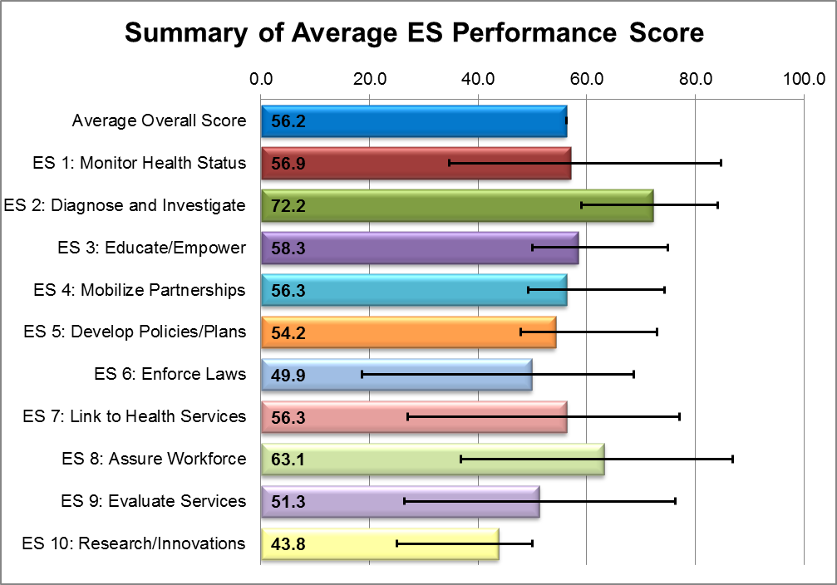

In Table 2 below, each score (performance, priority, and contribution scores) at the Essential Service level is a calculated average of the respective Model Standard scores within that Essential Service.

Model Standards by Essential Services | Performance Scores
ES 1: Monitor Health Status | 56.9
1.1 Community Health Assessment | 58.3
1.2 Current Technology | 50.0
1.3 Registries | 62.5
ES 2: Diagnose and Investigate | 72.2
2.1 Identification/Surveillance | 66.7
2.2 Emergency Response | 62.5
2.3 Laboratories | 87.5
ES 3: Educate/Empower | 58.3
3.1 Health Education/Promotion | 50.0
3.2 Health Communication | 58.3
3.3 Risk Communication | 66.7
ES 4: Mobilize Partnerships | 56.3
4.1 Constituency Development | 62.5
4.2 Community Partnerships | 50.0
ES 5: Develop Policies/Plans | 54.2
5.1 Governmental Presence | 41.7
5.2 Policy Development | 58.3
5.3 CHIP/Strategic Planning | 50.0
5.4 Emergency Plan | 66.7
ES 6: Enforce Laws | 49.9
6.1 Review Laws | 56.3
6.2 Improve Laws | 33.3
6.3 Enforce Laws | 60.0
ES 7: Link to Health Services | 56.3
7.1 Personal Health Service Needs | 62.5
7.2 Assure Linkage | 50.0
ES 8: Assure Workforce | 63.1
8.1 Workforce Assessment | 50.0
8.2 Workforce Standards | 75.0
8.3 Continuing Education | 65.0
8.4 Leadership Development | 62.5
ES 9: Evaluate Services | 51.3
9.1 Evaluation of Population Health | 43.8
9.2 Evaluation of Personal Health | 60.0
9.3 Evaluation of LPHS | 50.0
ES 10: Research/Innovations | 43.8
10.1 Foster Innovation | 37.5
10.2 Academic Linkages | 50.0
10.3 Research Capacity | 43.8
Average Overall Score | 56.2
Median Score | 56.3

Community Themes and Strengths Assessment

Summary

Two elements comprise the 2016 Loup Basin Community Health Needs Assessment: a community survey and key informant interviews. The Loup Basin Community Survey is a 17-question survey covering various aspects of a healthy community, including health factors, health problems, risky behaviors, and various aspects of satisfaction with life in the community. Key informant interviewees included health professionals, school administrators, and other individuals long-involved in their local communities, who provided their perspectives about the quality of life in their community. Following are highlights from the Loup Basin Community Survey and Key Informant Interviews.

Loup Basin Community Survey

- 95.8% of respondents reported that they are satisfied with the quality of life in their community.
- 98.8% of respondents reported that the community is a good place to raise children.
- 94.6% of respondents reported that their community is a good place to grow old.
- 99.5% of respondents reported that their community is a safe place to live.
- 73.4% of respondents indicated that there is economic opportunity in their community.
- 82.9% of respondents reported that they were satisfied with the health care system in their community.
- The top three perceived health problems indicated by respondents were (1) Cancers (indicated by 62.1%), (2) Aging problems (e.g., arthritis, hearing/vision loss, etc.) (48.5%), and (3) Heart disease and stroke (45.2%).
- The top three perceived risky behaviors indicated by respondents were (1) Alcohol and drug use (indicated by 74.2%), (2) Being overweight (67.7%), and (3) Texting/cell phone use while driving (62.1%).

Key Informant Interviews

Key informants indicated many strengths in their respective communities, including community cohesion, community institutions (schools, hospitals, fire department, etc.), community safety, access to recreational opportunities, and many others. At the same time, many factors detrimental to the quality of life in the community were noted, with the most common being themed around health care and mental health services. Several interviewees noted the difficulty facing members of their community in obtaining mental health services, due largely to a lack of available services. Other interviewees focused on the lack of medical services in their community, especially specialists.
It is important to note that there was a wide array of perspectives voiced by interviewees due to their living in different communities and having different life experiences.

Methodology

In 2015-2016, the Loup Basin Public Health Department conducted a Community Health Needs Assessment. This needs assessment provides valuable data on community perceptions that can be used by the health department for planning purposes. The needs assessment also provides the three major hospitals in the area with valuable data for their own planning processes. The three major hospitals in the area served by the Loup Basin Public Health Department are located in Custer, Howard, and Valley Counties (see Appendices A, B, and C for survey results specific to these three counties). In addition, the following other counties are served by Loup Basin: Blaine, Loup, Wheeler, Valley, Garfield, Greeley, and Sherman.
Two elements comprise this needs assessment: a community survey and a key informant interview (see Appendices D and E for the survey instrument and interview questions). Following is a brief description of the survey and key informant interview, as well as the methodology used to collect each.

Loup Basin Community Survey

The Loup Basin Community Survey is a 17-question survey covering various aspects of a healthy community, including health factors, health problems, risky behaviors, and various aspects of satisfaction with life in the community. The survey was administered at Loup Basin’s flu clinics (held in each of the nine counties in the district) from August to October of 2015. Staff at the clinics would ask those receiving a flu shot to participate in the survey. Area hospitals and schools were also given a link to an online version of the survey to distribute to staff. There was a total of 438 respondents to the survey.

Key Informant Interviews

Health professionals, school administrators, and other individuals long-involved in their local communities were asked to participate in a brief and informal five-question interview about the quality of life in their community. Key informants were selected based on their knowledge, insight, and involvement with their community. These interviews were conducted primarily in the form of a paper-and-pencil response to five open-ended questions. A total of 16 interviews were conducted in November and December of 2015.

Loup Basin Community Survey Results

Demographics

There was a total of 438 respondents to the Loup Basin Community Survey. While each county was represented in the survey, the majority of respondents came from Custer, Valley, Howard, and Garfield counties (Figure 1).

Figure 1 | County (n=438)
 |  | Number of Respondents | % of Survey Sample
Blaine |  | 14 | 3.2%
Custer |  | 115 | 26.3%
Garfield |  | 56 | 12.8%
Greeley |  | 23 | 5.3%
Howard |  | 66 | 15.1%
Loup |  | 9 | 2.1%
Sherman |  | 13 | 3.0%
Valley |  | 85 | 19.4%
Wheeler |  | 20 | 4.6%
Other (outside of Loup Basin) |  | 22 | 5.0%
Unidentified (zip code not provided) |  | 15 | 3.4%
Total |  | 438

There was a fairly even distribution of respondents across all age groups, with the exception of the 25 and under age group (Figure 2).

Figure 2 | Age (n=433)
25 or less |  | 26-39 | 40-54 | 55-64 | 65 or over
7.1% |  | 24.5% | 24.7% | 22.8% | 20.9%

More than three-fourths (76.7%) of respondents were female (Figure 3).

Figure 3 | Gender (n=433)
Male |  | Female
23.3% |  | 76.7%

The vast majority (97.9%) of respondents identified as White/Caucasian (Figure 4).

Figure 4 | Race/ethnicity (n=432)
African-American/ Black |  | Asian/ Pacific Islander | Hispanic/ Latino | Native American | White/ Caucasian | Two or more races
0.5% |  | 0.5% | 0.5% | 0.5% | 97.9% | 0.2%

The majority of respondents represent long-standing in their community, with 72.1% reporting that they have lived in their community for 10 years or more (Figure 5).

Figure 5 | Length of time lived in community (n=430)
1-5 years |  | 5-10 years | 10 or more years
17.0% |  | 10.9% | 72.1%

Representing their wide geographical placement, respondents reported a wide variety of facilities most often used for their health care needs, with the top three being Howard County Medical Center, Valley County Health System, and Broken Bow Clinic (Figure 6).

Figure 6 | Facility most often used for health care needs (n=382)
Howard County Medical Center |  | 24.9%
Valley County Health System |  | 22.8%
Broken Bow Clinic |  | 11.5%
Burwell Family Practice |  | 7.9%
Central Nebraska Medical Clinic |  | 5.0%
Jennie Melham Medical Center |  | 4.5%
Callaway Clinic |  | 7.1%
Stevens Medical Clinic |  | 2.6%
Other |  | 13.7%

Survey Results
Overall, respondents reported relatively high levels of community satisfaction on six survey items. The vast majority (95% or more) reported satisfaction with the quality of life in their community, the community as a place to raise children, the community as a place to grow old, and the community as a safe place to live. Satisfaction with the health care system in the community was lower at 82.9%, and satisfaction with economic opportunities in the community was even lower at 73.4% (Figure 7).

*Response options: Yes or No

Respondents were asked to identify the three most important factors for a healthy community from a pre-defined list. The top three responses were good place to raise children, good schools, and low crime/safe neighborhoods (Figure 8).

*Respondents were asked to select the top 3 from a given list.

Respondents were asked to identify the top three health problems that are most concerning in their community. Cancers was selected as the clear top concern, followed by aging problems, heart disease and stroke, alcohol and drug related illness and death, high blood pressure, and diabetes (Figure 9).

*Respondents were asked to select the top 3 from a given list.

Respondents were asked to identify the top three risky behaviors that are most concerning in their community. The top three selections were alcohol and drug use, being overweight, and texting/cell phone use while driving (Figure 10).

*Respondents were asked to select the top 3 from a given list.

The vast majority of respondents rated their community as either “somewhat healthy” (48.3%) or “healthy” (42.6%), responses in position 3 and 4 on a 5-point scale (Figure 11).

Respondents tended to rate their overall health as slightly higher than their rating of the overall health for their community, with 30.5% rating their health as “somewhat healthy”, 56.5% as “healthy”, and 9.3% as “very healthy” (Figure 12, compare to Figure 11 above).

All but 16.7% of respondents reported spending at least some time volunteering for community service (Figure 13).

Key Informant Interview Results

Discussion

A total of 16 individuals from 7 different counties in the Loup Basin District participated in key informant interviews. The interviewees were selected based on their knowledge and involvement in the public activities of their respective communities. Among the interviewees there was strong representation from health professionals and school administrators, as well as others long-involved in their local communities. The majority of the interviewees have lived in their respective communities for at least ten years (much longer in most cases). It is important to note that the interviewees held widely different views about the strengths and needs of their communities, as they represented not only different communities, but also different professional points of view. Accordingly, searching for commonalities among the interview responses can be challenging. Nevertheless, at times a there were some shared opinions among some respondents.

Following is a brief summary of the key informant interviews organized around the five central focus areas of the interviews: (1) health and quality of life in the community, (2) strengths and factors contributing to the quality of life in the community, (3) weaknesses and factors detrimental to the quality of life in the community, (4) barriers to improving the health and quality of life in the community, and (5) solutions.

Following this discussion is a complete bulleted list of responses from the interviews.

Health and Quality of Life in the Community

Of the 16 interviewees, 13 made positive statements regarding the quality of life in their community, and the remaining three tended to be more neutral. Some factors mentioned by the interviewees as negatively impacting the quality of life in the community include lack of regular hours at health clinics, lack of resources for some families making healthy living more difficult, mental health issues, lack of family cohesion (parenting skills), lack of access to healthy food options, and a lack of options for entertainment.

Interviewees also noted many positive elements that promote health in their community. These include community cohesion, support for the elderly, strong community institutions (such as hospital, school, fire department), opportunities for recreation, and generally safe neighborhoods.

Strengths and Factors Contributing to the Quality of Life in the Community

In addition to the aforementioned community strengths, respondents provided numerous other strengths and factors that contribute in a positive way to the quality of life in their community. Each interviewee appeared to have a unique opinion on what makes their community healthy, though there was agreement among several that health care is a positive factor, along with community cohesion, and clean air and water (though clean air was also a detrimental factor according to one interviewee). Following is a summarized list of the positive factors mentioned by the interviewees:
- Access to health care (proximity, low wait time, low cost)
- Quality health care
- Clean air
- Quality water
- Access to recreational opportunities (outdoor recreation, exercise facilities, swimming, organized sports)
- Community cohesion through neighbors, churches, schools, other organizations
- Fire and rescue
- City officials
- Good schools and strong community support for schools
- Access to counseling services for youth
- Local business and community support for local business
- Services for the elderly
- Low crime
- Stable housing

Weaknesses and Factors Detrimental to Quality of Life in the Community

Interviewees were asked about what they perceive to be weaknesses and contributing factors that decrease the quality of life in their community. As with perceived community strengths, there was a broad array of perceived weaknesses, though the most common theme was around health care and mental health services. Several interviewees noted the difficulty facing members of their community in obtaining mental health services, due largely to a lack of available services. Other interviewees focused on the lack of medical services in their community, especially specialists. Following is a summarized list of the weaknesses and factors detrimental to the quality of life in the community mentioned by interviewees:

- Hard to obtain mental health care and lack of mental health services
- Long wait times for and distance from medical specialists and other health care needs (including psychiatrists)
- Poor air quality associated with agriculture
- Need for more recreational services
- Need for improved infrastructure and buildings
- Lack of good paying jobs and unemployment
- Poor health habits (obesity, poor eating, lack of exercise)
- Lack of adequate housing
- Remoteness of rural communities from services
- Need for parenting education
- Cost of insurance and lack of jobs that provide health insurance benefits
- Declining youth population
- Lack of community spirit
- Crime
- Poor educational system
- Low education
- Lack of self-reliance
- Lack of entertainment options for youth and adults

Barriers to Improving the Health and Quality of Life in the Community

Interviewees were asked about existing barriers to improving the health and quality of life in their community. Once again, responses were highly varied, but with a fairly common theme of improving access to medical and mental health services. However, some interviewees perceived that there are ample services in their community. Following is a summarized list of barriers to improving the health and quality of life in the community mentioned by the interviewees:

- Distance from specialists and other health services
- Lack of home health services
- Lack of affordability of health services
- Hospital billing system
- Lack of knowledge about nutrition and lack of opportunities for healthy eating
- Lack of opportunities for exercise (such as walking trails and exercise centers)
- Privacy issues – stigma facing those who seek mental health services
- Unwillingness to change
- Need for daycare services
- Lack of entertainment opportunities

Solutions

Finally, interviewees were asked what they thought could be done to address the barriers inhibiting community health in terms of specific actions, policies, or funding priorities. Based on their varied perceptions of community need, interviewees had varied perceptions of solutions. Below is a condensed list of solutions offered by the interviewees:
- Recruit high quality medical doctors
- Use public funds for vaccinations
- Construct facilities for older citizens
- Increase sales tax
- Improve school wellness policies
- Make more mental health and counseling services available
- Improve HIPAA compliance at clinics and hospitals
- Support for parents
- Economic development (jobs and housing)
- New community swimming pool
- Promote healthy eating and exercise

Interview Responses

- In general, who would you rate the health and quality of life in the community?
- Excellent.
- Good.
- Very good at times air quality presents challenges.
- Very good.
- Very good.
- Health and quality of life in Greeley County is average. The community of Greely does have a health clinic open once a week and Spalding’s clinic is open regularly.
- I think people have the opportunity to have a great quality of life, but some of the resources are out of reach for some families. For instance, the wellness center costs money.
- Scale of 1 to 5 = 3.
- The health and quality of life in the Burwell community is very good.
- On a scale of 1-10 (1 low, 10 high) about a 6. My biggest concern is in the area of mental health and family cohesion (parenting skills).
- General health is good for all ages as is quality of life. Quality of life is better than great, it is excellent.
- Very good. Family members and friends helping so older people can remain in their own homes.
- Health in Garfield is generally very good, life here is also good.
- I would say Ord’s quality of life is really pretty good. We have a lot to offer with a great hospital, school system, fire department, soon to be Shopko and new hotel. We have great parks, golf course, hopefully a new pool soon and we are surrounded by 3 lakes less than 30 minutes away in each direction. As for health goes, I would say overall we are pretty healthy. There are a lot of people that take advantage of our walking trail by either walking, biking or running. I feel very safe in this town and up until this past year we left our house unlocked, but one unfortunate event and we now lock our house to keep that person from returning. We take great pride in the way Ord looks and we receive many compliments on how pretty this town it.
- The community continues to struggle to move to the next level in health improvement. Years of bad habits and limited number of places to get a healthy variety of food. We are trying to collaborate with different partners to facilitate education and health awareness at schools and community activities. The quality of life is improving for every new business and housing options that materialize. Healthcare, schools, religion, civic center and job opportunities help drive a more active population.
- Health is good. Quality of life is good. Would be nice if there was more to do in the community besides going to the bar for entertainment.

- What are the strengths and contributing factors that improve the quality of life in the community? Please explain why.
- Easy and reliable access to health care in general practitioners, low wait times on screening and low cost affordability. Loup Basin is an excellent resource.
- Clean air and good water quality. Close proximity to quality health care. Close proximity to recreational opportunities.
- This community looks out for its residents. There are many organizations through church/school/community that provide offerings for people in need. We have excellent health care and facilities in place.
- Good neighbors, good fire and rescue, good church, good doctors, good hospitals, affordable.
- City officials and school want to be great. People support improvements to town.
- Both the communities of Greely and Spalding support their local schools.
- 2 clinics, 2 hospitals, dentists, physical therapist, wellness center, clean air (for the most part), good neighbors, clean water.
- Doctors, hospital, blue/brown house – exercise facility through hospital/grant money, walking routes, various festivals during year (homecoming, etc.), social gatherings, Augie’s exercise facility, swimming pool, baseball, softball, care team, pharmacy, tops, weight watchers.
- The strengths that improve the quality of life are Calamus Reservoir provides a lot of different activities for the residents in the community. Safe community.
- HEMC – Boys Town brought in for counseling. Center for Psych coming to the school.
- We are isolated from pollution which is outstanding for general health as well as epidemics. We have pure water as well as air. We have good doctors and health care available.
- Rural, clean air, neighbors helping neighbors, community of friends, caring people.
- General support for the community improves the quality of life and attitude towards life.
- I think our parks and recreation system is great. Again we are 30 minutes or less from 3 lakes that provide means of boating, fishing, swimming, etc. Getting outside and taking advantage of them promotes a healthy lifestyle. A good school system, along with a great hospital and a sound business area all make for a great quality of life. There is a relatively low unemployment and that helps as well. We do not have the homeless like they do in larger cities. Living in a smaller community everyone pretty much knows everyone and we look out for one another. The elderly have access to assisted living, public transportation and a wonderful healthcare system. The Ord school has a very low number of dropouts and many successful graduates and many return to raise their families. Not a real big overturn of housing so that should say that people are happy and staying. Our crime rate is very low.
- The community leaders continue to take an active role in making sure current business stay and new ones start. We all have a vested interest in recruiting people to come and live here and we make sure that there are opportunities for them to grow and prosper.
- Neighbors caring for and about each other. The smallness of the community – everyone knows everyone.

- What are the weaknesses and contributing factors that decrease the quality of life in the community? Please explain why.
- Hard to gain mental health care, long wait times for certain med specialties – psychiatrists. Rural mentality is hard to overcome.
- Maybe distance to specialized health care.
- At times air quality can be an issue. This can be associated with agriculture.
- A number of miles to town. This can be a liability but it is also an asset.
- More recreational areas need to be built for the area. The bricks downtown are old and need to be replaced, people that visit the school make comment on how rough they are.
- Contributing factors that weaken the overall health is the few agencies that provide mental health support and the lack of places to work out, get a prescription in Greeley and the few social events.
- Lack of good paying jobs (limits what resources people can use). Lack of knowledge of the need to take responsibility for their own health (obesity, junk food, lack of exercise).
- Too much suicide, lack of availability of mental health counseling, lack of motivation to exercise, too much alcohol, other than school/sports lacking in stuff for adolescents to do. Too many video games, need to get kids outside.
- Adequate housing, at time the remoteness of the community.
- Parenting, people unsure how to help their children cope and deal with difficult situations.
- We have good health care, but we must travel many miles to receive the care as well as having access to medications.
- Distance for health care. Cost of insurance. Lack of jobs that provide benefits such as health insurance, school population declining.
- Negative feelings toward community. Thinking only of one’s self-interest. Not wishing to support funding of community improvements.
- Unemployment, crime, smog, poor education system, non-existent healthcare.
- Trying to make sure that the cycle of low education and relying on the system is changed. People have a hard time being effective contributors to the overall growth and health of the community. We have to promote “self-starters” and cannot allow complacency.
- There is basically nothing to do in the community at night. Doesn’t really matter what your age is. There are school events, but not everyone wants to go to them.

- What barriers, if any, exist to improving health and quality of life in the community?
- Proximity to specialists. Home health in high demand and no access in rural sites.
- Size of community (population base).
- Some people are lacking funds to pursue health issues. There are however organizations in place in people need help and are willing to advocate for themselves.
- We have good home health care available. Bottom line is we live in a safe place with all services available.
- City needs to do what’s best for the entire community not just 10 people. The hospital needs to get a billing system, we go elsewhere because of it.
- Some barriers would be the lack of resources.
- People are not learning how to shop for and prepare healthy diets. There are no walking trails.
- Small town privacy issues. People leave town for help. More training on suicide prevention. Somehow/some way alleviate the stigma associated with mental health issues.
- We are all fortunate to have a strong, healthy community here in Burwell. There are a lot of different services provided in our community. Doctor, nurses, chiropractor, physical therapy, nursing home, dentist, etc.
- An “it’s always been this way” mentality.
- Access is the main problem. Also awareness of what is a health problem and information concerning treatment and cure.
- No hospital, nursing home, no place to move into if did have job.
- I think if anything I hear that we continue to have the need for more daycare especially for newborns that sometimes prevents new moms from returning to work. And we could use a really nice restaurant in Ord. And something for the kids to do like a movie theater or bowling alley. Not sure how those things would help with the health are but they are recurring things that I hear on the street.
- Healthy eating opportunities. Walking paths, wellness center (the lack of these).
- Distance to health facilities would be nice if there was a wellness center, stretching, weights, etc. or a satellite clinic even for just one day.

- What needs to be done to address these issues? What specific actions, policy, or funding priorities would you support because they would contribute to a healthier community?
- Continue to recruit high quality MD to rural sites and satellite clinics. Continue vaccinations from public funding.
- Currently older citizen facilities are inadequate. Looking for a change with construction currently under way.
- Sales tax would be fine. If you want a great school and city it costs!
- Hopefully the poorly written school wellness policies will be rewritten so that schools will teach kids and families how to be healthier. This will spread into communities so that the healthy choices will be the easy choices.
- More mental health counseling available. Really push for HIPAA – I hear a lot of people say I won’t go to the clinic or hospital due to privacy issues.
- Keep doing what you are doing.
- Parenting support for all but especially for broken homes.
- The clinics that LBPHD offers are an excellent solution to the problem because help and information come to the people in their own communities.
- Bring in more jobs, housing, etc.
- We need to be pro-community and be willing to support community activities and encourage others to see the positive of all community actions.
- I think our economic development group does a great job of listening to the needs of the community. When Alco closed they actively recruited another similar retailer. They also were able to get a nice hotel. I think the big push now is the need for a new pool so that the kids have a fun place to go in the summer. It was needed 15 years ago when my girls were little so it is way past due and this is something I would support.
- Our 5-year plan at the medical center is to be the catalyst for a wellness center in the community. We also continue to look for ways to promote healthy eating and exercise and the community is applying for a grant to establish a walking and activities path.
- Most of these issues require money, which is in short supply and hard to get. People do not want taxes raised because of the small population these ventures to increase health would not be self-sufficient to fund themselves.

Community Survey Results for
Custer County

Demographics

Number of respondents from Custer County: 115

Figure 14 | Age (n=105)
25 or less |  | 26-39 | 40-54 | 55-64 | 65 or over
5.7% |  | 18.1% | 23.8% | 29.5% | 22.9%

Figure 15 | Gender (n=112)
Male |  | Female
30.4% |  | 69.6%

Figure 16 | Race/ethnicity (n=113)
African-American/ Black |  | Asian/ Pacific Islander | Hispanic/ Latino | Native American | White/ Caucasian | Two or more races
0.0% |  | 0.0% | 0.0% | 0.0% | 100% | 0.0%

Figure 17 | Length of time lived in community (n=113)
1-5 years |  | 5-10 years | 10 or more years
12.4% |  | 9.7% | 77.9%

Figure 18 | Facility most often used for health care needs (n=99)
Broken Bow Clinic |  | 29.3%
Central Nebraska Medical Clinic |  | 23.2%
Callaway Clinic |  | 15.2%
Callaway Hospital |  | 9.1%
Jennie Melharm Medical Center |  | 7.1%
Other |  | 16.1%

Survey Results

*Response options: Yes or No

*Respondents were asked to select the top 3 from a given list.

*Respondents were asked to select the top 3 from a given list.

*Respondents were asked to select the top 3 from a given list.

Community Survey Results for Howard County

Demographics

Number of respondents from Howard County: 66

Figure 26 | Age (n=66)
25 or less |  | 26-39 | 40-54 | 55-64 | 65 or over
12.1% |  | 31.8% | 22.7% | 22.7% | 10.6%

Figure 27 | Gender (n=66)
Male |  | Female
15.2% |  | 84.8%

Figure 28 | Race/ethnicity (n=65)
African-American/ Black |  | Asian/ Pacific Islander | Hispanic/ Latino | Native American | White/ Caucasian | Two or more races
1.5% |  | 3.1% | 0.0% | 1.5% | 93.8% | 0.0%

Figure 29 | Length of time lived in community (n=65)
1-5 years |  | 5-10 years | 10 or more years
24.6% |  | 7.7% | 67.7%

Figure 30 | Facility most often used for health care needs (n=64)
Howard County Medical Center |  | 89.1%
Other |  | 10.9%

Survey Results

*Response options: Yes or No

*Respondents were asked to select the top 3 from a given list.

*Respondents were asked to select the top 3 from a given list.

*Respondents were asked to select the top 3 from a given list.

Community Survey Results for
Valley County

Demographics

Number of respondents from Valley County: 85

Figure 38 | Age (n=85)
25 or less |  | 26-39 | 40-54 | 55-64 | 65 or over
3.5% |  | 25.9% | 29.4% | 18.8% | 22.4%

Figure 39 | Gender (n=85)
Male |  | Female
21.2% |  | 78.8%

Figure 40 | Race/ethnicity (n=85)
African-American/ Black |  | Asian/ Pacific Islander | Hispanic/ Latino | Native American | White/ Caucasian | Two or more races
1.2% |  | 0.0% | 1.2% | 0.0% | 97.6% | 0.0%

Figure 41 | Length of time lived in community (n=84)
1-5 years |  | 5-10 years | 10 or more years
15.5% |  | 13.1% | 71.4%

Figure 42 | Facility most often used for health care needs (n=78)
Valley County Health System |  | 70.5%
Broken Bow Clinic |  | 10.3%
Stevens Medical Clinic |  | 10.0%
Other |  | 9.2%

Survey Results

*Response options: Yes or No

*Respondents were asked to select the top 3 from a given list.

*Respondents were asked to select the top 3 from a given list.

*Respondents were asked to select the top 3 from a given list.

Prioritization Process
To be established when CHIP is completed in August 2016

