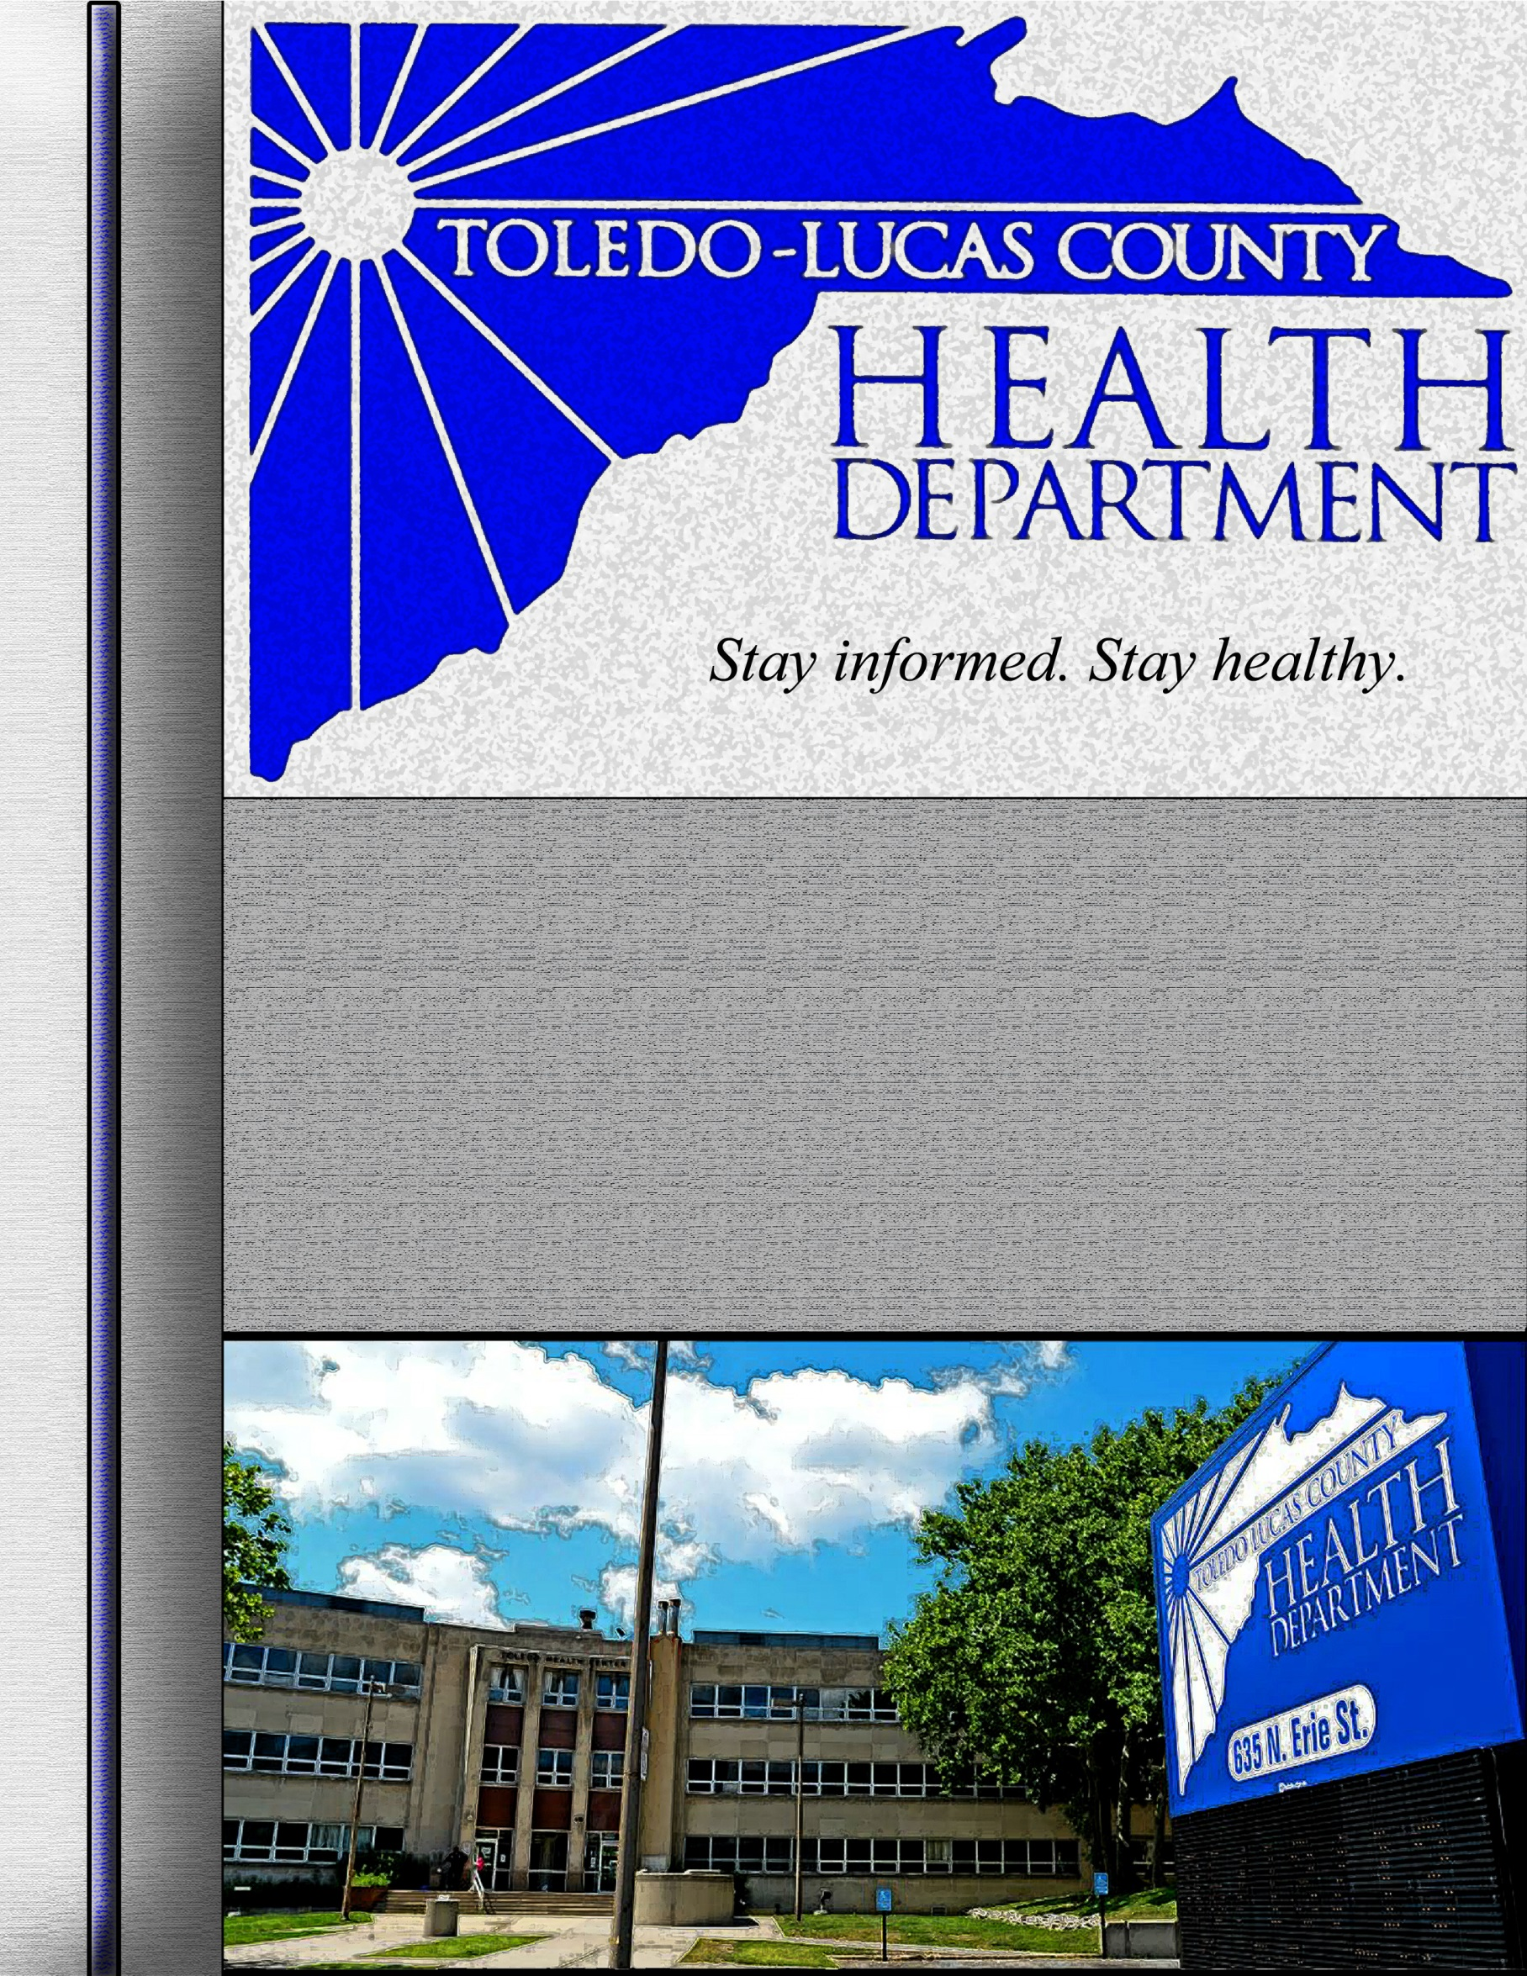

Quality Improvement Plan

2014 - 2016

This page is intentionally blank

This page is intentionally blank

Quality Improvement Plan
Signature Page

This plan has been approved and adopted by the following
Administrative staff and Board of Health President:

___________________________________________________ Date_________________
Donna Woodson, MD
Board of Health President

___________________________________________________ Date_________________
David Grossman, MD
Health Commissioner

___________________________________________________ Date_________________
Larry J. Vasko, RS, MPH
Deputy Health Commissioner

___________________________________________________ Date_________________
Joanne Melamed
Chief Financial Officer

___________________________________________________ Date_________________
Dave Miller
Human Resources

___________________________________________________ Date_________________
Eric Zgodzinski, MPH, RS, CPH
Environmental Health & Community Response Director

___________________________________________________ Date_________________
Barbara Gunning, PhD
Health Services Director

Quality Improvement Plan
Record of Adoption & Changes
QI Plan Adoption Date: 5/22/2014
Date of Revision/ Alteration | Initials of Staff Responsible | Description of Changes
5/28/14 | BP | Updated Appendix B

Quality Improvement Plan
Table of Contents
 | Quality Improvement Glossary |  | 4
 | Section I | Introduction | 6
Mission & Vision
Quality Improvement
Core Agency Values
Core Public Health Functions
 | Section II | Leadership, Culture, & QI Council | 8
Agency Leadership & Culture of Quality
Quality Improvement Council
Quality Improvement Teams
 | Section III | Strategies, Communication, & Goals | 13
Quality Improvement Implementation Strategies
Quality Improvement Goals
Quality Improvement Communication
 | Section IV | Evaluation, Resources, & References | 16
Evaluation Process
References
 | Section V | Appendices | 17
 | Appendix A  Appendix B  Appendix C  Appendix D | QI Council Roster  Team Charter Template  Quality Improvement Tools  Quality Improvement Resources

Quality Improvement Glossary

A common vocabulary is used agency-wide for communicating about quality and quality-improvement initiatives. Key terms and frequently used acronyms are listed below.

Community Health Assessment (CHA): The CHA is a collaborative process conducted in partnership with other organizations and describes the health status of the population, identifies areas for health improvement, determines factors that contribute to health issues, and identifies assets and resources that can be mobilized to address population health improvement (Public Health Accreditation Board, 2011).

Community Health Improvement Plan (CHIP): The purpose of the CHIP is to describe how a health department and the community it serves will work together to improve the health of the population within department’s jurisdiction (Public Health Accreditation Board, 2011).

Continuous Quality Improvement (CQI): A systematic, department-wide approach for achieving measurable improvements in the efficiency, effectiveness, performance, accountability, and outcomes of the processes or services provided. Applies use of a formal process (PDCA, etc.) to “dissect” a problem, discover a root cause, implement a solution, measure success/failures, and/or sustain progress.

Evidence-based practice (EBP): Entails making decisions about how to promote health or provide care by integrating the best available evidence with practitioner expertise and other resources, and with the characteristics, state, needs, values and preferences of those who will be affected.

Public Health Accreditation Board (PHAB): A nonprofit organization dedicated to improving and protecting the health of the public by advancing the quality and performance of Tribal, state, local, and territorial public health departments (Public Health Accreditation Board, 2012).

Performance Management: The practice of actively using performance data to improve the public’s health. This practice involves strategic use of performance measures and standards to establish performance targets and goals (Turning Point, 2003).

Plan, Do, Check, Act (PDCA): An iterative, four-stage, problem-solving model for improving a process or carrying out change. PDCA stems from the scientific method (hypothesize, experiment, evaluate). A fundamental principle of PDCA is iteration. Once a hypothesis is supported or negated, executing the cycle again will extend what one has learned (Embracing Quality in Local Public Health: Michigan’s QI Guidebook, 2008).

Objective: A measurable condition or level of achievement at each stage of progression toward a goal; objectives carry with them a relevant time frame within which the objectives should be met (Agency for Healthcare Research & Quality, 1999).

Quality Assurance (QA): Guaranteeing that the quality of a product/service meets some predetermined standard.

Quality Culture: QI is fully embedded into the way the agency does business, across all levels, departments, and programs. Leadership and staff are fully committed to quality, and results of QI efforts are communicated internally and externally. Even if leadership changes, the basics of QI are so ingrained in staff that they seek out the root cause of problems. They do not assume that an intervention will be effective, but rather they establish and quantify progress toward measurable objectives. (Roadmap to a Culture of Quality Improvement, NACCHO, 2012).

Quality Improvement (QI): Quality improvement in public health is the use of a deliberate and defined improvement process, such as Plan-Do-Check-Act, which is focused on activities that are responsive to community needs and improving population health. It refers to a continuous and ongoing effort to achieve measurable improvements in the efficiency, effectiveness, performance, accountability, outcomes, and other indicators of quality in services or processes which achieve equity and improve the health of the community. (Riley, Moran, Corso, Beitsch, Bialek, and Cofsky. Defining Quality Improvement in Public Health. Journal of Public Health Management and Practice.
January/February 2010).

QI Project Size: Quality improvement projects will vary in their scope depending on the process examined and the goals of each project.

Little QI:
Little QI represents small, limited quality improvement efforts at the program or process level.

Big QI:
These are QI projects that examine processes affecting the divisional level or entire health department.

Giant QI:
These are QI projects that encompass the entire health department and at least one other external agency. The processes examined might encompass the health department’s jurisdictional area or the interaction between the department and external agencies or stakeholders.

Section I | Introduction

Mission & Vision

The mission of the Toledo-Lucas County Health Department is to improve the health and well-being of all Lucas County residents. This is achieved through health promotion, disease and injury prevention, and the pursuit of a clean and safe environment.

Quality Improvement

The Toledo-Lucas County Health Department (TLCHD) has embraced continuous quality improvement (CQI) as a means to ensure we are fulfilling our mission & vision in service to our constituents. TLCHD has adopted the Plan, Do, Check, Act (PDCA) QI methodology. This approach will be used throughout the department on an ongoing basis in order to develop a Culture of Quality and will help TLCHD better serve both our customers and employees.

This Quality Improvement Plan will provide the framework for the selection of QI projects, the formation of QI teams, and will ultimately help to instill a culture of QI throughout the agency. The implementation of this plan will also support TLCHD in its efforts to realize and sustain national accreditation, as well as achieve the priorities set forth in its Strategic Plan.

Core Agency Values

The Toledo-Lucas County Health Department holds public accountability as a valued standard in our mission to improve the health of our community. Our values drive our efforts to provide the best services possible and to seek out new best practices as they are made available.

We demonstrate public accountability through the following values:

Integrity: TLCHD is committed to maintaining the highest service standards possible.

Excellence: TLCHD strives to improve how we do what we do every day to ensure that our practices are always best practices.

Collaboration: TLCHD seeks out partnerships and collaborative efforts with local and national healthcare and other promotional organizations because collaboration helps pool knowledge and resources to serve our community better.

Accountability: TLCHD is applying for national Public Health Accreditation sponsored by the Public Health Accreditation Board (PHAB). Accreditation will ensure that we remain accountable in every facet of operation to our agency’s strategic mission and our ongoing efforts to improve the health and wellbeing of all Lucas County residents. PHAB accreditation will help us to ensure our standards and practices align with, and even surpass, the rigorous criteria required to become a nationally accredited public health agency.
Core Public Health Functions

The TLCHD uses the core public health functions of Assessment, Policy Development, and Assurance as the framework for our services. These three core functions ensure that our department continually strives to provide the Ten Essential Services of Public Health to our community.

Assessment:

- Monitor health status to identify and solve community health problems
(e.g., community health profile, vital statistics, and health status)

- Diagnose and investigate health problems and health hazards in the community
(e.g., epidemiologic surveillance systems, laboratory support)

Policy Development:

- Inform, educate, and empower people about health issues
(e.g., health promotion and social marketing)

- Mobilize community partnerships and action to identify and solve health problems
(e.g., convening and facilitating community groups to promote health)

- Develop policies and plans that support individual and community health efforts
(e.g., leadership development and health system planning)

Assurance:

- Enforce laws and regulations that protect health and ensure safety
(e.g., enforcement of sanitary codes to ensure safety of environment)

- Link people to needed personal health services and ensure the provision of health care when otherwise unavailable (e.g., services that increase access to healthcare)

- Assure competent public and personal health care workforce
(e.g., education and training for all public health care providers).

- Evaluate effectiveness, accessibility, and quality of personal and population-based health services (e.g., continuous evaluation of public health programs)

- Research for new insights and innovative solutions to health problems
(e.g., links with academic institutions and capacity for epidemiologic and economic analyses)

Section II | Leadership, Culture, & QI Council

Agency Leadership

The TLCHD recognizes that one of the keys to the success of any continuous quality improvement process is direct support from administrative leadership. This includes, but is not limited to, the Health Commissioner, Deputy Health Commissioner, the Community Services & Environmental Health Director, Health Services Director, and supervisors within each division. Our leaders support QI activities through planned coordination and communication of the results of QI initiatives. Leaders ensure that the Board of Health, staff, and various stakeholders have knowledge of, and input into, ongoing QI initiatives as a means of continually improving performance.

Culture of Quality

A Quality Improvement Plan Team convened in February, 2014, and completed the National Association of County & City Health Officials’ (NACCHO) Self-Assessment Tool (S.A.T.) to assess the current culture of quality improvement within the agency. The TLCHD is currently between Phase 2 and 3 on NACCHO’s Roadmap to a Culture of Quality Improvement (http://qiroadmap.org/). At this stage our organization has a rudimentary understanding of QI, but does not actively engage in QI activities or allocate dedicated staff time and resources that are required for the advancement of our culture.

The QI Plan Team completed a QI culture “Current vs. Desired State” exercise from the results of the S.A.T. Consistent with Phase 2 & 3 agency placement on the Roadmap, the exercise focused on elements of leadership, support, QI investment, and training. The current state of the agency was assessed directly preceding the adoption of this plan and is summarized below. Strategies to move TLCHD from its current QI state to the desired state are addressed in Section III.

Current State | Desired State
- Lack of communication regarding QI between departments | - Coordinated communication between departments on the progress of QI projects.  - System for sharing QI projects and results
- Primary job expectation is on task completion rather than the process leading to, or involved with, task completion | - Job responsibilities are accounted for both through the process of their completion and the final result. Employees have more freedom to improve the processes involved in their daily work.
- Adequate time is not actively allocated for QI projects. Employees are unable to actively work QI initiatives into their daily responsibilities | - Administrative leadership engages all staff on QI principles and projects at department meetings  - Administrative leadership embraces and creates time for QI within daily responsibilities
- Lack of formal process for reporting potential QI projects or work process changes | - Formal process for reporting potential QI projects and employee work process considerations
- No formal QI processes are in place for QI projects | - Agency-wide adoption and implementation of QI processes and tools  - Designation of a QI Coordinator(s) to oversee progress and process of QI activities department wide  - Centralized location for policies & procedures so that all employees know what can be improved upon
- Employees with any level of QI or other additional training are un-proportionally burdened with a greater work load | - Widely available trainings in QI and other related areas.  - Increasing employee knowledge base.  - Robust training system for all employees and new hires.  - All employees see QI as part of their job

Quality Improvement Council

The establishment of a QI Council will provide TLCHD’s QI program with clear guidance and assure organizational support. The department QI Coordinator will serve as the co-chair for the council and will be the primary contact for departmental QI activities. The Chair of the QI council will be elected annually from the membership and coordinate QI Council meetings and activities with the QI Coordinator.

QI Coordinator

The Toledo-Lucas County Health Department will identify a Quality Improvement Coordinator to help facilitate and ensure the implementation of all quality improvement initiatives.

QI Coordinator responsibilities will include:
- Work with council chair to set QI Council meeting agendas
- Co-chair QI Council meetings and activities
- Maintain a database and hard copy binder of all QI project records and reports
- Establish a communication protocol for employees to contact the QI Coordinator or QI Council members with suggestions for QI projects (e.g., anonymous suggestion boxes, supervisor collection of staff suggestions at meetings, etc.)
- Coordinate with Public Information Officer for internal and external customer communication
- Work with the Workforce Development Coordinator to maintain database of QI training records and certificates for all employees.

The QI Coordinator will be the only permanent member of the QI Council. This individual’s fixed presence on the council will ensure a sustained and knowledgeable presence will be available to guide and coordinate quality improvement activities across the department.

QI Council Membership

The membership of the QI Council will be composed of a team representing all departmental areas of the organization. QI Council members will champion QI efforts in their departmental areas. A list of these representatives is maintained in Appendix A.

Membership will include the following staff:
- QI Coordinator
- Two members from the Community Services & Environmental Health Division
- Two members from the Health Services Division
- Two members from Vital Statistics
- One executive administrative member (e.g., Health Commissioner, Deputy Health Commissioner, Chief Financial Officer, CSRP Director, HS Director)
- One non-executive administrative member (e.g., I.T., clerks, etc.)
- Two nursing representatives
- The membership will consist of no more than three directors or supervisors at any one time.

Members will serve on the QI Council for two years. Member rotation will be staggered such that no more than half of the council will be refreshed each year.

QI Council Responsibilities

The QI Council is responsible for the revision and maintenance of this QI Plan. To ensure this plan aligns with TLCHD’s strategic mission and vision, it will be fully evaluated and revised every three years following the revision of the Strategic Plan. The QI Council will update this plan within 60 days of the Strategic Plan’s revision. Additionally, the QI Council will review this plan annually to monitor progress towards its goals and objectives.

The QI council will elect a Chair to oversee QI council meetings and ensure council responsibilities are being fulfilled. This position will be elected annually. The QI Coordinator will serve as co-chair.

The QI Council will guide the selection and monitor QI projects throughout their duration, and oversee implementation of goals and strategies.

Additionally, the Council will ensure that QI project results are communicated to both internal staff and external stakeholders. Communication may be facilitated through the QI Coordinator, the Team Leader of a QI project, or the QI Council directly. Quality Improvement project updates and reports will be provided to the Board of Health quarterly. The QI Council will also be responsible for assuring that necessary changes resulting from QI projects are implemented and adopted.

All Council decisions will be governed by group consensus. Where consensus cannot be reached, a majority vote of the membership will be held and the result adhered to by all members.

To fulfill its responsibilities, the QI council will meet bi-monthly in the first year of its inception and quarterly thereafter. In the event additional meetings prove necessary to meet council responsibilities or are requested by the council membership, the council chair and co-chair will convene a majority vote of the membership to determine whether additional meetings will be convened, how many, and the date(s) and duration.

QI Projects

Project selection will be guided by the QI Council. Projects will be selected based on Strategic Plan priorities, quality assurance & program evaluations, customer satisfaction surveys, employee needs-assessments & suggestions, or as problem areas in the department’s operation become apparent. All staff are empowered to identify and communicate problems that may be resolved through a QI project. Additionally, projects may be selected based on data collected through the department’s performance management system.

The final decision to begin a project will be made based on data collected and/or the identification of operational deficiencies.

A system of electronic and hard copy QI project records will be maintained. Upon the completion of a QI project, the final report and all related documentation will be submitted to, and maintained by, the QI Coordinator in a QI Plan & Project Binder in room 250B. Digital copies are available on the G-Drive in the Accreditation & Quality Improvement folder.

Quality Improvement Teams

For each QI project undertaken by TLCHD, a QI team will be established. The teams will consist of 5-7 members, and the members will be selected by the QI Council. Each team will have a team leader appointed by the QI Council. The leader will be responsible for overseeing team activities and discussing questions or concerns with the QI Council and Coordinator as needed throughout the duration of the project.

Each team will be responsible for the initiative charged to it by the QI Council, and will only be responsible for one QI initiative at a time. Teams will meet once every two weeks (bi-weekly) and may increase or decrease meeting frequency as needed to meet the obligations of the QI project.

QI Teams will abide by the QI Team Charter and other guidance provided by the QI Council for the duration of the QI project.

QI Team Charter

Once the QI Council decides on the formation of a new QI team and its members, the Team Leader will draft the team charter. The team charter is a crucial document that will be completed at the start of a QI project and will serve as a guide for the team. The QI Team Charter is a living document and can be changed throughout the QI process. A team charter template guide is available in Appendix B. The QI Council will review all Team Charters to ensure each QI Team has established measureable objectives and priorities.

Section III | Strategies, Communication, & Goals

Quality Improvement Implementation Strategies

                - TLCHD recognizes the need to actively pursue strategies to move our organization towards the “Desired State” outlined in Section II. The tools used to conduct these activities are described in Appendix C.

The Agency has adopted the Plan, Do, Check, Act (PDCA) methodology as the framework for conducting all QI activities; the PDCA is described below.

Plan, Do, Check, Act
Plan
The first step involves identifying preliminary opportunities for improvement. After a decision is made to undertake a QI initiative, a QI team is assembled. This team will consist of staff that will be directly affected by the outcomes of the project. The focus will be to analyze data to identify concerns and determine anticipated outcomes. Ideas for improving processes are identified. This step requires the most time and effort. Customers, both internal and external that will be affected by the process will be identified, data compiled, and solutions proposed. The last part of Plan phase is to develop an improvement theory to test.
Do
This step involves using the proposed improvement theory developed through the assessments and measurements of the planning phase, and if the theory proves successful, implementing the solution on a trial basis as a new part of the process.
Check
At this stage, data is again collected to compare the results of the new process with those of the previous one.
Act
This stage involves two actions. The first is to decide, based upon the data collected in the Check phase whether to adopt the change theory, adapt (make slight changes to the theory) or to abandon the improvement theory and start over. The second action in this phase is to decide future plans. So if the team decided to adopt or adapt the improvement theory, it must indicate how it will monitor the gains going forward. If the improvement theory was abandoned, it must decide on how it will continue.

The Quality Improvement Plan Team convened in February, 2014, developing specific strategies that will bring our agency to its “Desired State” over time. Because the S.A.T. placed our agency between Phases 2 – 3 on NACCHO’s Roadmap, our strategies focus primarily on learning and culture.

Training Strategies
Goal 1: |  | All employees at TLCHD will have QI training corresponding to the level of their involvement with QI activities.
The Toledo-Lucas County Health Department will engage all current employees and new hires in Quality Improvement training. In April, 2014, the department partnered with The Center for Public Health Practice at The Ohio State University to train all employees in the basics of quality improvement. TLCHD staff were trained using the introductory modules 1-3 of The Ohio State University’s Continuous Quality Improvement for Public Health: The Fundamentals. Staff that were unavailable to attend the in-person trainings completed these modules on their own and submitted their certificates of completion to the QI Coordinator.

Objective 1: Beginning May 2014 and ongoing thereafter, all new hires are required to complete the first three modules of The Ohio State University’s Continuous Quality Improvement for Public Health: The Fundamentals within the first 90 days of employment. New hires will also be given review materials on the PDCA cycle. Measured by: printed certificate of completion (Human Resources Director).

Objective 2: Members of the QI Council will complete all modules (4-8) of the CQI for Public Health: Tool Time course within the first three weeks of their inception into the council.

Objective 3: Members of active QI teams will complete the modules (4-8) of the CQI for Public Health: Tool Time within three weeks of a project’s initiation. The modules will provide each team member with basic understanding of the tools that will be used throughout the duration of the PDCA project cycle.

Objective 4: Department leadership will be trained to actively champion quality improvement efforts at all levels of the agency within two years of this QI Plan’s adoption date.

Goal 2: |  | Employees will have access to additional internal and external quality improvement training opportunities and resources.
Objective 1: Available quality improvement training opportunities, both internal and external, shall be communicated to department staff (e.g., QI Council Summit). Within the first 2 years of this Plan’s adoption, additional training for QI Council & team members will be prioritized.

Objective 2: Necessary resources will be planned for and allocated to allow staff to attend quality improvement training opportunities. (See Resources in Section IV)

Objective 3: Establish a QI resource library for quick access to QI principles and tools.

Communication Strategies
Goal 3: |  | Regular communication between administrative and frontline staff regarding quality improvement activities and progress
The Toledo-Lucas County Health Department recognizes that regular communication on the progress of our quality improvement activities is essential to the establishment of a culture of quality throughout our organization. These objectives will ensure the entire staff, including TLCHD’s satellite facilities, will receive consistent updates regarding ongoing projects being conducted by TLCHD staff.

Objective 1: Quality improvement information/activity updates will be provided in the department’s monthly newsletter and/or by email burst.

Objective 2: Quality improvement updates will be included on the agendas of monthly divisional staff meetings as they become available. In addition, supervisors will be asked to collect QI project suggestions from their employees at these meetings.

Objective 3: The QI Coordinator or appropriate QI Team leader will update the Board of Health on the department’s QI activities and progress or on the status of a specific QI project. Board updates will be communicated quarterly.

Goal 4: |  | Recognition for quality improvement through public sharing of QI project results and efforts
TLCHD realizes that participating on a QI team involves a dedicated commitment, and employees serving on the QI Council and QI teams who make this commitment need to be recognized for their efforts. Working to improve the services offered by TLCHD to its customers is an excellent example of teamwork and dedication to public health and our agency.

Objective 1: QI storyboards detailing the process and outcomes of QI projects will be displayed publicly in common areas.

Objective 2: All TLCHD employees participating on QI teams and QI Council will be recognized at the annual all-staff retreat. Completed QI projects will be summarily presented by the QI team responsible.

Objective 3: Staff members will receive a certificate of appreciation signed by the Health Commissioner once their project is complete as well as recognition in the department’s monthly newsletter for outstanding QI efforts.

Objective 4: The QI Council will investigate the establishment of a plaque for department staff who have participated and/or achieved in Quality Improvement efforts within the department.

Objective 5: Additional incentives for completed trainings and QI initiatives will be discussed by the QI Council within the first year of its inception. (e.g., Employee of note parking spot, auction of a personal day, etc.)

Section IV |  |  |  | Evaluation, Resources, & References

Evaluation

This QI Plan will be evaluated on an annual basis by the QI Council during the first quarter of each year. The evaluation will determine if the aspects of the plan are being followed, and if any improvements or revisions are necessary. The evaluation will include a summary of the progress toward goals and objectives of the agency’s QI Plan, as well as the QI activities conducted during the past year. The outcomes accomplished by each QI team will be reviewed including the process that was targeted, the performance indicators utilized, measurement outcomes and data aggregation, the assessment and analysis process, and the improvement initiatives implemented in response to the results of the QI project.

The QI Plan will be fully evaluated and revised every three years following the revision of the Strategic Plan to ensure this plan aligns with TLCHD’s strategic mission and vision.

Resources

All staff in attendance at the QI trainings in April, 2014 were provided with the Memory Jogger 2: Tools for Continuous Improvement and Effective Planning booklet to serve as a QI resource guide.

Additional QI learning materials will be made available within the Accreditation & Quality Improvement folder in the Common folder of the G-Drive and communicated to staff in accordance with the Communication Strategies in Section III.

Available QI trainings will also be communicated to staff in accordance with the Communication Strategies in Section III. For QI trainings that are not available free of charge, the QI Coordinator will work with the CFO/Grants Coordinator to determine appropriate agency financing.

Appendix D will contain a list of resource links including available training opportunities and tools.

References

This Quality Improvement Plan was developed by the Toledo-Lucas County Health Department to guide all efforts in the establishment of a Culture of Quality. References for the development of this plan include Mahoning County Board of Health, Delaware General Health District, Licking County Health Department, the Center for Public Health Practice at The Ohio State University, the National Network of Public Health Institutes, and the National Association of County & City Health Officials.

Section V | Appendices

 |  | List of Appendices
 | Appendix A |  |  |  | 18
 |  |  | QI Council Roster
 | Appendix B |  |  |  | 19
 |  |  | Team Charter Template
 | Appendix C |  |  |  | 24
 |  |  | Quality Improvement Tools
 | Appendix D |  |  |  | 29
 |  |  | Quality Improvement Resources

Appendix A | QI Council Roster

QI Council Roster
Division | Member Name | Inception Date  (2 Year Tenure) | Member Position/Job Title
QI Coordinator
Administration
Community Services & Environmental Health
Health Services
Vital Statistics
Nursing
Updated:

Appendix B | Team Charter Template

Team Charter Detail by Section:

A Blank Template can be found with the Quality Improvement materials in the G-Drive Common folder.

QI Team Information
Section 1. Charter (Project or Task Force)
What it does: | Establishes the nature of the work.
Why it is important: | Differentiates the team work in the following way:  - A Project is typically a well-defined system or process change, the scope and implementation needs are known up front, the project timeline is predictable, and the outcome known.  - A Task Force is usually less prescribed, usually focusing on a problem to be solved or an improvement opportunity. The charter is a vehicle by which the team can reach consensus on the aim, define the boundaries of the process, and identify the means by which the effort will measure its success.
Example: | Project: Implementation of a scheduling system.  Task Force: Waits and Delay, Improvement Team.
Section 2. Team Name
What it does: | Identifies the team.
Why it is important: | Enables the team to distinguish the effort from others.  Tip: Keep it simple, unique, and easily stated.
Example: | WIC Waiting Room Time Reduction Team.
Section 3. Version (Number/Date)
What it does: | Tracks and clarifies versions of the charter, identifies current charter.
Why it is important: | Charters if used well will be iterative; it is important to establish the last time the document was edited.  Tip: Using only the last edited date is the simplest method.
Example: | December 12, 20XX or Version #5, December 12, 20XX.
Section 4. Subject
What it does: | Identifies the area of focus.
Why it is important: | Clarifies the intent of the project.
Example: | WIC Intake Department.
Section 5. QI Council Sponsor
What it does: | Identifies the senior leader that supports and/or initiated this effort.
Why it is important: | Established who in senior leadership cares about this effort and has overall operational accountability.  The Sponsor will be expected to break down barriers and “go to bat” for the team.
Example: | Mary Jane, Health Officer

Section 6. Team Leader
What it does: | Identifies one individual who will guide the team to achieve successful outcomes and who will communicate to senior leaders.
Why it is important: | Established who will conduct team meetings, provide focus and direction, and will ensure productive use of team member’s time. This person is not necessarily the same individual who will be “in charge” of the process, but should be a person who will “lose sleep” over the outcome.
Example: | Joe Smith, WIC Department Manager
Section 7. Team Members and Area of Expertise
What it does: | Defines who will be on the team and why.
Why it is important: | Assure that all the people necessary to effect change will be involved.  Tip: You may have people that you do not need on the core team however, they are key stakeholders and must be consulted with, and made aware of, changes. These individuals should be identified in the Charter.  Refer to the high level process utilized to define the scope to verify that the team has representation from each major process step.
Example: | Team Member: Billy Bob – WIC Intake Supervisor

PLAN: Identify an Opportunity and Plan for Improvement
Section 8. Problem / Opportunity Statement
What it does: | States why this effort was initiated and what will be affected by the outcome.
Why it is important: | Orients team and others to the true need for the effort. The source and analysis of the data that identified the problem or opportunity should be included and used as a baseline.
Example: | WIC applicants are complaining that it takes too much time to process their in-person application and there is a lack of privacy while giving information to the clerk.
Section 9. AIM Statement (Mission)
What it does: | It describes what the team intends to do, providing the team with a focus and a way to measure progress.  The aim should be derived from a known problem (data) and need for corrective action.
Why it is important: | Clarifies where the team is going and enables them to know when they get there. A well stated aim affords a team the opportunity to improve many aspects of the system or process related to the aim.  TIP: Most successful improvement efforts have a succinct aim with a measurable stretch goal. The measure should be monitored over time and tracked in the form of a statistical process control chart.
Example: | AIM: To reduce the waiting time by 50%.

Section 10. Current Process
What it does: | Specifies the boundaries of the process you are involved in. They may be stated in time frames and/or process steps.
Why it is important: | Sets the stage; provides focus; identifies limits.  Tip: Map out a 7-9 step high-level process flow for the scope you’ve defined. This will help you understand what you need to be successful, including validating team membership.
Example: | “The time the person arrives in the WIC Department to the time they have successfully filled out the application and leave.”
Section 11. Customers/Stakeholders and Customer Needs Addressed
What it does: | Identifies the customers and stakeholders (individuals or departments) of the product or service you provide that may be impacted by the outcome. Also, it specifies the ways in which you meet their stated needs.
Why it is important: | Identifying customers early helps you decide if they need to be represented on the actual team. The identification of their needs and how well you are or are not meeting them must be continually assessed during the improvement process. Also, increases team's awareness.
Example: | John Smith - Applicant for WIC benefits.
Section 12. Collect Data On The Current Process
What it does: | Baseline data that describe the current state are critical to further understanding the process.
Why it is important: | Baseline data establishes a foundation for measuring improvements.
Example: | Number of individuals are receiving WIC benefits today.
Section 13. Identify All Possible Causes
What it does: | Identifies the root cause of the problem. Numerous causes will emerge when examining the QI opportunity, and it's important to determine the underlying cause. Describes both positive and negative factors that must be discussed and understood prior to the work beginning. In this process, the following may be identified:  Assumptions: statements of requirements that must be accepted;  Constraints: an element that might restrict or regulate project actions or outcomes;  Obstacles: a factor that might impede progress;  Risks: a course of action that might pose a hazard or cause loss.
Why it is important: | In order to ensure than an improvement or intervention with the greatest chance of success is selected. Clarifies expectations; requires people to reflect on the effort in a more thoughtful way; can redefine the work; may facilitate the removal of known obstructions in advance; gives credibility to teams (that they have considered possible issues).
Example: | Using cause and effect/fish-bone diagram and the 5 Whys are useful for determining the actual root cause.  Assumption: The WIC intake area can be rearranged to make for private booths  Constraints: Information Technology solutions will not be entertained at this time (system upgrade planned in 2 years).

Section 14. Identify Potential Improvements. S.M.A.R.T. Objectives
What it does: | Listing out the S.M.A.R.T. (specific, measurable, achievable, realistic, time frame) objectives for the effort will help define the opportunities to improve.
Why it is important: | It enables the team to reach consensus on what will be addressed during the course of the effort.  Tip: Group similar objectives and give them a descriptive title; for example, Eliminating Waste. Grouping objectives into change concepts facilitates creative thinking with improvement teams.
Example: | Eliminating Waste  - Eliminate unnecessary waiting time  - Reduce duplicative data entry
Section 15. Success Measures
What it does: | Defines how you measure the success of the improvement effort or the project as a whole.
Why it is important: | Metrics help the team and sponsor to understand when and if an implemented improvement is meeting the desired goal.  Tips: Be specific. Agree to definitions and data sources. It is ideal to have a balanced set of measures: satisfaction / costs / outcome. Identify one overarching measure that can be an assay for the entire effort – measure it over time and use a control chart. Keep it simple – use sampling.
Example: | Overall applicant cycle time to get service and complete an application will be reduced by 50%  Obstacles: Departmental practices related to scheduling applicants differ widely.  Risks: Changes may not conform to legal requirements
Section 16. Available Resources
What it does: | Articulate who and what is available to support the team. This might include a facilitator, trainers, or funds.
Why it is important: | Provides both the team and senior leadership with an opportunity to negotiate what the team needs to be successful.
Example: | Facilitator: Fiona Ogre. On campus team workshops. Up to $5,000 is available for teaching assistant.
Section 17. Additional Resources Required
What it does: | Articulate what else will be needed to make this project successful. This might include a subject matter expert (SME), etc.
Why it is important: | Provides both the team and senior leadership with an opportunity to negotiate what the team needs to be successful.
Example: | SME: Ginger Mercy. SME for Value Stream Analysis.  Up to $5,000 is available for additional support personnel.
Section 18. Develop an Improvement Theory
What it does: | Articulates the effect that you expect the improvement to have on the problem.
Why it is important: | This crystallizes what you expect to achieve as a result of your intervention, and documents the connection between the improvement you plan to test and the measurable improvement objective.
Example: | If we have a centralized call center for WIC, then our WIC caseload will increase.
Section 19. Key Milestones
What it does: | Marks significant expectations and/or deliverables the team can expect.
Why it is important: | Holds the team accountable. Maps progress.
Example: | Current State Assessment due March 15th.  Recommendations to be presented to senior leadership in 6 weeks.
DO: Test the Theory for Improvement
Section 21. Implement the Improvement
What it does: | Puts the Action Plan into effect.
Why it is important: | To see if the Action Plan works.
Section 22. Collect and Document the Data
What it does: | Collect and document the data gathered from the implementation.
Why it is important: | So we can measure the success of the implementation
Section 23. Document Problems and Unexpected Observations
What it does: | Keeps track of problems that arose and unexpected observations.
Why it is important: | So that other people can be aware when they are conducted the implementation.
Example: | We noticed a 30-day time delay in getting data from the state lab that was unexpected.

CHECK/STUDY: Use Data to Study Results of the Test
Section 24. Analyze the Effect of the Intervention
What it does: | Reflect on the analysis, and consider any additional information that emerged as well.
Why it is important: | Compare the results of your test against the measurable objective.
Example: | Pareto charts, histograms, run charts, scatter plots, control charts and radar charts are all tools that can assist with this analysis.
Section 25. Document Lessons Learned, Knowledge Gained, and Any Surprising Results That Emerged
What it does: | Summarizes lessons learned, knowledge gained, and any surprising results that emerged
Why it is important: | For future assistance with similar projects.
Example: | WIC voucher testing needs to be done over two days to get adequate results.

ACT: Establish Future Plans
Section 26. Adopt, Adapt, or Abandon
What it does: | Clarifies the concluding result of the QI project.  Adopt: Standardize the improvement if the measurable objective in the aim statement has been met. This involved establishing a mechanism for those performing the new process to measure and monitor benchmarks on a regular basis to ensure that improvements are maintained.  Adapt: The team may decide to repeat the test, gather different data, revise the intervention, or otherwise adjust the test methodology. Repeat "DO" phase.  Abandon: If the changes made to the process did not result in an improvement, consider lessons learned from the initial test, and return to the "PLAN" phase.
Why it is important: | To keep track of the final decisions made and why they were made.
Example: | Adopted the QI project for the district because we saw positive results in one county.
Section 27. Communication Plan (Who, How, and When):
What it does: | Clarifies your communication plan.
Why it is important: | Identifies everyone who is expecting to receive communication on this team effort.
Example: | The entire team will give a report out to the stakeholders 6 weeks from the start of the project (~ Nov15).  The Team Leader will update the Sponsor weekly (agenda item at the regular staff meeting).
*Team Chartering by John W. Moran and Grace L. Duffy http://www.texas-quality.org/SiteImages/125/Newsletter/April%202010%20Newsletter.pdf
*"The ABCs of PDCA" by Grace Gorenflo of the National Association of County and City Health Officers and John W. Moran of the public Health Foundation and University of Minnesota School of Public Health. Gorenflo G, Moren JW. The ABCs of PDCA for Public Health Agencies. ASQ Healthcare update, June 2010. Formatted for electronic entry.
Appendix C | Quality Improvement Tools

QI Tool | What the Tool Does | Public Health Memory Jogger II
Activity Network Diagram/ Gantt Chart | Used to: Schedule sequential and simultaneous tasks.  - Gives team members the chance to show what their piece of the plan requires and helps team members see why they are critical to the success of the project.  - Helps team focus its attention and scare resources on critical tasks | Page 3
 |  | 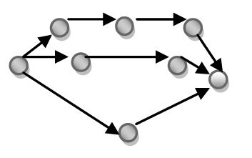
Affinity Diagram | Used to: Gather and group ideas  - Encourages open thinking and gets all team members involved and enthusiastic  - Allows team members to build on each other’s creativity while staying focused on the task at hand | Page 12
 |  | 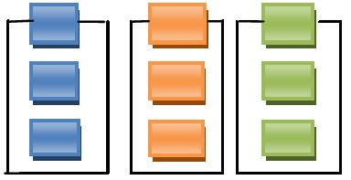
Brainstorming | Used to: Create bigger and better ideas  - Encourages open thinking and gets all team members involved and enthusiastic  - Allows team members to build on each other’s creativity while staying focused on the task at hand | Page 19
Cause and Effect/ Fishbone Diagram | Used to: Find and cure causes, not symptoms  - Enables a team to focus on the content of the problem, not the problem’s history or difference personal issues of team members  - Creates a snapshot of the collective knowledge and consensus of a team around a problem  - Focuses the team on causes, not symptoms | Page 23
 |  | 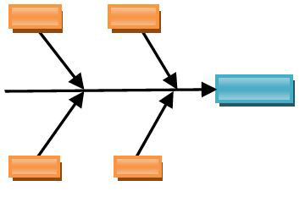

QI Tool | What the Tool Does | Public Health Memory Jogger II
Check Sheet | Used to: Count and accumulate data  - Creates easy-to-understand data ~ makes patterns in the data become more obvious.  - Builds a clearer picture of “the facts”, as opposed to opinions of each team member, through observation. | Page 31
Control Charts | Used to: Recognize sources of variation  - Serves as a tool for detecting and monitoring process variation. Provides a common language for discussing process performance.  - Helps improve a process to perform with higher quality, lower cost, and higher effective capacity. | Page 36
 |  | 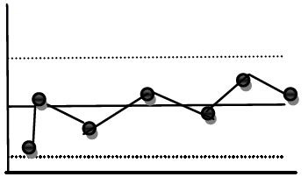
Data Points | Used to: Turn data into information  - Determines what type of data you have  - Determines what type of data is needed | Page 52
Flowchart | Used to: Illustrate a picture of the process  - Allows the team to come to agreement on the steps of the process. Can serve as a training aid.  - Shows unexpected complexity and problem areas. Also shows where simplification and standardization may be possible.  - Helps the team compare and contrast the actual versus the ideal flow of a process to help identify improvement opportunities | Page 56
 |  | 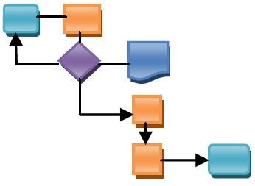

QI Tool | What the Tool Does | Public Health Memory Jogger II
Force Field Analysis | Used to: Identify positives and negatives of change  - Presents the “positives” and “negatives” of a situation so they are easily compared  - Forces people to think together about all aspects of making the desired change as a permanent one. | Page 63
 |  | 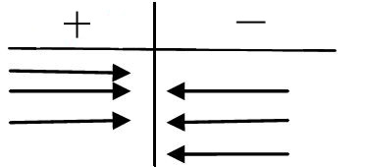
Histogram | Used to: Identify process centering, spread, and shape  - Displays large amounts of data by showing the frequency of occurrences  - Provides useful information for predicting future performance.  - Helps indicate there has been a change in the process.  - Illustrates quickly the underlying distribution of the data | Page 66
 |  | 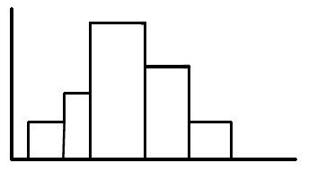
Interrelationship Diagram | Used to: Look for drivers and outcomes  - Encourages team members to think in multiple directions rather than linearly.  - Explores the cause and effect relationships among all the issues  - Allows a team to identify root cause(s) even when credible data doesn’t exist | Page 76
 |  | 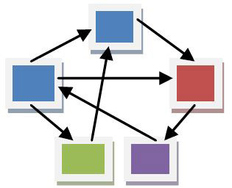
Matrix Diagram | Used to: Find relationships  - Makes patterns of responsibilities visible and clear so that there is even distribution of tasks  - Helps a team come to consensus on small decisions, enhancing the quality and support for the final decision. | Page 85
 |  | 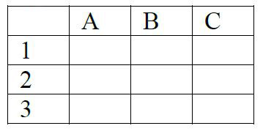

QI Tool | What the Tool Does | Public Health Memory Jogger II
Nominal Group Technique | Used to: Rank for consensus  - Allows every team member to rank issues without being pressured by others.  - Makes a team’s consensus visible  - Puts quiet team members on an equal footing with more dominant members | Page 91
 |  | 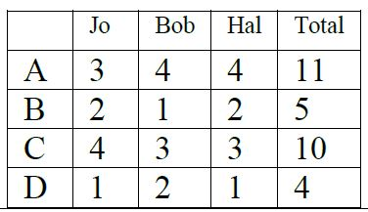
Pareto Chart | Used to: Focus on key problems  - Helps teams focus on those causes that will have the greatest impact if solved. (Based on the Pareto principle ~ 20% of the sources cause 80% of any problem.)  - Progress is measured in a highly visible format that provides incentive to push on for more improvement. | Page 95
 |  | 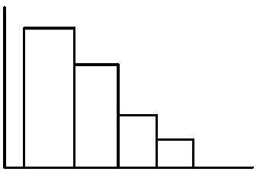
Prioritization Matrices | Used to: Weigh your options  - Forces a team to focus on the best thing(s) to do and not everything they could do.  - Increases the chance of follow-through because consensus is sought at each step in the process (from criteria to conclusions) | Page 105
 |  | 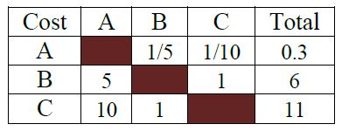
Process Capability | Used to: Measure conformance to customer requirements  - Helps a team answer the question “Is the process capable?”  - Helps to determine if there has been a change in the process | Page 106
 |  | 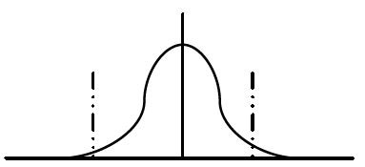

QI Tool | What the Tool Does | Public Health Memory Jogger II
Radar Chart | Used to: Rate organization performance  - Makes concentrations of strengths and weaknesses visible.  - Clearly defines full performance in each category  - Captures the different perceptions of all the team members about organization performance | Page 121
Run Chart | Used to: Track trends  - Monitors the performance of one or more processes over time to detect trends, shifts, or cycles.  - Allows a team to compare a performance measure before and after implementation of a solution to measure its impact | Page 125
 |  | 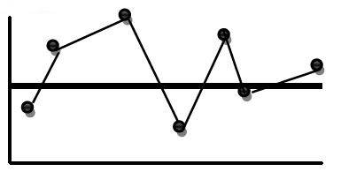
Scatter Diagram | Used to: Measure relationships between variables  - Supplies the data to confirm a hypothesis that two variables are related.  - Provides a follow-up to a Cause & Effect Diagram to find out if there is more than just a consensus connection between causes and the effect. | Page 129
 |  | 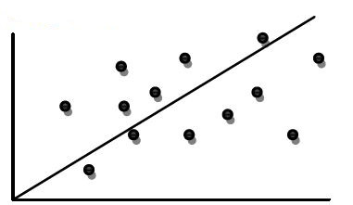
Tree Diagram | Used to: Map the tasks for implementation  - Allows all participants (and reviewers outside the team) to check all of the logical links and completeness at every level of plan detail.  - Reveals the real level of complexity involved in the achievement of any goal, making potentially overwhelming projects manageable, as well as uncovering unknown complexity. | Page 140
 |  | 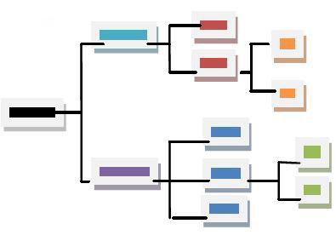
* Source: Brassard, Michael; Ritter, Diane. (2010). Public Health Memory Jogger II: Second Edition. Salem, NH: GOAL/QPC.
Appendix D | Quality Improvement Resources

QI Resources
National Network of Public Health Institutes (NNPHI)
The NNPHI offers a variety of tools and resources- including presentations, samples and guides- on many QI topic areas.

http://nnphi.org/tools/public-health-performance-improvement-toolkit-2?view=file&topic=59
Center for Public Health Practice (CPHP) at The Ohio State University
The CPHP offers the foundation of TLCHD’s QI Training. All employees are trained on the CQI for Public Health: The Fundamentals modules (1-3). QI Council members and QI team members are additionally trained using the CQI for Public Health: Tool Time modules (4-8)

Modules 1-3
http://cph.osu.edu/practice/cqi-public-health-fundamentals

Modules 4-8
http://cph.osu.edu/practice/cqi-public-health-tool-time
National Association of County & City Health Officials (NACCHO)
NACCHO offers several Quality Improvement and Accreditation tools.

Their Roadmap to a Culture of Quality and the Culture of Quality Self-Assessment Tool were both utilized in the development of this plan, and serve as guides for TLCHD’s QI endeavors.

http://www.naccho.org/topics/infrastructure/accreditation/qi-culture.cfm
Public Health Quality Improvement Exchange (PHQIX)
PHQIX is an online exchange and communication hub for information regarding quality improvement initiatives and learning. Users can search a database of QI projects conducted nationally and interact with the online community to answer questions and idea-source possible projects.

https://www.phqix.org/
*Additional Resources will be added to this list as they are made available.*

