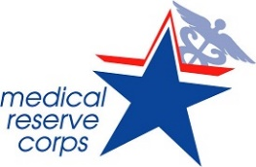

Developing a Strategic Plan/ Roadmap for Your MRC Unit
Mission Statement

Scope & Purpose of the unit

SMART Objective
1-
2-
3-

Recruitment Strategy

Retention Strategy

Recognition strategy

SWOT
Strengths

Weaknesses

Opportunities

Threats

