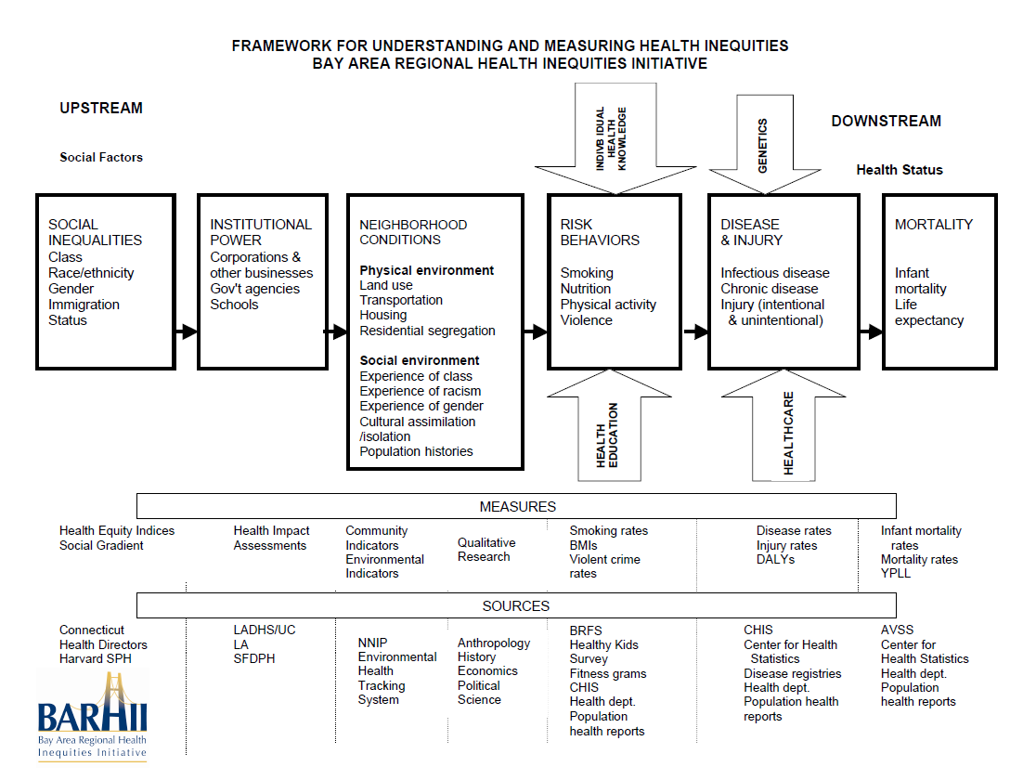
Directions: Think about the types of data you have that describe health in your community. Then determine if the types of data you have are indicators of social inequalities, institutional power, neighborhood conditions, risk behaviors, disease & injury, or mortality. Refer to the BARHII model above.
Social Inequalities | Institutional Power | Neighborhood Conditions | Risk Behaviors | Disease & Injury | Mortality
e.g. concentrated poverty &segregation | e.g. unfair labor practices | e.g. crime rates | e.g. teen substance abuse | e.g. cancer rates | e.g. infant mortality

Questions for Discussion and Community Health Improvement Planning

- What do you notice about the types of data you have? Where, on the BARHII upstream-downstream continuum, does most of your data lie?

- Based on the data you have, what gaps in knowledge about the determinants of health and inequity do you anticipate having?

- What are the implications of these gaps in knowledge for your community health improvement process?

- What types of strategies can you employ to reduce your gap in knowledge? Who needs to be involved? How would you structure the process?

- What challenges do you anticipate in addressing social determinants of health and inequity?

- What are some strategies you can employ to overcome these challenges?

