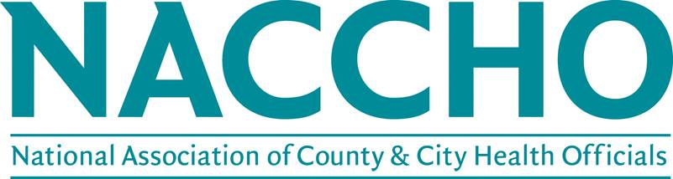

Advisory Group Application Instructions:
To apply, individuals should do the following:
- Click here to login to “My NACCHO”
- Select “My NACCHO” from the left navigation (second option)
- Click on >>Join, under “My Groups” (top right)
Thank you for your interest in serving on a NACCHO Advisory Group. Priority to serve will be given to active (dues paying) members. Not sure if you are an active member? Please email membership@naccho.org or call 877.533.1320 (Toll Free)
If you are applying to more than one committee, please prioritize the top three advisory groups for which you would like to be considered. Once you select your first group, a drop down menu for your second choice will appear, and likewise for the third.
In 500 words or less, (*the character limit includes spaces) include the following in your experience statement, as it pertains to the advisory group in which you are applying:
- Explain why you are interested in serving on this committee/workgroup
- Briefly describe relevant experience for each of your choices
You are encouraged to compose your statements of experience in a separate document and enter them into this form only when they are final. Once submitted, you will not be able to edit your application.

Every attempt will be made to appoint members to their first choice, but please note that this will not always be possible. A limited number of openings are available for most advisory groups. Thank you for your interest in serving NACCHO.

For more information about NACCHO's advisory groups, email advisorygroups@naccho.org.

