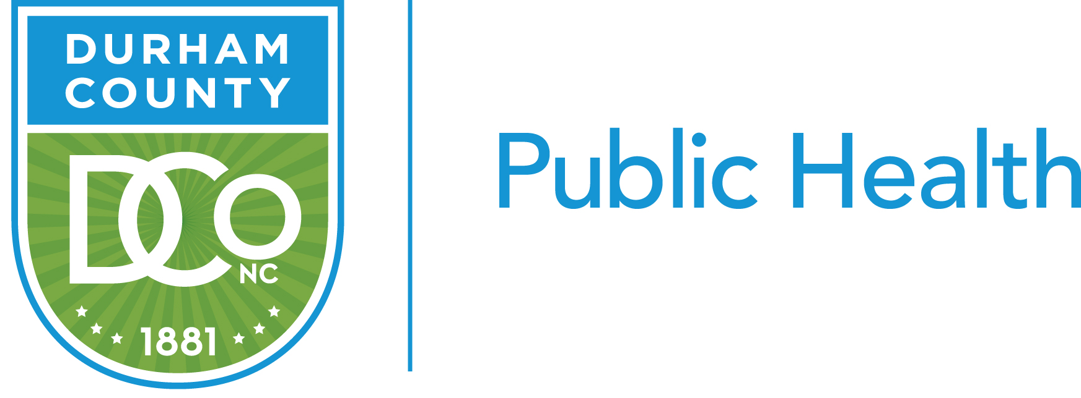
QI storyboard
QI Project Name: | Durham County Healthy Vending Initiative
QI Project Team Members: | Rochelle Talley, Willa Robinson, Kelly Warnock, Michele Easterling, Tara Blackley, Ola Aloba

PLAN
Identify an opportunity and
Plan for Improvement

1. Getting Started
Healthy vending machine food options are not regularly available to Durham County (DCo) employees. The current ordering/supply process between the vendor and DCo, leaves item selection to the discretion of the vendor.
The current vending process is not consistent with Durham's County Government (DCo) strategic goal 2: health and well-being for all. Section 2.1F of this goal focuses on promoting employee wellness.

2. Assemble the Team
1. Rochelle Talley, QI/QA Coordinator
2. Willa Robinson, PH Education Program Manager
3. Kelly Warnock, PH Nutrition Program Manager
4. Michele Easterling, PH Nutrition Administrator
5. Tara Blackley, Deputy Director of PH
6. Ola Aloba, Program Manager Accreditation and Strategic Initiatives

3. Examine the Current Approach
Team assessed vending environment, created an inventory of vending machines and locations. Team also examined Durham County's current vending machine processes: our current process was identified in the following steps: (a) Vendor contacted via note by employees to request healthier food items/choices, (b) Vendor receives request, (c) Vendor subjectively chooses items to include in the vending machine - vendor may not have consulted responsible DCo’s staff re: specific items to supply, (d) Items are placed in vending machine by vendor, and (e) If items remains in vending machine for too long, due to poor sales, the vendor replaces this item with another item of their choice to improve sales.

4. Identify Potential Solutions
Identify potential solutions: (a) re-educate the community and vendor about healthy eating and its effects on our health (b) review or create flow chart for current and
future health vending processes, (c) provide vendor with healthy edible choices from which to supply Durham County's vending machine.

5. Develop an Improvement Theory
Improve DCo’s vending process so that by July 1st, 2020 healthy options are available 100% of the time in all 21 county vending machines. Create a policy, system and environment change to positively impact employee health behavior.

6. Data Collection
A. What are staff buying from vending machines?

Snickers (51), Peanut M&Ms (37), Twix (36), Lays Chips (36) and Cheez its (33) are the most commonly purchased from the snack vending.

Egg Salad (6) and Beef and Jalapeno Burrito (6) are most purchased from the food vending

Pepsi (54) and Mountain Dew (52) are most commonly purchased from the Pepsi Machine

Coke (63) and Water (40) are most commonly purchased from the coke machine
AIM: By December 31st, 2019, increase from 9.8% to 80% the percentage of times the vendor complies with Durham County government’s order for 100% healthy food item refills in 21 of its 21 vending machines by improving the ordering process with the vendor. Healthy items are defined per American Heart Association as beverages that contain no more than 66 calories per 8 oz serving, snacks with less than 200 calories per serving and entrees with less than 500 calories per serving.

B. Weekly staff vending machine usage and favorite types of items purchased:

Food/Snack: 41% purchases Snickers, M&Ms, Twix, Lays Chips, Cheez Its, egg salad, burrito.

Beverages: 48% obtain Pepsi, Mountain Dew, Coke and water.

C. Taste Test: The following items were tested with Durham County employees.
Belvita Biscuits (n = 51): 86.3% loved this item. 13.7% would likely not buy this item.
Original Chex-Mix (n = 41): 87.8% loved this item. 12.2% would likely not buy this item.
Nature Valley Granola Bar
(n = 47) 93.7% loved this item. 6.3% would likely not buy this item.
Terra Vegetable Chips (n = 63) 77.8% loved this item. 22.2% would likely not buy this item.

DO
Test the Theory for Improvement

6. Test the Theory – In planning stages

CHECK
Use Data to Study Results
of the Test
7. Check the Results – To be completed

ACT
Standardize the Improvement and Establish Future Plans

8. Standardize the Improvement or Develop New Theory
Act by standardizing successful processes in all vending machines across Durham County. Then, re-evaluate and periodically monitor progress. Utilize our experiences in process and policy change to educate organizations across Durham County.

9. Establish Future Plans
- Develop a healthy vending county wide policy
- Secure a healthy vending contract with a vendor
- Expand this initiative to other Durham community organizations that are not managed by Durham County Government.
- Expand this initiative with collaborators across the state

