Community Strengths and Themes Open House Summary
Total # Surveys returned to date = 475
63 people attended the open house with 11 Steering Committee/Health Dept Staff running stations.
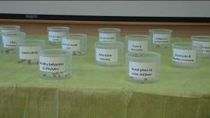
People heard about the event in these top five ways:
- Word of mouth from agencies, steering committee members
- Daily Record Newspaper
- CWU Health classes
- Flyer/Poster
- Publicity at library

Bean Counting Station:
What do you think is most important for a healthy community?
58 participants
Factor | Votes
Low adult death & disease rates | 42
Good jobs & Healthy Economy | 257
Strong family life | 155
Parks & Recreation | 186
Low levels of child abuse | 67
Low infant deaths | 65
Affordable Housing | 163
Low crime/safe neighborhoods | 161
Access to health care | 204
Good place to raise children | 162
religious or spiritual values | 99
Healthy behaviors and lifestyle | 224
Arts & cultural events | 104
Excellent race relations | 69
Clean environment | 160
Good schools | 170
Other | 65

Other:
No bad people in the school,
no guns in school
Recreation & active living
Excellent library
Good places to volunteer & serve
Commitment to social justice/
equity-especially at food environment,
wages/conditions sustainable
ag & livelihoods
Educational opportunities such as
the KVCH library, support groups,
parenting & disease specific
Affordable "non college resident"
housing I am single, one income,
can't afford $800 plus rent
Healthy local food & nutrition education
Access to nutritious food
Good mental health care
Low poverty rates
Access to lifelong learning through
a strong public library

Texting Poll:
What do you think are the most important health issues in Kittitas County?
access to mental health care
obesity
drug and alcohol dependency
addictions
people not aware of opportunities for good life
alcoholism
obesity
living wage jobs
high rate of child abuse currently
economy
personal safety (Morgan)
access to health care
low income population access to healthy life choice support
school building infrastructure
commitment to sustainability and social justice
more living wage jobs
we need winter access to the parks and clear in town pathways and sidewalks
safe housing
personal disaster preparedness
access to health care (all ages/incomes)
lonely seniors
affordable and accessible local food and nutrition education
poverty
access to information
access to nutritious food

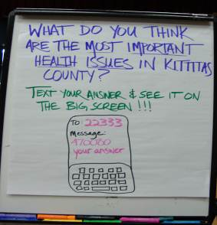

Graffiti Wall Activity Station:
What do you like best about Kittitas County?
Outdoor recreation, access is close by with four season, wild & civilized "parks" | x
Friendly people :) | xx
Farmer's market and local food, me too, ditto
Families
outdoor events
knowing everyone
ability to contribute to thinking/action in public/community health
accessibility to community programs
locals :)
supportive community in which to achieve mental and physical health for myself & my family
close community
safe community
I like that people are not bullies! :)
walking and biking
clean environment
great agency and organization networking
wild things and wild places forever!
mountain views
cultural opportunities (music, libraries, arts, lectures and history)
University brings invaluable diversity to community, YES!
sports programs for young children
Fresh fruits and veggies!
Small town! :) | x
natural beauty
gardening
caring community, partners sense of volunteerism
Peoh point
everything is in within walking distance or there is access to transportation
Low amounts of sewage in drinking water :)
various seasons/weather
sense of community | x
activism
Farmer's market | x
diverse local economy/businesses
great people
Roslyn's urban forest, YEH!
Downtown festivities | x
Outdoor recreation
sun
Healthy habits
love school
school
diversity of place and people-CWU is a valued asset
my children are happy because living next to school
low cost of living
geography
Seussapalooza!
small community feel
Great place to raise kids! | x
community support, open country
so many necessities within walking distance
four seasons
no traffic
libraries
walk ability/small town feel
great volunteer opportunities for all ages
nice people
variety of free or low costing community events
Reecer Creek pubs
lower crime
recreations and cultural opportunities
good educational opportunities
good restaurants
small town atmosphere-community
gateway to the alpine lakes wilderness
open minded people
small town
beautiful land
CWU
arts and recreation
Yes, friendly people and dogs and animals!

Roslyn's urban forest, YEH!
Downtown festivities | x
Outdoor recreation
sun
Healthy habits
love school
school
diversity of place and people-CWU is a valued asset
my children are happy because living next to school
low cost of living
geography
Seussapalooza!
small community feel
Great place to raise kids! | x
community support, open country
so many necessities within walking distance
four seasons
no traffic
libraries
walk ability/small town feel
great volunteer opportunities for all ages
nice people
variety of free or low costing community events
Reecer Creek pubs
lower crime
recreations and cultural opportunities
good educational opportunities
good restaurants
small town atmosphere-community
gateway to the alpine lakes wilderness
open minded people
small town
beautiful land
CWU
arts and recreation
Yes, friendly people and dogs and animals!

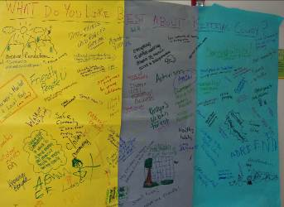

Facilitated Discussion Station:
What do you think would improve the quality of life in Kittitas County
Mas recursas para particuipar en deportas
Mas actividades de bajo costo
CWU needs additional housing to lower in city housing prices for non students
A new middle school
Greenway trail
Housing options
Take Steve & Rob off KXLE
More live music venues | √
More local news and events reported in the Daily Record newspaper
Free parking at the walking trails, such as John Wayne Trail
Local trail access map
No plastic shopping bags
Compostable takeout food containers
Winter farmer's market
Mas clases de ingles durante el dia para comunicar mejor
Living wage jobs | √√√
More accessible health care
More access to better paying jobs
Better shopping/more options
Cheaper shopping
More of the community doing more of the activities, personal involvement & connection
Self sustaining LOCAL economy
Cross generational mixing
Improved support and training for parents to reduce child abuse incidents in our county
People shoveling their walks when there is snow
Year round access to farmer's market
public transportation/rapid transit whiter geography commuter bus
Health care specific commuter system
More professional jobs locally
More advanced professional jobs
Parks up north
More pedestrian and bike friendly
No cars on CWU campus
Improved economic development resources
More action less talk
CWU/County relations

Lights at EHS stadium 5-7 during winter season for a safe outdoor walk/run without automobile worry
Better connections between upper and lower county
Bicycle rentals
Diversify our reason for being a destination location
short stay emergency shelters | √
Better/more public TV and radio access
Drug rehab services for youth
Distribution of resources-upper county is left out in the cold
Regional library district
Something? Someone’s? To visit/monitor senior choosing? To live alone in an undesirable environment

Map Activity Station:
We do not have used the situs address data that we collected here, yet in the Assessment process.
