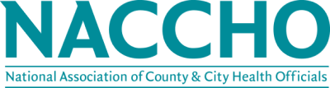

NACCHO and Esri are pleased to announce a new and exclusive member benefit. Esri offers the most powerful mapping and spatial analytics technology available and provides users with a scientific-based approach to solving problems in real-time.
Geography is the science that connects people, places and their interactions. Geographic information system (GIS) technology can help health organizations make sense of those complex interactions. The resulting location intelligence offers tremendous value in promoting health and well-being on a personal and a population level while also supporting major strategic plans for resource allocation and growth. ESRI has developed Community Analyst, which helps allocate scarce community resources more effectively, communicate important information to policy makers and constituents, and improve community outreach. Part of the ArcGIS platform, Community Analyst comes with spatial analysis tools and global data that cover over 90% of world’s population with 15,000+ variables on market data.
Community Analyst Bundle:
- ArcGIS Desktop Basic, Single Use, Term License
- ArcGIS Online (AGOL) Organizational Subscription with One (1) Creator Named User with 1,100 credits
- Community Analyst Premium Application, One (1) Named User
Total Value: $1000.00
NACCHO Member Price: $900.00 (10% discount)
To learn more about this new member benefit, please contact membership at 877.533.1320 or membership@naccho.org.

