User’s Guide

Pandemic Influenza
Tabletop Exercise Template

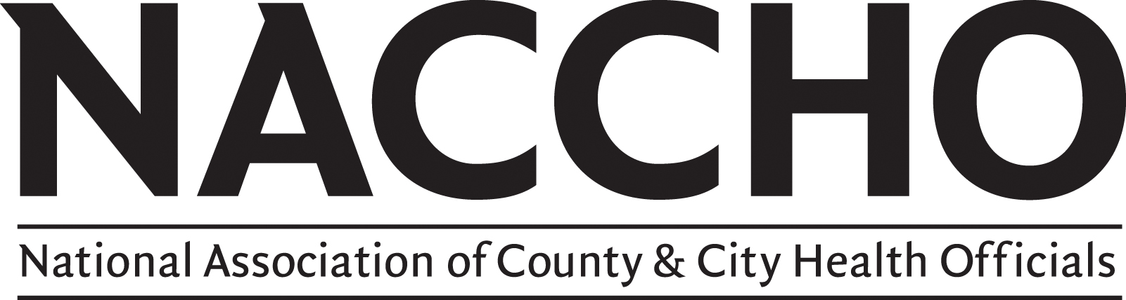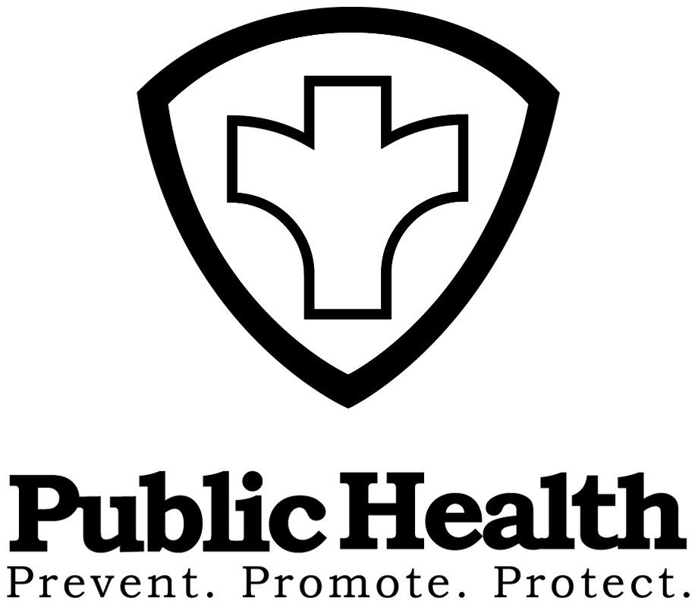

User’s Guide: NACCHO’s Pandemic Influenza Tabletop Exercise Template

Introduction

Local health departments create and continuously enhance their pandemic influenza plans, and exercises are an appropriate means to test them. There are many different types of exercises to choose from including functional drills, discussion workshops and tabletops. Tabletop exercises are an appropriate way to test plans, or specific elements of plans that have been developed.

Purpose

This template is intended to be used as a simple guide to create a tabletop exercise that can be easily adjusted to best meet the needs of the exercise planners. It may be used in coordination with the Homeland Security Exercise Evaluation Program (HSEEP) toolkit to develop, conduct and evaluate an HSEEP-compliant pandemic influenza exercise.

About this tool

NACCHO’s Pandemic Influenza Tabletop Exercise Template was developed and tested by local health officials to assist local health departments in designing and conducting discussion-based tabletops exercises of pandemic influenza response functions. The template includes objectives, points of review, local events and discussion questions for three pandemic response functions: Business Continuity, Epidemiology and Surveillance and Community Containment. These functions may be tested independently or together depending on the scope of the exercise.

Preparation

In order to make the best use of this template, exercise planners are encouraged to do the following:

- Assess your health department’s response capabilities, resource availability and exercise history to determine if a discussion-based exercise is appropriate. A simple way to do this is to ask the questions:
What hazards or risks in your community are you most likely to face?
What type and level of emergency response is your agency ready to test? What agencies and personnel need to participate in an exercise?
What plans do you intend to test?

- Organize an exercise planning team to determine the scope and complexity of the exercise. This team should identify response functions that will be tested. They should define the Who, What, Where and When of the exercise

- Write the statement of purpose for the exercise. The statement of purpose can be a single sentence that incorporates the components of the exercise and provides a broad exercise goal.

Elements of the Tool

The exercise template has 3 elements:

A. A Power Point presentation that can be tailored to each exercise

B. Scenario Objective Worksheet – one for each of the three response functions identified above – that include the objectives, points of review, local events and discussion questions

C. Exercise evaluation worksheets

In the objective worksheet, each objective has corresponding points of review. Beneath each objective is a grid with events and discussion questions that progress chronologically from left to right across the spreadsheet. The Power Point presentation includes placeholders where the objectives, local events and discussion questions should be inserted. The exercise evaluation worksheets are to be used by the assigned evaluator during the exercise. They utilize the points of review as way to measure the performance of the tabletop participants on each objective.

How to Use the Tool

Step 1: Review the elements

Step 2: Organize an exercise design team consisting of two or more staff to help develop the tabletop

Step 3: Review your health department’s needs assessment and exercise goals that you identified in preparation (see Preparation section)

Step 4: Identify the objectives for the exercise that match your exercise goals (See Scenario Objective Worksheet, Column 1, Objective). You can adjust the objectives as necessary to meet your health department’s goals or create your own. A good rule of thumb is that objectives should be SMART - simple, measurable, achievable, realistic and time-efficient.

Step 5: Identify the events that would stimulate questions and discussion related to each objective (See Scenario Objective Worksheet, Columns 2- X, Local Events 1-4).

Step 6: For each event, identify questions that would be asked during the exercise. Select questions that reflect the scope and complexity of the exercise, or add your own (See Scenario Objective Worksheet, Columns, X-X, Questions 1-4)

Step 7: Insert your chosen objectives, events, and questions into the Power Point. We suggest putting additional questions in the notes section of the Power Point for the facilitator’s use during the exercise.

Step 8: Identify “players” and subject matter experts to participate in the tabletop and send out save the date information. Ensure key decision-makers have been invited, as well as a facilitator, note takers, observers and evaluators (See Exercise Evaluation worksheets)

Step 9: Conduct the tabletop exercise using your finalized Power Point.

Step 10: Evaluate the exercise using the exercise evaluation worksheets that correspond to your selected objectives. Be sure to edit the worksheets as needed so that the objectives and points of review accurately reflect what the exercise will test.

Step 11: Record the results of the tabletop and all unresolved issues. We suggest using an After Action Report (AAR) format.

Step 12: Share your After Action Report with your stakeholders and develop steps to address unresolved issues and improve your pandemic influenza plan.

Disclaimer

This template is not a comprehensive exercise design tool. It provides the fundamental elements of a discussion-based exercise for testing a response to pandemic influenza, but it does not include supporting elements such as facilitation guidelines, controller and evaluator instructions, logistical checklists and planning timelines. These and other resources can be found in the HSEEP toolkit at https://hseep.dhs.gov/.

Useful Links
www.LLIS.gov: Lessons Learned Information Sharing is the national network of Lessons Learned and Best Practices for emergency response providers and homeland security officials. LLIS.gov's secure, restricted-access information is designed to facilitate efforts to prevent, prepare for and respond to acts of terrorism and other incidents across all disciplines and communities throughout the US.
www.pandemicflu.gov: One-stop access to U.S. Government avian and pandemic flu information. Managed by the Department of Health and Human Services.
www.pandemicpractices.org: This project aims to enhance public health preparedness for an influenza pandemic and conserve resources by sharing promising practices. CIDRAP and the Pew Center on the States (PCS) launched this initiative to collect and peer-review practices that can be adapted or adopted by public health stakeholders.

Questions?

If you have any questions about NACCHO’s Pandemic Influenza Exercise Template, please contact:

Vicki Johnson, MSc
National Association of County and City Health Officials
1100 17th Street, NW, Second Floor
Washington, DC 20036
Office: (202) 783-5550 x. 217
E-mail: vjohnson@naccho.org

