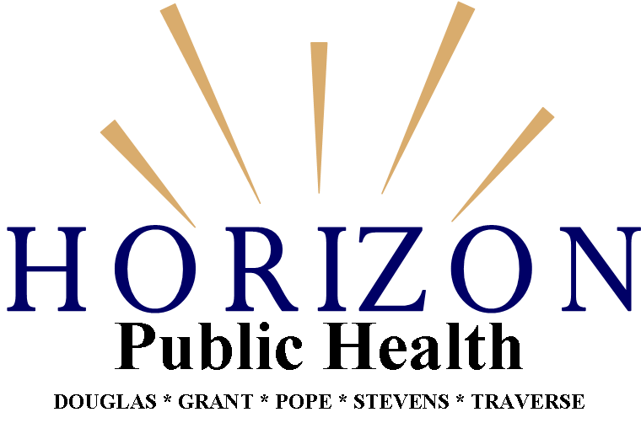

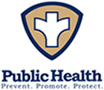

PERFORMANCE MANAGEMENT PLAN

Purpose and Background
Performance management is the practice of actively using performance data to improve the public’s health. At the core of any performance management system is a systematic, data-driven process aimed at helping an organization improve overall functioning, demonstrate accountability, and achieve its organizational and strategic goals. It must occur at all levels of an organization and is most effective when integrated into the organization’s daily operations and practices.
Horizon Public Health is committed to providing programs and services that are of the highest quality and achieve the best possible outcomes. Horizon Public Health believes that the use of a robust and functioning performance management system not only facilitates improved health outcomes for the population we serve, it is just good business practice. The development and adoption of this Performance Management Plan sets the foundation for developing a culture of quality improvement across Horizon Public Health. And it represents the promise of Horizon Public Health, from its governing body to each and every employee, to continually strive for performance excellence and optimal population health outcomes.
Horizon Public Health Mission, Vision and Values
The mission of Horizon Public Health is to enhance the health and the well-being of all who live, learn, work and play in the five county Horizon community. Our vision, which is broad in scope and future-oriented, is built on the following principles:
  - Innovative Programs & Services: Horizon Public Health is committed to excellence in the programs and services that support the health and well-being of community members from pre-conception to end of life.
  - Fully Integrated Public Health Department: Horizon Public Health will meet the needs of the geographic area through a seamless provision of services and respect for cultural diversity. Cohesive working relationships across and within program areas will foster an atmosphere of unity.
  - Committed to Collaboration: Horizon Public Health is a visible and valued collaborative community partner that fosters an environment that supports collaborative efforts.
  - Foundational Capabilities: Horizon Public Health is a strong, progressive public health department supported by visionary leadership, grounded in the principles and core essential services of public health and committed to evidence-based practices.
  - Financial stability: Horizon Public Health will strive to ensure financial stability and growth by exploring new and strengthening current revenue sources and maximizing program and personnel efficiencies.
  - Robust human resources to support public health work: Horizon Public Health will assure an innovative and competent public health workforce with strong leadership, educated staff, and adequate resources that result in public health professionals dedicated to serving the community.

And the shared values of the governing body and staff of Horizon Public Health support that mission and vision. As an organization, we are guided by these values:
- Teamwork – We respect, support and value our co-workers and the knowledge that each individual brings to the organization.
- Dependability, trust, integrity – We serve the best interests of the public by adhering to the highest standards of truth, fairness and established codes of conduct.
- Respect – We value the diversity and uniqueness of every individual and continually strive to ensure equal treatment and opportunity for all. We earn and preserve trust through our behavior and the quality of our work.
- Collaboration – We develop positive relationships within and external to our organization. Our partnerships are critical for exchanging information, planning strategies, sharing resources and ultimately, achieving our shared goals
- Purposefulness – We believe in and continually support the mission and vision of our organization in the individual and collective work we do. We aspire to the provision of evidence-based programs and services that result in efficient and effective practices and outcomes.
- Community service – We acknowledge and respect our roles as public servants. Understanding, addressing and striving to meet the needs of the communities in which we work is a top priority.
- Creativity, innovation, responsiveness – We are in a continuous search for improved and more efficient and effective processes. New ideas that seek to improve effectiveness and efficiency are welcomed.
- Commitment to excellence –Horizon Public Health will strive to achieve organizational excellence, both to ensure the quality of services provided and to create a workplace that fosters well-trained, creative and motivated staff.

Policy Statement
Horizon Public Health shall implement and maintain a Performance Management System that encompasses the establishment of performance standards; the development, application and use of performance measures; consistent and comprehensive monitoring and reporting of results; and the implementation of quality improvement processes to assure continual progress toward performance excellence and optimal population health outcomes. The Performance Management System shall be guided and supported by a leadership team and governing body that encourages and supports a quality organizational culture with a strong emphasis on learning, teamwork and a customer focus.
Organizing Structure Supporting the Horizon Performance Management System
Everyone has a role in Horizon Public Health’s Performance Management System (PMS). Communication must flow back and forth between all those that contribute to the success of Horizon’s PMS. The organizing structure and the various roles that support this system are described below.

HORIZON PUBLIC HEALTH PERFORMANCE MANAGEMENT SYSTEM
Organizing Structure

Performance Improvement Project (PIP) Team - Customer Satisfaction

Performance Improvement Project Team

Performance Improvement Project Team

Horizon Performance Management Leadership Team
Performance Management Committee/
Accreditation Team
Horizon Community Health Board
Horizon Performance Management Council
Performance Improvement Project Team

Performance Improvement Project Team
Performance Improvement Project Team

HORIZON PUBLIC HEALTH PERFORMANCE MANAGEMENT SYSTEM
ROLES AND RESPONSIBILITIES

ROLE | RESPONSIBILITY
Horizon Community Health Board | - Provides high-level oversight and accountability  - Adopts Performance Management System Policy  - Assures allocation of financial resources to support Performance Management System and Performance Improvement (PI) Initiatives  - Provides an outside perspective on Performance Management and PI Projects  - Informed of final outcomes of performance measures and PI Projects
Performance Management Council | - Participates in identification of public health services most in need of quality improvement and areas of focus from an outside community perspective  - Provides feedback for completed and ongoing projects  - Reviews performance and project outcomes and makes recommendations  - Forwards recommendations for Performance Management System sustainability and enhancement to Horizon CHB
Performance Management Leadership Team | - Facilitates the implementation of the Performance Management System  - Provides access to resources and training, as appropriate  - Apprised of all current standards, measures, and PI Projects  - Assures that all staff are informed of and understand the outcomes of standards, measures, and completed PI Projects
Performance Management Committee/Accreditation Team | - Understands the Performance Management System  - Identifies, discusses, and develops performance standards, measures and potential PI Projects  - Develops and applies criteria for the selection of PI Projects
Performance Improvement Project (PIP) Teams | - Understand the Performance Management System  - Implement and participate in evaluation of PI Projects  - Engage in the Performance Management Process by suggesting ideas; collecting, monitoring and reporting data; providing feedback to their program; participating in projects and encouraging other staff to participate  - Apply improved processes to their program-specific work

Goals of Horizon Public Health’s Performance Management System
- Create a systematic approach, consistent with the organization’s mission, vision and values, for incorporating performance management into the daily work of Horizon Public Health employees
- Identify areas that will benefit from quality improvement, develop improvement strategies, evaluate impact of strategies, and make recommendations to HPH leadership to maximize resources and expertise
- Strengthen and support workforce capacity by engaging staff at all levels in the performance management process and culture, and by encouraging sound judgment, meaningful improvement and collaboration among staff.
- Assist programs in demonstrating program effectiveness and efficiencies and in meeting goals, objectives and regulatory or reporting requirements
- Establish a systematic process for assessing customer satisfaction with public health services
- Increase Horizon Public Health accountability to the customers, the governing body, and the general public through consistent performance reporting

Alignment with other Plans
Various “plans” have been developed by Horizon Public Health that support its mission, vision and values. While each of these plans provide guidance for the Horizon Public Health organization, its employees and for the individuals and communities it serves from a unique aspect, the Performance Management Plan must transcend all of these plans and continually challenging Horizon Public Health to move its programs and services to a higher standard of excellence. When establishing priority Performance Improvement Projects (PIPs), consideration shall be given to the priorities addressed in all of the following plans:
- Community Health Improvement Plan (CHIP) – The CHIP describes those issues that have been identified, through a partnership between Horizon Public Health and its many community partners, as priority issues to be collectively addressed by the community partners. The development of clear goals, objectives and an action plan for each of the priority issues has a positive impact on those health factors that significantly threaten the health status of the population in the 5 Horizon counties.
- Strategic Plan – The Strategic Plan serves to address goals and objectives within control of Horizon Public Health to both improve the identified health factors and to provide the necessary infrastructure and workforce to protect the health and well-being of those within the 5-county service area.
- Workforce Development Plan (WDP) – The WDP provides a framework to assure that all of the Horizon Public Health workforce are able to demonstrate competency in performance areas essential to their work and essential for supporting the health and well-being of the community.
- Quality Improvement (QI) Plan – The QI Plan establishes a process and the priority areas to address in order that Horizon Public Health is deliberate in its intent and commitment to strive for continuous quality improvement.
Performance Management Framework
In 2013, the Public Health Foundation released a “refreshed” version of the Turning Point Performance Management Framework, adapted from the original version developed in 2003. Just before that release, in September 2012, the Performance Improvement Steering Committee, a standing committee of Minnesota’s State Community Health Services Advisory Committee (SCHSAC), developed its own Performance Management Framework, based on the principle components of the Turning Point Framework. Horizon Public Health has chosen to develop its Performance Management System using the Minnesota model of Performance Management.
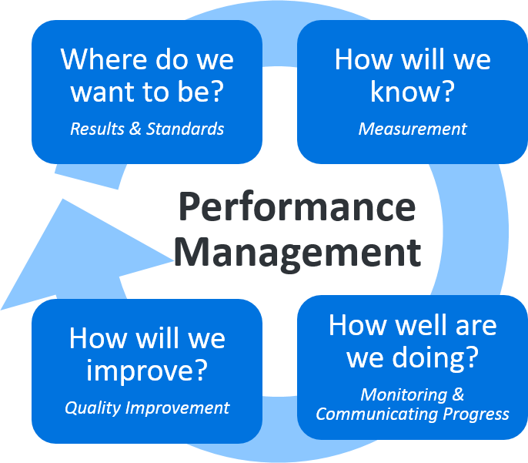
This framework is familiar to most public health managers and staff who routinely set objectives for programs and organizations, and then develop measures to monitor progress and identify improvement opportunities. It embeds the four primary components of any performance management system, but uses simplified questions that really drill down to the intent of those components. Moreover, it is easily understood and embraced by staff, leadership and the governing board of Horizon Public Health.
Adopted Definitions:
In order to promote consistency in implementing and communicating Horizon Public Health’s performance management system, the following terms were adopted as common language:
Vision - a statement of the ideal individual or community condition or the state of
organizational operations which is typically not measurable.
Standard - A quantifiable statement of a generally-accepted level of performance that can be descriptive or numerical; a guideline used to assess an organization’s performance; a desired level of achievement. A standard may be set by external guidelines established by national or state organizations, as a result of scientific research, or by the expectations of the organization’s leadership, funders, or the public.
Performance measure - A measure of how well a program, agency or service system is working; a quantitative indicator of capacity, process, or outcomes relevant to the assessment of performance.
Action plan - Possible actions that could be implemented to make a difference on the performance measure/indicator.
Individuals/Communities Served - A person, family, organization or community who benefits from the program or agency service delivery
Stakeholder - A person or organization who has a significant interest in the performance of a program, agency or service system

Implementation of Performance Management System
Performance management is a continuous and ongoing process to achieve measurable improvements in the efficiency, effectiveness, performance, accountability, outcomes and other indicators of quality in services and/or processes which achieve equity and improve the health of the community.
Performance Management Committee –
Horizon Public Health’s Performance Management Committee (Attachment A), comprised of 10 – 15 employees representing the scope of programs and services provided by Horizon Public Health as well as staff of varied disciplines, bears the primary responsibility for the development, implementation, and ongoing maintenance of the Performance Management System (PMS). Having met every other week during the development of the PMS, this Committee will continue to meet monthly as it also assumes the responsibilities of Horizon’s Accreditation Team. The Roles and Responsibilities document provides greater detail of the Committee’s primary functions.
Performance Management Self-Assessment –
As an initial step in this process and consistent with Public Health Accreditation Standards (Measure 9.1.2A), the 13 members of the Horizon Public Health Performance Management Committee completed an organizational self-assessment to identify the extent to which the four primary components of a performance management system were currently in place and being utilized within the organization. The Self-Assessment tool, developed by the Public Health Foundation, addresses indicators of performance management capacity relative to visible leadership, performance standards, performance measurement, reporting progress and quality improvement.
The results of the PM self-assessment were reviewed by the Performance Management Committee with the following identified as areas most in need of immediate strengthening:
- While performance improvement projects are regularly being implemented in many of Horizon Public Health’s program areas, these are informal processes that are being implemented without defined standards and measures, are typically not supported by data and there is little, if any, formal documentation of the project.
- Performance management efforts that are being considered at the administration level are not communicated throughout the organization and most staff are unaware of these efforts.
- Feedback from individuals and organizations served is limited only to those program areas in which the program has developed and implemented a standard customer satisfaction survey specific to that program area. Even in those program areas in which customer feedback is being gathered, that feedback is rarely being compiled, analyzed and used to implement performance improvement measures.
The Performance Management Self-Assessment will be annually completed by the Performance Management Committee in order to measure progress in advancing a Performance Management culture throughout the organization.
Consideration and Selection of Performance Improvement Projects (PIP) –
Any staff member may recommend a PIP to the Performance Management Committee (PMC) for consideration at any time. PIPs are considered by the PMC first and foremost based on alignment with Horizon Public Health’s mission, strategic plan priorities, and feedback from individuals and organizations served. When multiple PIP ideas are presented, an established set of key principles will be applied to the selection process as follows:
- Projects should have a clear relationship to organizational mission, values and plans (CHIP and Strategic Plans)
- Opportunity for performance improvement should be readily evident as well as programmatically and financially feasible
- Feedback from individuals and organizations/communities served, as well as any potential impact on those individuals/communities, should be considered in the selection of a Performance Improvement Project (PIP)
- Desired outcome must be measurable and data must be available and adequate to support the PIP
- Identified measures should:
- Be valid, reliable, and responsive
- Inform planning, evaluation, and policy decisions
- Be meaningful and easy to understand
- Be important to staff and to leadership
- Align with PHAB Domains and positively impact accreditation status

Performance Improvement Project Teams –
A Performance Improvement Project Team shall be established for each project selected. Each PIP Team shall consist of 5 – 7 members and its members will represent the affected program, discipline and where applicable, individuals served. Each PIP Team shall prepare a presentation to the Performance Management Committee at the conclusion of the project. Within a month following the completion of the PIP’s finalization, the PIP Team members will be surveyed to determine their Performance Improvement learnings, perceived contribution to the PIP, value of the project experience and to seek suggestions for overall agency Performance Improvement efforts.
Feedback from individuals served -
Obtaining feedback from individuals, organizations and communities served addresses how Horizon Public Health listens to the voice of those it serves, builds relationships with those individuals/organizations, determines whether their needs were met, and uses individual/community feedback to improve and identify opportunities for innovation or improvement.
Individuals, organizations and communities served by Horizon Public Health will regularly and repeatedly be involved in improvement efforts. Findings from individual and community feedback will be considered:
• To evaluate a key performance indicator
• To revise, correct or improve a process
• To identify individual/community needs and expectations
• To evaluate a change in service or a new service
• To inform planning, decision-making, and resource allocation

Monitoring and Evaluation -
The implementation of Performance Improvement Projects (PIPs) realize their value only when rigorously monitored and evaluated at pre-established timeframes throughout the year. Each PIP Team shall establish its own individual targets and timeframes and maintain documentation of its progress at those targeted timeframes. The Performance Management Committee shall meet quarterly to review PIP progress reports, review summary of feedback received from individuals and organizations served, and consider additional PIP proposals. A brief summary of the PMC’s findings, along with any recommendations or comments from the PMC, shall then be reviewed by the Performance Improvement Leadership Team (PMLT). The Performance Management Council will likewise review the results on a semi-annual basis and develop an annual report of Performance Management projects and activities, which will then be presented to the Horizon Community Health Board.
In addition to compiling and issuing quarterly progress reports, the Performance Management Committee shall annually, at the first meeting of the year, review the organization’s overall Performance Management Plan to assess the effectiveness of the plan in overseeing PI projects and in supporting the integration of a performance improvement culture throughout the organization. Recommendations for any revisions to the Performance Management Plan shall be forwarded to the PMLT, the Performance Management Council and ultimately, to the Horizon Community Health Board for consideration and adoption.

Communication –
Creating a culture of quality improvement requires that a very deliberate and comprehensive communication plan be established that utilizes multiple communication modes and resources. The Performance Management Plan, which provides the overall guidance and structure of Horizon Public Health’s PMS, shall be presented and/or reviewed annually during an All Staff meeting, and employees shall be encouraged to go to the organization’s website or electronic files to review the entire document. Likewise, during the orientation process, all new employees will receive information about Horizon Public Health’s PMS and directed to the website or electronic files to review the document.
It is equally as important that all employees are aware of and informed of the results of all performance improvement projects being implemented. The Program Supervisors shall be responsible for assuring that the PIP Teams regularly provide progress reports to their respective program teams. The Program Supervisors shall also report progress and results of the performance improvement projects within their respective program teams to the other Public Health Supervisors at their Performance Management Leadership Team (PMLT) meetings which are scheduled every other month.
The use of multiple communication modes will also assure that all staff have access to, and are informed of the PIPs currently underway at Horizon Public Health. A summary of those PIPs and regular progress reports may be included in the quarterly Horizon Public Health newsletter, posted on the organization’s website, and potentially posted on the HR Connect webpage which hosts all of Horizon’s benefit information.
The Performance Management Council shall receive and review progress and results of the Performance Improvement Projects at least twice each year, including presentations of the project results from the PIP Teams. The Horizon Community Health Board shall annually, at a minimum, review a summary of the PIPs and consider recommendations for revisions to the Performance Management Plan.
Capacity Building, Training and Resources -
Horizon Public Health incorporates multiple opportunities for development and training in performance improvement to assure that all staff possess the essential knowledge and skills to support their participation in Performance Improvement Projects (PIPs) that are relevant and have impact on the program areas in which they work.
- Employee Orientation – As a component of new employee orientation, staff will receive an introduction to performance improvement/quality improvement to review basic PI/QI concepts in order to advance a culture of quality improvement.
- “Just in Time” Training – Using “just-in-time” training allows Horizon Public Health to focus resources on training individuals on advanced PI/QI materials and tools applicable to specific PI/QI projects and in a timely manner that does not precede the project to the point that the employee is likely to have forgotten the material/tools.
- Staff Involvement in PI/QI Project Ideas – A “Performance Improvement Project Proposal” form has been created and made accessible to all staff (Attachment B). Staff are encouraged to identify areas of improvement in their respective areas of work. Program staff are encouraged to collectively identify potential areas of improvement and, if the PI Project is reviewed and approved, staff are encouraged to be involved as a member of the PIP Team.
- Staff Meetings – All program staff and their respective Public Health Supervisors, are encouraged to discuss performance improvement project ideas at regular program staff meetings. In addition, all-staff meetings offer an opportunity to update staff on organizational performance measures and highlight program achievements in performance improvement.

Attachment A

HORIZON PERFORMANCE MANAGEMENT SYSTEM

PERFORMANCE MANAGEMENT COMMITTEE
ACCREDITATION TEAM
Membership – March 2017

Name Program Area Position
Sandy Tubbs Administration Administrator
Greta Siegel Finance and Grants Assistant Administrator
Betsy Hills Long Term Care – Under 65 Supervisor
Kelsey Peterson Administration Accreditation Coordinator
Kelly Irish Long Term Care – MN Choices Certified Assessor
Gretchen Rasmussen Long Term Care – Under 65 Case Manager
Ashley Bohlsen Long Term Care – Over 65 Case Manager
Katie Tolifson Long Term Care – Under 65 Certified Assessor/CM
Roxy Olberding Long Term Care Program Support Specialist
Doreen Hanson Child/Family Health/DP&C Public Health Nurse
Jodie Trill Child/Family Health Home Visitor/Educator
Jessica Peterson Health Promotion/SHIP Health Educator
Tara Paschka Child/Family Health/WIC Registered Dietician
Kaylene Mecklenburg Administration Office Support

Attachment B

HORIZON PERFORMANCE MANAGEMENT SYSTEM

PERFORMANCE IMPROVEMENT PROJECT PROPOSAL
Project Title: _________________________________________________________________
Submitted by: _________________________________________________________________
Date submitted to Performance Management Committee: _______________________________
Briefly describe the program, project and/or process that should be considered for a Performance Improvement Project (PIP): ________________________________________________________________________________________________________________________________________________________________________________________________________________________________________________________________________________________________________________________
What is the desired or perceived outcome from this PIP? Who would benefit from this PIP? __________________________________________________________________________________________________________________________________________________________________________________________________________________________________________
Is this Performance Improvement Project measurable? _______ Yes _______ No
What data, either statistical, based on employee experience, or from individual/community feedback, is currently available that supports the need for this PIP? ________________________________________________________________________________________________________________________________________________________________________________________________________________________________________________________________________________________________________________________
Would there be any potential impact on other programs and services? If yes, please describe.
__________________________________________________________________________________________________________________________________________________________________________________________________________________________________________
What resources (human and financial) would be necessary to implement the PI Project?
__________________________________________________________________________________________________________________________________________________________________________________________________________________________________________

HORIZON PERFORMANCE MANAGEMENT SYSTEM

Performance Management Work Plan
Performance Improvement Project: Feedback from Individuals Served
VISION
Obtaining and applying the data gathered from feedback from individuals served by Horizon Public Health programs is a key component of Horizon Public Health’s Performance Management System
Standard 1: Where do we want to be?
By October 1, 2017, 100 % of Horizon Public Health programs that provide individual-level services will be utilizing a common set of questions to gather feedback from individuals served.
Measure 1: How will we know?
The percent of Horizon Public Health programs providing individual-level services that are seeking feedback from individuals served in those programs using a common set of questions.
Quarterly Target: 100% of program areas providing individual-level services are seeking feedback from individuals served using a common set of questions.
Measure 2: How will we know?
The percent of individuals surveyed that responded to the common set of questions.
Quarterly Target: 50% of individuals surveyed will respond to the common set of questions.
Standard 2: Where do we want to be?
By June 30, 2018, data obtained from individual feedback on the completed common set of questions will be reviewed and analyzed quarterly and the results of the analysis documented.
Measure 1: How will we know?
Documentation of the analysis of the data collected from individual feedback for Horizon Public Health.
Quarterly Target: Analysis of data obtained from individual feedback is documented each quarter.

Standard 3: Where do we want to be?
By June 30, 2018, data obtained from the program-specific individual feedback surveys will be reviewed and analyzed with the results of the program-specific analysis documented.
Measure 1: How will we know?
Documentation of analysis of the data collected from the program-specific individual feedback surveys
Semi-Annual Target: Analysis of data obtained from program-specific surveys is documented semi-annually

