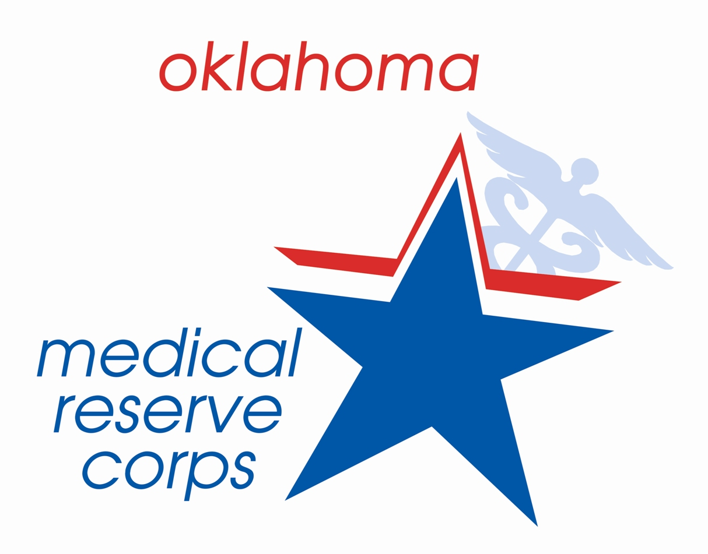
Oklahoma Medical Reserve Corps
Volunteer Position Description

TITLE: Staging Liaison/Assistant Unit Leader

PURPOSE: To provide operational support to OKMRC volunteers during deployment, and to provide support to both volunteers and unit leaders during response

QUALIFICATIONS and REQUIRED TRAINING:

- OKMRC member in good standing
- Good understanding of the MRC and its mission
- Completion of MRC orientation and Required Trainings
- Positive attitude, problem solver
- Excellent organizational and communication skills
- Strong advocate for volunteers
  - PHYSICAL –light to moderate
    - Could require standing for long periods of time and/or working in adverse conditions

DUTIES AND RESPONSIBILITIES:

- Deploy to response locations upon short notice
- Supervise and greet volunteers arriving for work shifts at response location
- Act as liaison to requesting agency and other response partner agencies
- Ensure volunteers sign in and out as directed (ICS – 214)
- Facilitate Just-in-Time training and operational briefings for all arriving volunteers
- Provide operational and logistics support as needed
- Assist Local Unit Coordinator with all duties relating to the local MRC unit, including but not limited to:
  - Pre-deployment and Post-deployment screening tools

BENEFITS: Direct involvement in OKMRC response deployments, personnel management and emergency response experience

TIME COMMITMENT: Varies with response, a staging liaison will be on site whenever OKMRC volunteers are working

WORK LOCATION: Response location

THESE PEOPLE REPORT TO YOU: OKMRC Volunteers

REPORTS TO: Local OKMRC Coordinator

