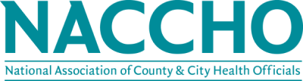

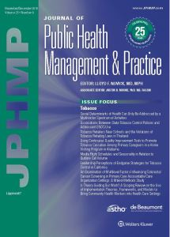

The Journal of Public Health Management and Practice (JPHMP) provides practical information applicable to the design and implementation of public health programs. It is peer-reviewed and written by leading public health researchers and practitioners from local, state, and federal public health agencies. With the Journal of Public Health Management and Practice, you'll explore the everyday challenges of public health and you'll get hands-on, step-by-step solutions public health professionals across the country are using.

JPHMP is offered to members of the National Association of County and City Health Officials (NACCHO) at a reduced rate. An individual subscription includes 6 print issues, full-text online access to all current and back issues, as well access to Journal of Public Health Management and Practice for the iPad ! ®.
NACCHO members receive the following reduced price on an annual print/online bundled subscription to JPHMP:
- NACCHO Member individual rate: $62.99
- NACCHO Member LHD/organizational rate: $160.00

To get this reduced subscription price, NACCHO members must call or email the
Lippincott/Wolters Kluwer Customer Service support team directly:
  - Email: customerservice@lww.com
  - Telephone: 1-800-638-3030
Unsure if you are a member and want to take advantage of this new member benefit? Email membership@naccho.org or call 877.533.1320.

