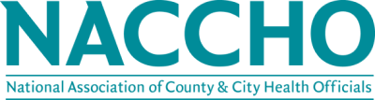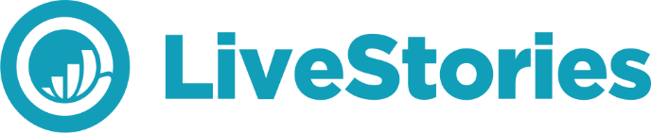

NACCHO is pleased to offer a new member benefit through our partnership with LiveStories. Local Health Departments want to connect with their communities and NACCHO wants to support that work.
NACCHO is excited to partner with LiveStories to put all of your state's health data at your fingertips. Over the last few years, LiveStories has been collecting, cleaning, and organizing health data about your state. To get a true understanding of the health conditions in your community, you have to work with many disparate data sources - federal vs. state vs. local or public vs. private. Health departments spend 80% of their time on finding and cleaning data, leaving very little time to explore, understand, and use the data. It should be the other way around - you should not have to struggle to get clean, relevant data.
You are invited to an exclusive webinar about your state's health data. NACCHO is committed to helping local health departments build capacity. This webinar delivers on that commitment and will focus on:
- Sourcing health data about your state
- Understanding nuances about these datasets
- Discovering powerful insights within the data
- Sharing an exclusive discount for NACCHO members to access all of this data
Register now for your specific state's webinar at: https://www.livestories.com/naccho
Unsure if you are a member and want to take advantage of this new member benefit? Email membership@naccho.org or call 877.533.1320.

