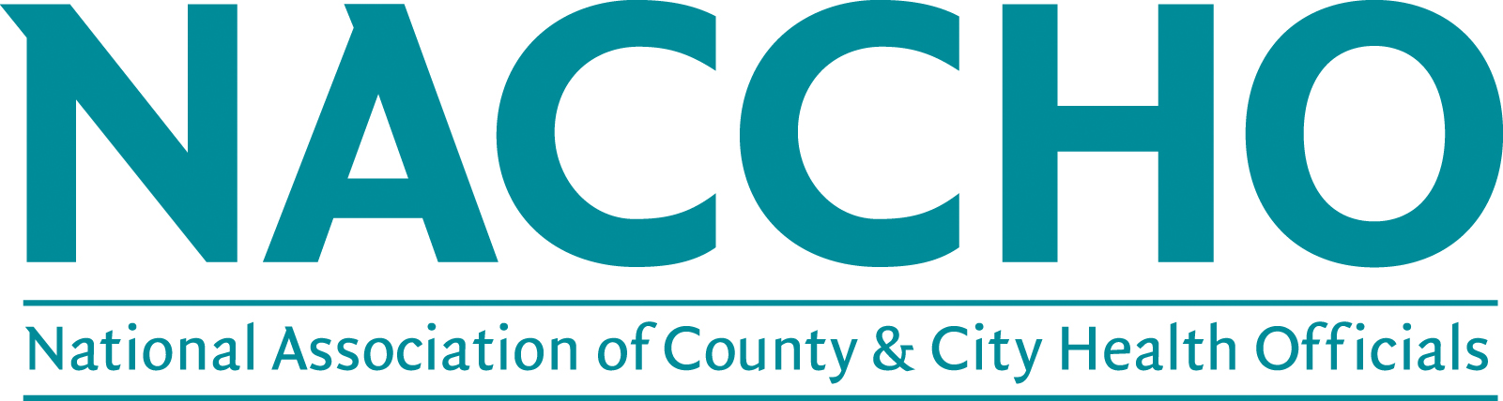

Increasing Disability Inclusion in the MAPP Process Application

Please complete the application below by inserting text into the designated areas below. Save the application as a Word document and email it to slyons@naccho.org. Applications must include the RFA Application form, budget request, and at least one letter of support from a partner organization that serves people with disabilities in the applicant’s jurisdiction. Application forms submitted without the accompanying letter of support will NOT be reviewed.

Applicant/Project Lead Contact Information

Full Name of Designated Project Lead:
Position Title:
Local Health Department:
Phone:
Email:
City, State, Zip Code:

Contract Information
Participating local health departments will enter into a contract with NACCHO to complete the deliverable(s) described in the Request for Application (RFA). Agreement with NACCHO standard contract language terms and conditions is a requirement for application. No modifications will be made. The information below will help to begin the contracting process immediately upon selection.

Our agency has read NACCHO’s standard contract language and provided a copy to the individual with signing authority at the local health department for advanced consideration. ___Yes ___No

If you selected ‘No’ (the local health department has not provided a copy to the individual with signing authority for advanced consideration or the health department does not agree to the contract language or is not able to sign and return a contract to NACCHO within 30 days), please explain.

[Use this space to answer the above question. Box can be expanded to fit the length of response.]

Name and title of authorized signer of contract:
Address:
E-mail:
Telephone number:
Official name of organization on contract:
Agency EIN/tax ID number:

Organizational Capacity (25 points)

Please describe your agency’s experience using the MAPP framework to conduct community health assessments and community health improvement planning. Responses should include when your agency first started using MAPP and what lessons have been learned to inform your current cycle. (500 word limit)

[Use this space to answer the above question. Box can be expanded to fit the length of response.]

Readiness to Implement (25 points)

Please describe your current MAPP efforts, including which Phase(s) you are working on and what cycle (e.g. is this the first time going through the MAPP process, second, third). Please also describe any current activities or assets that may enhance your agency’s ability to achieve the stated project requirements and expectations. Include facilitators such as funding, leadership support, or in-house expertise that may support the effort.
(500 word limit)

[Use this space to answer the above question. Box can be expanded to fit the length of response.]

Partnerships (25 Points)

Describe your agency’s past and/or current partnerships with organizations that serve people with disabilities in your jurisdiction. Also describe how these partnerships can be leveraged to increase inclusion of people with disabilities in your agency’s latest community health assessment and community health improvement plan.
(500 word limit)

[Use this space to answer the above question. Box can be expanded to fit the length of response.]

Statement of Need (25 Points)

Provide a statement of need describing why your agency wants to pursue this project and the vision for how the opportunity will advance disability inclusion within your latest community health assessment and community health improvement plan process. Responses should include current demographic information about people with disabilities within your jurisdiction and how the MAPP process can have an impact among this population. (500 word limit)

[Use this space to answer the above question. Box can be expanded to fit the length of response.]

Budget Request
Funding per awardee is $10,000 total.

Instructions for Budget Narrative Form

The budget narrative should be consistent with the goals, objectives, and activities proposed within the application. Items that may be included in the request for funds are staff salary and fringe benefits, phone/facsimile, postage, accessibility accommodations, and contractual fees. If additional funds and/or resources will be leveraged, please describe them. Funds cannot be used for the purchase or upkeep of office equipment. Additionally, project funds cannot be used to purchase food or beverages.
Please note that the awards are categorized as consultants, disbursed in two invoice periods upon receipt of deliverables. The purpose of the budget narrative is to demonstrate that the applicant has considered appropriate funding needed to accomplish the work it has proposed.

Sample Budget Narrative

[Insert name of your agency]

Increasing Disability Inclusion in the MAPP Process Project

November 1, 2019 – March 31, 2020

(Based on 5-Month Budget)

A. Direct Salaries and Wages

Personnel Total $4,410.00

Position Title and Name | Annual Salary | Time | Months | Amount Requested
INSERT TITLE HERE  INSERT NAME HERE | $70,000 | 15% | 5 | $4,410.00

Example Justification
Jane Roberts has been with Smith County Health Department since July 2005. She is the Community Health Program Manager and has experience with engaging community partners and coordinates community health improvement strategies within the department.

B. Direct Staffing Fringe Benefits

Fringe Benefits Total $1014.30

23% of Total Direct Staff Salaries = Fringe Benefits
C. Accessibility Accommodations Total $1,000.00

Example Justification

Interpreter services for two (2) community health forums on January 15th and February 12th, 2020.

D. Other Total $500.00

Project-Specific Postage $330.00

Example Justification

- Bulk mailing of community health forum meeting to community partners

December 2019 mailing of community health forum meeting information

Project-Specific Printing & Duplication $170.00

Example Justification

- Large print copies of community health assessment (200 @$.17 per copy) 34
Purchase in January 2020

- Duplication of two-sided brochures for training purposes (800 @$.17 per side)
Purchase in February 2020

E. Indirect Costs Total $482.41

The rate is 6.8% and is computed on the following direct cost base of $7,094.30

Total Indirect Costs = $
Grand Total Requested $7,576.71

ADDITIONAL INFORMATION

Questions about request for application and application can be directed to:

Sara Lyons, MPH
Program Analyst, Health and Disability
(202)-507-4237
slyons@naccho.org

Jennifer Li
Senior Advisor
(202) 507-4242
jli@naccho.org

*Applicants are required to designate one main point of contact with whom NACCHO will directly communicate on all matters related to this project, including selection notification. This person will be responsible for submitting all deliverables, participating in calls or webinars, and completing evaluation activities. This person is also responsible for providing NACCHO with additional names and contact information of staff to be included on communications from NACCHO.

