Mental Health Strategies Playbook

This document summarizes key strategies discussed during the July 28, 2022, Rural Café Community of Practice meeting. Local health departments participating in Year 2 of NACCHO’s Rural and Frontier Local Health Department COVID Workforce Capacity Building Project can reference this playbook when looking for new ways to practice self-care or support the health and wellbeing of their colleagues.
  - Interested in learning more about the strategies included in this playbook? Use the LHD TA Request Survey (deloitte.com) to request 1-on-1 or small group technical assistance!

Table of Contents
Introduction and How to Use this Playbook 3
Individual-Level Strategies 4
Setting Boundaries 4
Making a Plan 4
Blowing off Steam and Introducing Movement 4
Team/Small-Group-Level Strategies 4
Team Bonding 4
Proactively Checking in with Colleagues 5
Organization-Level Strategies 5
New/Updated Policies and Practices 5
Appreciation 5

Introduction and How to Use this Playbook
This playbook is a result of the discussions during the July 28, 2022, Rural Cafe Community of Practice event on Mental Health Strategies and Situation Reporting. During the meeting local health department representatives weighed in on two questions:
- What can you do to take care of yourself at work?
- What can you do to take care of your colleagues at work?
CoP attendees continued to build on the ideas of their peers throughout the session, yielding more than 40 suggestions—both currently in use and aspirational—to support the long-term wellbeing and mental health of staff. With this in mind, this document is organized these ideas into three sections:
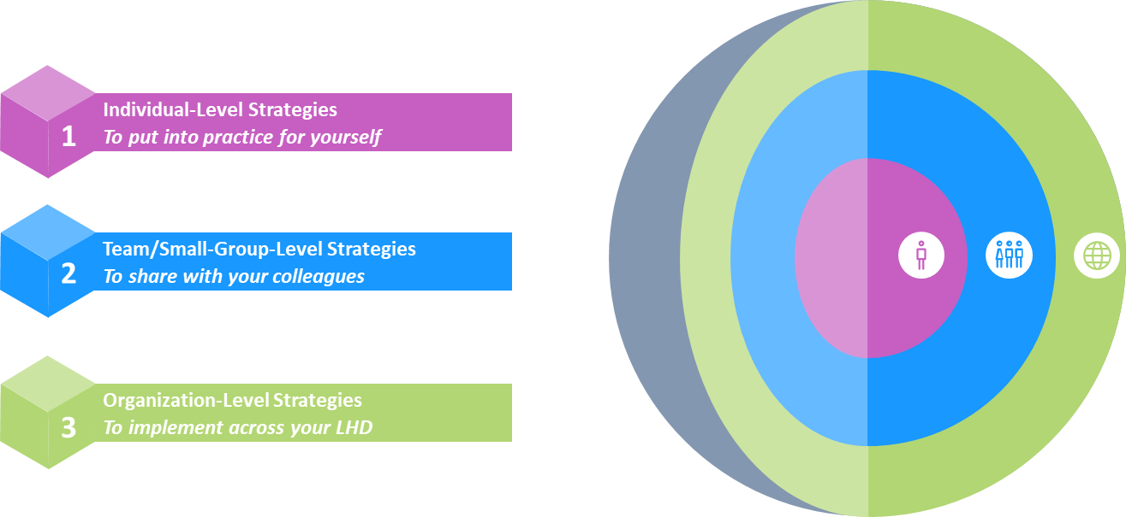
This playbook is not meant to be exhaustive, as it primarily captures and packages ideas generated by Community of Practice attendees. Rather, local health departments can consider using it as a starting place to refresh existing strategies and implement new approaches designed to support workforce resilience, mental health, and wellbeing. This document also includes several spotlight boxes on setting healthy boundaries and strategies and practices individuals in leadership or supervisory positions can adopt to promote mental health and wellbeing at work. For additional mental health strategies and techniques not discussed during the Community of Practice event, you can also refer to Section 2 of the Emergency Staffing Standard Operating Procedure document. Additional resources may also be found in the Year 2 Rural and Frontier Local Health Department COVID Workforce Capacity Building Project Resource List.

Individual-Level Strategies
Below are some strategies your local health department peers currently use or would like to use to take care of themselves at work.

Setting Boundaries
- Create a wellbeing checklist and review it routinely to determine if you need to make any adjustments to your workday

If you would like to develop a personalized checklist to regularly assess how you are taking care of yourself, look no further! Below is an example of some of the criteria you can use to prepare a checklist that feels right to you:
Personal Wellbeing
- Number of working meals (eating lunch/dinner at desk)
- Number of days personal activity goal achieved (e.g., reading, exercise, knitting)
- Number of nights with sufficient sleep
Work Demands
- Number of days unplugged
- Number of hours worked while on vacation
- Number of days scheduled vacation time was cancelled
Engagement
- Number of days feeling energized
- Number of days with sufficient professional and personal balance
Setting healthy boundaries between work and the other demands of life is easier said than done. As you consider what works well for you or brainstorm with colleagues, you can ask and answer the following questions:
- Are you an early bird or a night owl?
- What time do you typically start working and end working?
- What are your off-limits hours?
- Do you like having video on or off for virtual meetings?
- What is the best way to reach you for regular work stuff and more timely/urgent needs (e.g., email, Teams, text/call, Skype)?
Preparing a Wellbeing Checklist & Setting Boundaries
- Identify ways to distance oneself from work when you are not working (e.g., hobbies, time with family, time with friends)
- Determine a time to put phone down/close your laptop, and communicate your off-limits hours accordingly
- Use time before or after work to focus on wellbeing
- Postpone additional work until the next day when possible

Making a Plan
- Proactively plan out work with stopping points/breaks
- Put walking/stretch breaks, lunch breaks, and other protected time in your calendar
- Identify different locations to take breaks to further recharge and focus
- Use resources available to you (e.g., Employee Assistance Program)

Blowing off Steam and Introducing Movement
- Use breathing techniques such as 4-7-8 (inhale for 4 counts, hold for 7 counts, exhale for 8 counts)
- Develop an exercise routine in tune with what your body needs
- Take 10-minute walks or stretch breaks during the workday
- Stand while working or alternate body positions
- Introduce humor as stress relief

Team/Small-Group-Level Strategies
Below are some strategies your local health department peers currently use or would like to use to support the mental health and wellbeing of their colleagues.

Team Bonding
- Out-of-office activities such as hikes, ski trips, or barbecues
- In-office activities such as potlucks or trivia
- Discuss non-work topics during the day
- Sharing emojis or memes to boost morale and foster connection
- Develop a “Celebrate Us” spreadsheet or “fun” channel on Microsoft Teams to share favorite foods/treats, favorite books/movies/music/tv show, hobbies, relaxation activities

Proactively Checking in with Colleagues
- Ask someone how they are doing when they seem stressed or overwhelmed
- See the whole person—ask how someone’s family is/take an interest in their life outside of work
- Invite others to join walking breaks or lunch breaks
- Set up group check-ins in addition to one-on-one sessions

Organization-Level Strategies
Below are some strategies your local health department peers introduced or would like to introduce across their organizations.

New/Updated Policies and Practices

During the Rural Café Community of Practice meeting on 7/28, many local health department representatives described how important it is for leaders and supervisors to model behaviors that encourage others to prioritize their mental health and wellbeing. Some additional behaviors leaders/supervisors can model include but are not limited to:
- Demonstrate commitment to work-life balance—take breaks, use vacation time, sign off and do not continue monitoring work emails, etc.
- Facilitate regular one-on-one and small-group wellbeing check-ins
- Provide recognition and appreciation
- Be vulnerable and let others know when support is needed
If you are in a supervisory/leadership position in your organization, consider what you are already doing—and what more you might like to do—to model wellbeing practices.
If you are not in a supervisory/leadership position in your organization, consider how you might be able to elevate these ideas to your supervisors/leaders (e.g., during your next check-in, at your next team meeting, at an All Hands Meeting).
Leadership/Supervisor Spotlight
- Formally institute walking breaks, extended lunches, and/or flexible working schedules
- Require use of vacation time
- Provide pay outside of sick time when colleagues are out with COVID-19
- Proactively discuss wellbeing in all-staff meetings, particularly as COVID-19 response ramps up again alongside ongoing operations
- Routinely invite local mental health professionals to facilitate group check-ins
- Develop a Mental Health and Wellbeing Champions program
- Use frequent program reports to discuss workload and re-allocate work as needed
- Use available space in office to create a recharge room with comfortable furniture, soft lighting, and wellbeing reading materials

Appreciation
- Recognize staff contributions in small and large-group settings (e.g., Team Meetings, All Hands Meetings, awards ceremonies)
- Create a staff birthdays/milestones spreadsheet
- Set aside time to celebrate birthdays, baby showers, wedding showers, and work anniversaries

