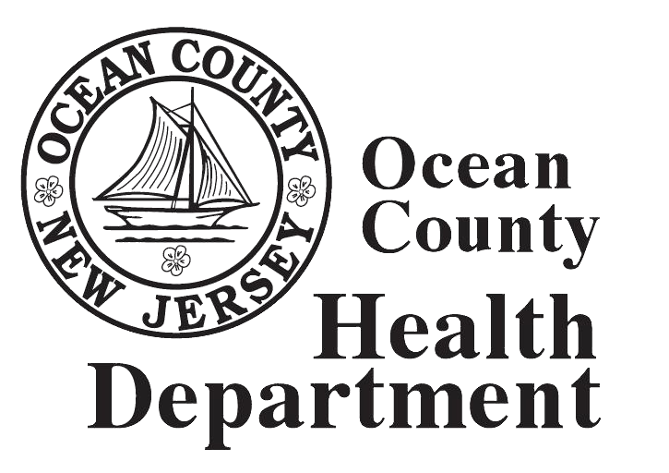 | Ocean County Overdose Fatality Review Program: A Social Autopsy of Overdose Decedents  2019-2020 | 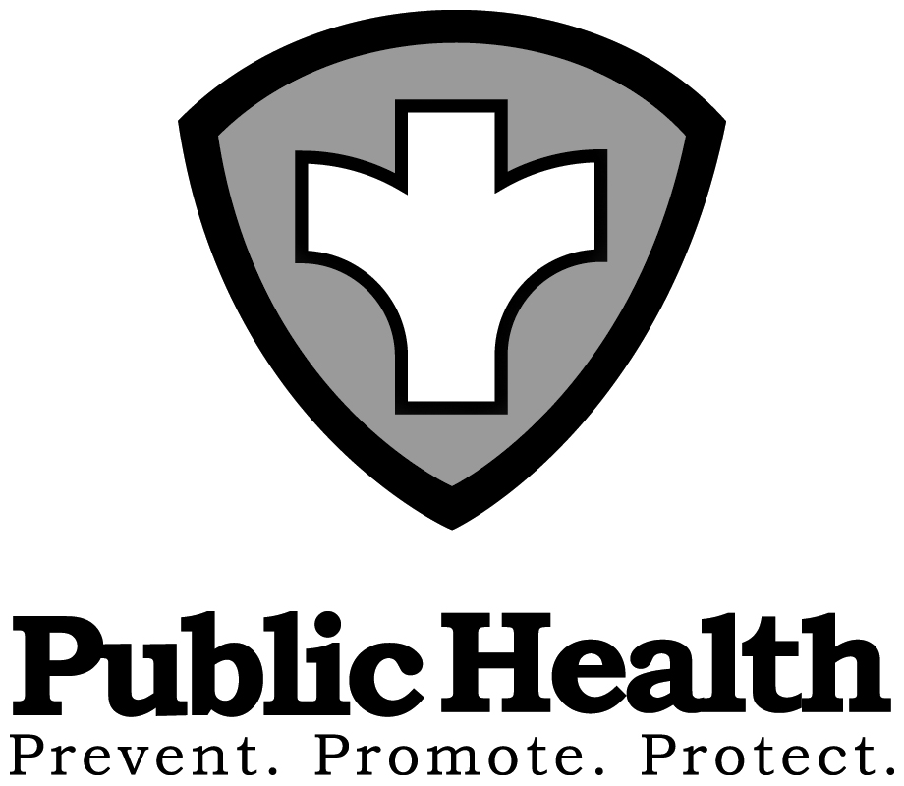

Ocean County, New Jersey has experienced an unprecedented number of overdose deaths over the past several years. In addition, Ocean County with the highest admission rate to substance use treatment facilities from 2013-2016. Because substance abuse has complex biological and social determinants, the Ocean County Health Department (OCHD) partnered on an innovative Overdose Fatality Review Pilot Program (OFRPP) in December 2016 to bring community partners together to conduct a social autopsy on overdose decedents. The pilot period of the fatality review officially began in 2017 as partnerships were made with community stakeholders. Additionally, the infrastructure for conducting a social autopsy was developed for Ocean County through an executive group. In 2018, the OC-OFRPP began reviewing decedent cases. The Ocean County Board of Health passed a resolution on September 26, 2018 to continue the program for two additional years (2019-2020) and to remove “pilot” from the name.
The OC-OFRP for 2019-2020 has evolved into a multi-prong approach to combat overdose death in Ocean County. The first prong is comprised of affiliated partners that meet monthly to perform a social autopsy on an overdose decedent identifying trends not captured in traditional data sets. These monthly meetings speak to the lives of the decedents by strategically reviewing the timeline of their life from potential childhood trauma to onset of use to attempts at recovery and ultimately; what lead to their use of opiates and their untimely overdose death. As this program is intended to address the opiate epidemic, which has been diagnosed as a serious public health emergency, the second prong approach is a robust data collection using federal, state and local sources. These two approaches to data collection is an attempt to identify social factors associated with substance use disorder, specifically the use of opiates,
The goal of the program is to identify programmatic fissures in public systems and social services that, if strengthened, could prevent future deaths. Through the identification of these missed opportunities in the system of care and subsequent development of targeted prevention, treatment and recovery strategies combined with recommendations on policies and laws this initiative’s long-term goal is the prevention of overdose death. Therefore, the third prong of the OC-OFRPP is attending local meetings to discuss opportunities to make change in the substance use disorder system of care as well as explore grants to fund these opportunities.
The main mission of the Ocean County Overdose Fatality Review Taskforce is, through the review of overdose fatalities, to identify gaps in public systems and social services that if strengthened, could prevent future deaths from drug overdose

The goal is to reduce overdose fatalities through targeted prevention, treatment and recovery strategies and programs
Objectives
    - Identify missed opportunities for prevention and gaps in system
    - Build working relationships between local stakeholders on overdose prevention
    - Recommend policies, programs, laws, etc. to prevent OD deaths
    - Inform local overdose & opioid misuse prevention strategy

