Inspection Frequency Policy
Purpose:
This policy will prescribe the process to initially designate a food establishment to one of four categories based on a priority assessment tool. At the time of permit issuance, the frequency of inspection and type of service performed by the Health Department shall be determined based on the categorization of the food establishment as: “no PHF (TCS) foods served”, “low priority”, “moderate priority”, or “high priority”. Factors such as a historical record of compliance status with Food Code provisions related to foodborne illness risk factors in a high priority establishment and the type of HACCP food processes in an establishment serving a highly susceptible population may justify an increase or decrease in inspection frequency.
Background:
The occurrence of foodborne illness risk factors in a foodservice establishment may be associated with attributes such as the types of food served, the extent of food preparation processes, and the nature of population being served. The evaluation of these attributes should be conducted by the Health Department not only at the time of issuance of the permit to operate but also when there is a change in the food service operation, such as a change in the menu. Creating an inspection frequency based on this evaluation of the operation allows inspection staff to effectively spend more time in high risk establishments that pose the greatest potential risk of causing foodborne illness. One of the strategic goals of the regulatory food program is that through routine inspection the Health Department may increase or decrease the inspection frequency of the higher risk establishments based on the incidence of risk factor provisions in the Food Code.
Action:
The Health Department has enrolled in the National Retail Food Regulatory Program Standards. Standard 3: Inspection Program Based on HACCP Principles requires that the Health Department develop and use a process that groups establishments into at least three categories based on potential and inherent food safety risks. In addition Standard 3 requires that the Health Department assign inspection frequency based on the risk categories to focus the program resources on food operations with the greatest food safety risk—the moderate and high priority establishments. The Health Department can meet this key requirement of Standard 3 by utilizing a priority assessment tool and the performance-and risk-based evaluation described in the FDA Food Code.
On October 1, 1995, the Virginia Department of Health, Division of Food and Environmental Services, issued Program Implementation Manual (PIM) #95-03: Nature and Frequency of Services. PIM #93-03 outlines a priority assessment tool to be used by a local health jurisdiction to categorize a food establishment as low, moderate, or high priority.

This priority assessment tool is a design feature of the food facility form in the statewide electronic inspections system, Virginia Environmental Inspection System (VENIS). Inspection frequency is determined based on “yes” or “no” answers to questions specific to the attributes of the foodservice establishment. The inspection frequency paired with a critical violation matrix becomes the primary scheduling tool for VENIS to determine the date of the next inspection.
Procedure:
VENIS Priority Assessment Tool: Questions and Decision Tree
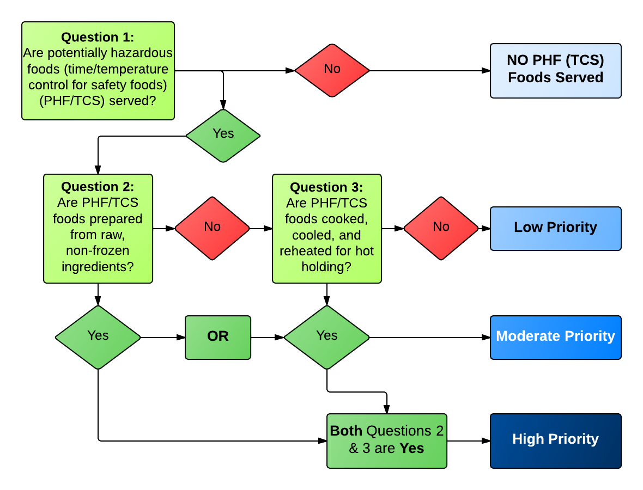

Inspection Frequency
Table 1. Inspection Frequency Using the Priority Assessment Tool and FDA Food Code, 8-401.10(A).
TJHD Priority Assessment Category | FDA Risk Category | Food Establishment Description | TJHD Inspection Frequency (# of times per year) | FDA Inspection Frequency (# of times per year)
No PHF (TCS) Foods Served | 1 | - HACCP Process 1 foods.  - Establishments that prepare, serve, or sell only non-PHFs (non-TCS foods).  - Examples include:  - Limited service mobile units (e.g. hotdog carts)  - Movie theater concessions  - Simple coffee shops | 1 | 1
Low Priority | 2 | - HACCP Process 1 & 2 foods.  - Establishments that heat only commercially processed, TCS foods for hot holding.  - No cooling of potentially hazardous foods TCS foods other than TCS foods cooled from ambient temperature.  - Examples include:  - Middle and secondary schools not serving a highly susceptible population  - Quick service operations  - Full service mobile units | 1-2 (schools are twice a year) | 1
Moderate Priority | 3 | - HACCP Process 1 & 2 with limited Process 3 foods.  - Most products are prepared or cooked and served immediately.  - May involve hot and cold holding of TCS foods after preparation or cooking.  - Complex preparation of TCS foods require cooking, cooling, and reheating for hot holding is limited to only a few TCS foods.  - Compliance history of establishment | 2 | 2
High Priority | 3 | - HACCP Process 1, 2, & 3 foods and food establishments serving highly susceptible populations.  - An example is a full service restaurant  - Extensive menu and handling of raw ingredients.  - Complex preparation including cooking, cooling, and reheating for hot holding of multiple TCS foods  - Variety of processes require hot and cold holding of TCS foods.  - May conduct specialized processes, e.g.:  - Smoking and curing  - Reduced oxygen packaging for extended shelf-life | 3 | 3

Nature of Annual Food Protection Services
The nature and frequency of food protection services performed by the Health Department at a food establishment depends initially on the VENIS priority assessment tool and decision tree. For each priority assessment category, a combination of annual services is recommended as follows:
Priority Assessment Category | Inspection Frequency | Routine Inspection | Risk Factor Assessment Inspection |  | Training Inspection
No PHF (TCS) Foods Served | 1 | 1 | 0 |  | 0
Low Priority | 1 | 1 | 0 |  | 0
Moderate Priority | 2 | 1 | 1 | OR | 1
High Priority | 3 | 1 | Any combination of 2 of either of these

Description of Food Protection Services
- Routine Inspection: An assessment of risk factors, public health interventions, and good retail practices with the application of all provisions of the Food Code.

- Risk Factor Assessment Inspection: An assessment of risk factors and public health interventions to determine compliance status (IN, OUT, NO, NA) with the application of specific critical and non-critical provisions of the Food Code (See Food Establishment Inspection Form, marking instructions, and Code reference sheet). The risk factor assessment inspections also conducted to investigate the report to the Health Department of a possible foodborne illness or outbreak.

- Complaint Inspection: An assessment of an establishment for the purpose of investigating a complaint reported to the Health Department. Most often applies to the good retail practices provisions of the Food Code.

- Compliance Inspection: An inspection conducted as part of a compliance schedule in accordance with an established Enforcement Policy.

