N95 Respirator Utilization
What are N95 Respirators?
N95 respirators are a type of personal protective equipment (PPE) crucial for safeguarding against airborne hazards. They are designed for a close facial fit and filter at least 95% of airborne particles as small as 0.3 microns. This makes them particularly effective in environments with potential exposure to airborne viruses, bacteria, dust, and other small particulates. These surgical N95 respirators are class II devices regulated by the FDA, under 21 CFR 878.4040, and CDC NIOSH under 42 CFR Part 84.
What do N95 Respirators look like?
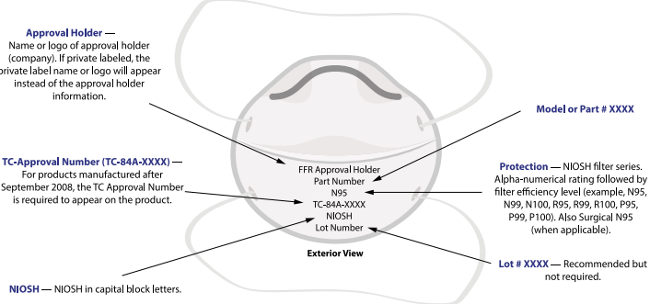
All N95 respirators should be National Institute for Occupational Safety and Health (NIOSH) approved & can be verified at this site: https://wwwn.cdc.gov/niosh-cel/
When to use an N95 Respirator?
In healthcare settings, N95 masks should be used when there's a risk of exposure to airborne particles, such as during patient care involving suspected or confirmed respiratory infections, especially during outbreaks or pandemics. N95 respirators are labeled as “single-use” disposable devices and are not designed for children or for facial hair.
What needs to be done prior to usage of an N95 Respirator?
An N95 respirator requires an annual fit test with an annual medical evaluation under 1910.134 App C- OSHA Respiratory Medical Evaluation Questionnaire: https://www.osha.gov/laws-regs/regulations/standardnumber/1910/1910.134AppC.
What is a User Seal Check?
This must be performed before each use of the N95 respirator to ensure it is placed on correctly.
Once the particulate respirator is properly donned, place your hands over the facepiece, covering as much surface area as possible. Exhale gently into the facepiece. The face fit is considered satisfactory if a slight positive pressure is being built up inside the facepiece without any evidence of outward leakage of air at the seal. A user should only wear respirator models with which they have achieved a successful fit test within the last year.
What does N95 Respirator Donning and Doffing look like?
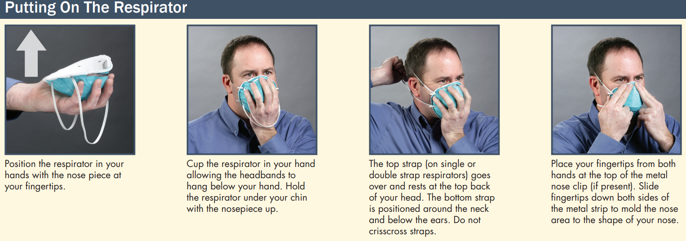
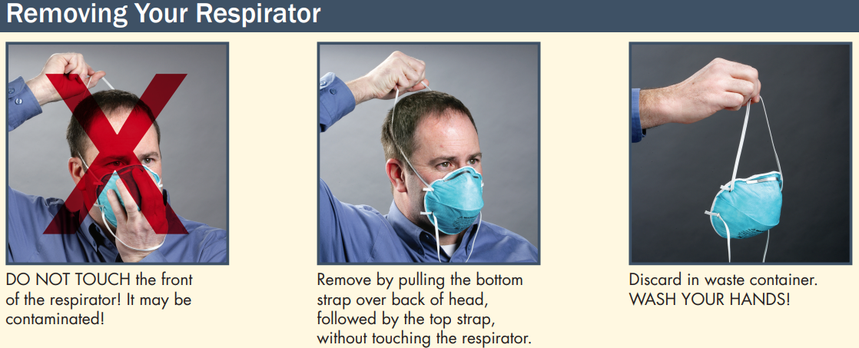
How is an N95 Respirator stored?
Store in original packaging keep in a dry area that is readily accessible to staff. Avoid humidity (over 80%) & temperatures outside of -4 to 86 Fahrenheit. Respirators expire every 5 years, so check the expiration date. Do not use a respirator if there are signs of damage; broken band or nose bridge, melting rubber seal, etc. Respirators are meant for single use so do not restore a used respirator for later. Break bands after use and dispose of used respirators in the trash.
References utilized:
Centers for Disease Control and Prevention. (2010). How to properly put on and take off a disposable respirator (DHHS (NIOSH) Publication No. 2010-133; CS 207843). U.S. Department of Health and Human Services, Centers for Disease Control and Prevention, National Institute for Occupational Safety and Health. https://www.cdc.gov/niosh/docs/2010-133/pdfs/2010-133.pdf
Centers for Disease Control and Prevention. (2025, February 3). Filtering facepiece respirators. National Institute for Occupational Safety and Health. Retrieved from https://www.cdc.gov/niosh/ppe/respirators/ffr.html
NIOSH. (2018). Filtering out confusion: Frequently asked questions about respiratory protection, user seal check (DHHS (NIOSH) Publication No. 2018–130). U.S. Department of Health and Human Services, Centers for Disease Control and Prevention, National Institute for Occupational Safety and Health. https://doi.org/10.26616/NIOSHPUB2018130
U.S. Food and Drug Administration. (2024). N95 respirators, surgical masks, face masks, and barrier face coverings. https://www.fda.gov/medical-devices/personal-protective-equipment-infection-control/n95-respirators-surgical-masks-face-masks-and-barrier-face-coverings
29 CFR § 1910.134 (2019). Respiratory protection. Occupational Safety and Health Administration. Retrieved from https://www.osha.gov/laws-regs/regulations/standardnumber/1910/1910.134
This presentation utilized Google Gemini AI content 2025

