[GUIDE]

Risk Factor Study Report
Template



September 2025

Table of Contents

Acknowledgements 4
How To Use the Template 5
[OPTIONAL] Executive Summary 6
Baseline Report 6
Subsequent Reports 6
Introduction 7
Background on Foodborne Illness Risk Factors 7
Description of Services/Purpose/Demographics 7
Background on the FDA Food Code 8
Background on the FDA Retail Program Standards 8
Purpose of Conducting a Risk Factor Study 8
Baseline Report 9
Results/Recommendations from Previous Baseline Risk Factor Study (RFS), If Applicable 9
Methods/Methodology 10
Data Collection Type 10
Method of Selection for RFS Inspections 11
Data Collection Process and Forms 13
Findings/Results and Discussion 16
Risk Factor Compliance 17
Breakdown of Results by Facility Type 17
Breakdown of Results by Most Observed Risk Factors 18
Recommendations, Priorities & Interventions 40
Recommendations for Foodservice and Retail Food 40
Recommendation for Regulatory Retail Food Protection programs 41
References 42

List of Figures

Sample Figure 1 (Southern Nevada HD) | Top 5 Primary Data Items IN-Compliance – Fast-Food/Full-Service Combined 20
Sample Figure 2 (Southern Nevada HD) | Top 5 Primary Data Items “OUT” of Compliance – Fast-Food/Full-Service Combined 22
Sample Figure 3 (Riverstone HD) | Percent of Observations OUT-of-Compliance by Risk Factor Category 23
Sample Figure 4 (CDPHE) | Poor Personal Hygiene - % of Observations In-Compliance and Out-of-Compliance 24
Sample Figure 5 (CDPHE) | Poor Personal Hygiene – Violation Items Marked OUT By Facility Type 24
Sample Figure 6 (CDPHE) | Improper Holding Times/Temperatures – Violation Items Marked OUT By Facility Type 25
Sample Figure 7 (Richmond HD) | Risk Factor % Out-of-Compliance for All Facility Types 26
Sample Figure 8 (Riverstone HD) | Percent (%) of Observations OUT-of-Compliance By Risk Factor Category 26
Sample Figure 9 (Rockingham HD) | Summary Chart of Out-of-Compliance Observations (2016 vs. 2021) 27
Sample Figure 10 (Rockingham HD) | Chart Comparing Percentage of Observations Found to be Out-of-Compliance Per Facility Type for All Data Items (2016 Study to 2021 study) 28
Sample Figure 11 (Rockingham HD) | 2021 Cross Contamination – Percentage of Out-of-Compliance Observations 29
Sample Figure 12 (Rockingham HD) | Meat Markets Percent of Out-of-Compliance Observations – Comparison (2016 vs. 2021) 29
Sample Figure 13 (Southern Nevada HD) | Personal Hygiene Percent Composition – Fast-Food and Full-Service Facilities Combined 32
Sample Figure 14 (Southern Nevada HD) | Handwashing % “OUT”: Pre- and Post-Handwashing Intervention 34
Sample Figure 15 (Vineland HD) | Full-Service Restaurants “OUT” of Compliance Observations 34
Sample Figure 16 (Washington Co HHS) | FBI Risk Factor Baseline Study – Facilities (Fast Food and Full-Service) IN-Compliance by Year 39
Sample Figure 17 (Washington Co HHS) | Citation of Hot/Cold Holding Violations (2007-2012) 39

List of Tables

Sample Table 1 | Annex 5 of the 2022 FDA Food Code contains a suggested protocol for grouping establishments by risk (NOTE: Please compare it to the Food Code version being used at time of Risk Factor Study to ensure correct Annex is identified.) 12
Sample Table 2 (Wake Co HD) | Industry Segments and Their Facility Types 13
Sample Table 3 (Northern Nevada HD) | Baseline Data Collection Timeline 14
Sample Table 4 (Rockingham HD) | 2020-2021 Data Collection Timeline 15
Sample Table 5 (Southern Nevada HD) | Top 5 Primary Data Items IN-Compliance – Fast-Food/Full-Service Combined 19
Sample Table 6 (Southern Nevada HD) | Top 5 Primary Data Items “OUT” of Compliance – Fast-Food/Full-Service Combined 21
Sample Table 7 (Riverstone HD) | CFPM prevalence by Facility Type 23
Sample Table 8 (Richmond HD) | Summary of Compliance Percentage of the Observations Per Facility 25
Sample Table 9 (Rockingham HD) | 2021 Summary of Compliance Percentages Per Facility Type for All Data Types (FoodSHIELD Report 6b) 28
Sample Table 10 (Rockingham HD) | Handwashing Frequency Observations 30
Sample Table 11 (Southern Nevada HD) | Personal Hygiene Percentage Composition – Fast Food/Full-Service Combined 30
Sample Table 12 (Southern Nevada HD) | Rank Comparison of the Top 5 Primary Data Items Marked “IN” (2016 vs. 2021) 31
Sample Table 13 (Southern Nevada HD) | Handwashing Amount and % Marked “OUT” for Fast-Food, Full-Service, and Fast-Food/Full-Service Combined (2016 vs. 2021) 33
Sample Table 14 (Wake Co HD) | Risk Factors IN-Compliance Comparison by RFS Year 35
Sample Table 15 (Wake Co HD) | Hospital Cafeteria Risk Factors IN-Compliance Comparison by RFS Year 36
Sample Table 16 (Wake Co HD) | Overall percent (%) of Observable and Applicable Data Items Found IN-Compliance by Facility Type 37
Sample Table 17 (Washington Co HHS) | Summary of Compliance Per Risk Factor 38
Sample Table 18 (Washington Co HHS) | FBI Risk Factor Study 2009 and 2014 Results 38

Acknowledgements
Thank you to the following jurisdictions who shared their completed Risk Factor Studies so that we could create this resource:
- Blue Ridge Health District, Charlottesville, VA (Blue Ridge HD)
- Chatham Health District, East Hampton, CT (Chatham HD)
- Colorado Department of Health and Environment, Glendale, Colorado (CDPHE)
- GNR Public Health, Gwinnet, Newton, and Rockdale Counties, GA (GNR Public Health)
- Jefferson County Health Department, Hillsboro, MO (Jefferson Co HD)
- Lincoln-Lancaster County Health Department, Lincoln Nebraska (Lincoln-Lancaster HD)
- Northeast Texas Health District, Tyler, TX (NE Texas HD)
- Outagamie County Public Health, Appleton, WI (Outagamie HD)
- Pennsylvania Department of Health, Harrisburg, PA (Pennsylvania DoH)
- Richmond County Health Department, Rockingham, NC (Richmond HD)
- Riverstone Health, Billings, MT (Riverstone HD) (formerly Yellowstone City/County Health Department)
- Rockingham County Health and Human Services, Reidsville, NC (Rockingham HD)
- Southern Nevada Health District, Las Vegas, NV (Southern Nevada HD)
- Northern Nevada Public Health, NV (Northern Nevada HD) (formerly Washoe County Health District)
- Tulsa City-County Health Department, Tulsa, OK (Tulsa City-County HD)
- Vineland Health Department, Vineland, NJ (Vineland HD)
- Wake County Environmental Health and Safety, Raleigh, NC (Wake Co HD)
- Washington County Health and Human Services, Hillsboro, OR. (Washington Co HHS)

NACCHO would like to thank staff Nicholas Adams, MHS, Christina Rohland, MPH, and Chelsea Gridley-Smith, PhD, for contributing to this report.

How To Use the Template
Starting from the next page, this document provides sample language, formatting ideas, and chart/table examples to assist state, local, tribal, and territorial (SLTT) retail food safety regulators in writing their FDA Retail Program Standard 9 Risk Factor Study Reports. This template is intended as a non-prescriptive resource offering examples for those who are new to writing a Risk Factor Study (RFS) Report. Jurisdictions are encouraged to use all or part of this document and customize it to meet the needs of your jurisdiction. The template guide was put together from Risk Factor Study reports authored by the contributing health departments listed in the Acknowledgements section. Credit has been given to the health department wherever their report language has been used as guiding text.
###

[OPTIONAL] Executive Summary

Baseline Report
“The purpose of this study is to evaluate the occurrence of foodborne illness risk factors in _____ (jurisdiction) retail food service facilities during ________ (period). It is a standalone report representing the baseline data collection for the occurrence of foodborne illness risk factors. This baseline report will be used by ___________ (jurisdiction) to determine trends in the occurrence of out-of-control risk factors in specific facility types and the efficacy of intervention strategies through subsequent risk factor studies. Future surveys will continue to be conducted every five years to evaluate the effectiveness of the foodborne illness risk factor interventions and to determine if additional interventions are needed.” (CDPHE & Jefferson Co HD)

Subsequent Reports
“In _______ (year of previous RFS), as part of the Program Standards, _______ (jurisdiction) completed an initial study to assess the frequency of foodborne illness risk factors in food service establishments. The survey identified risk factors based on the ______ United States Food and Drug Administration (FDA) Model Food Code (name the most recent FDA Food Code at the time or identify the year used, within two versions of the Food Code). The _______ (year of baseline RFS) survey provided the baseline assessment of the occurrence of foodborne illness risk factors in the County’s regulated food service establishments. ________ (jurisdiction) staff completed similar studies in ____ (year) and _____ (year) to provide a comparison of foodborne illness risk factors and to measure the effectiveness of their intervention strategies over the period.” (Wake Co HD)

Introduction

Background on Foodborne Illness Risk Factors
“Meals consumed outside of private homes contribute to the burden of foodborne illness. It is estimated that the average person in the United States eats out 5.9 times per week, resulting in 36% of the adult having eaten fast food in the last 24 hours. It is also estimated that more than 60% of foodborne illnesses are attributed to retail establishments. In 2014, the Centers for Disease Control and Prevention (CDC) reported that 70% of norovirus outbreaks from contaminated food are traced back to infected food workers, and 64% of norovirus outbreaks are traced to food contamination in a restaurant. Norovirus accounts for 58%, Salmonella 11%, and Clostridium Perfringens 10% of foodborne illness cases in the United States annually (Aron J. Hall, 2014). These components make the danger of acquiring a foodborne ailment, particularly norovirus, generally high.
The CDC estimates that 47.8 million cases of foodborne illness are acquired in the United States each year. Of those 47.8 million, approximately 128,000 will spend time in the hospital and 3,000 estimated deaths from illnesses acquired from unsafe food. The financial burden of foodborne illness is additionally significant, costing the U.S. somewhere in the range of $60-90 billion dollars every year (Centers for Disease Control and Prevention, 2011). The FDA, in conjunction with the CDC and the United States Department of Agriculture Food Safety Inspection Service (USDA FSIS), recognize that five fundamental factors add to foodborne illness.
The five fundamental foodborne illness risk factors are:
- Supplying food from unsafe sources
- Poor personal hygiene
- Inadequate cooking
- Improper food holding time/temperatures
- Contaminated equipment/protection from contamination.” (Richmond HD)

“Tracking and mitigating these risk factors through a food safety inspection program gives ____ (jurisdiction name) an opportunity to identify when risk factors are out of control and provide solutions through long-term intervention strategies that can reduce the occurrence and relative risk of these factors.” (CDPHE)

Description of Services/Purpose/Demographics
“The ________ (jurisdiction) is the Local Public Health Authority in _______ (state) responsible for regulating food safety in restaurants located within _________ (jurisdiction). The department’s Environment Health (EH) program conducts inspections, provides consultations and education, and carries out enforcement actions when necessary to reduce the risk of foodborne illness in restaurants. Environmental Health’s restaurant inspection program is authorized through an intergovernmental agreement to conduct this work on behalf of the ________ (State health authority).” (Washington Co HHS)
“_________’s (jurisdiction) retail food regulatory program aims to prevent problems with food safety beforehand, rather than to rely on a reactive approach once problems have already occurred. Our local ________ (division/program/section name) has been continuously working to enhance our services to retail food establishments and all its patrons.” (Richmond HD)
(Describe makeup and number of full-time employees, inspection, establishments, and jurisdiction demographics.)

Background on the FDA Food Code
“In ______ (jurisdiction), the regulation of food service establishments is based on the _________ (State Code Title). In ____ (year), the State of _______ (state) adopted a food code based on the _____ (year) FDA Food Code.” (Rockingham HD)
(Describe how your jurisdiction or state adopted its current version of the FDA food code.)

Background on the FDA Retail Program Standards
“On ____(date), _______(jurisdiction) enrolled in the FDA Voluntary National Retail Food Regulatory Program Standards (Retail Program Standards). These Standards serve as a guide for the design and management of a retail food regulatory program, with the ultimate goal of reducing the occurrence of risk factors that cause and contribute to foodborne illness. There are a total of nine Program Standards which outline the qualities of an effective and responsive retail food service regulatory program. This program helps enrolled jurisdictions improve their programs by reinforcing the use of risk-based inspections, good retail practices, and operational/environmental prerequisite programs while encouraging regulatory agencies and industry to focus on the factors that cause and contribute to foodborne illness.” (Rockingham HD) “The goal of the Retail Program Standards is to reduce risk factors associated with foodborne illness, and to provide a national benchmark for:
- Retail food program managers to evaluate their own programs; and
- Regulatory agencies to improve and build upon existing programs.“ (Wake Co HD)

Purpose of Conducting a Risk Factor Study
“To meet Standard 9 of the Retail Program Standards, jurisdictions must conduct a survey of the occurrence of these risk factors in their food establishments. By completing a second Risk Factor Study, ____ (jurisdiction) can track improvements in food safety practices using tools that can help the food safety regulatory program to:
- Measure the occurrence of foodborne illness risk factors in food service establishments and retail food stores
- Assess the effectiveness of ________’s (jurisdiction) Food Safety Programs
- Assess strengths and gaps in the design and delivery of program services
- Assist regulated food establishments’ focus on practices that can prevent foodborne illness outbreaks from happening in their establishments
- Identify risk factors in priority order and develop strategies to reduce their occurrence
- Evaluate trends over time to determine whether progress is being made towards reducing the occurrence of foodborne illness risk factors.” (Rockingham HD)
“In ______ (year), __________ (jurisdiction) ______________________________________________________________________________________________________________________________________________________ (provide background/reasoning for initiating risk factor study including: receipt of a grant, adoption of a new version of the Food Code, work done as a part of a Retail Program Standards Network, etc.). The FDA Retail Program Standards provides a guide for the design and management of a retail food regulatory program, with the goal of reducing the occurrence of risk factors that cause and contribute to foodborne illness.” (Blue Ridge HD)

Baseline Report
“The purpose of this study is to conduct baseline data collection of the occurrence of foodborne illness risk factors in retail food establishments in ____ (jurisdiction). This baseline data will help _____ (health department name) to determine the relationship between the occurrence of foodborne illness risk factors and the implementation of food safety management systems.” (CDPHE)

Results/Recommendations from Previous Baseline Risk Factor Study (RFS), If Applicable
“The purpose of the _______ (title of current RFS) is to compare _____ (year of previous RFS) and ______ (year of current RFS) data to the _____ (year) baseline study so that industry and regulatory agencies can measure behavioral changes that directly relate to foodborne illness. In addition, the study is comparable to the national risk factor data.” (Riverstone HD)
EXAMPLE: “In 2015-2016, Rockingham County Environmental Health conducted an initial baseline risk factor study where handwashing, cold holding, cross-contamination and date marking were found to be the four highest OUT-of-compliance risk factors in retail food establishments in Rockingham County. As a result of this baseline study, intervention strategies were developed and implemented to increase food safety knowledge in these establishments. The intervention strategies consisted of training food service employees on proper handwashing procedures, providing establishments with food thermometers and educational stickers that listed the correct cold holding temperatures. These intervention strategies have been successful in reducing the occurrence of handwashing and cold holding violations during inspections. However, Environmental Health staff are repeatedly finding that during successive inspections, the trained food service employees trained have been replaced with new employees that have not been properly trained by the managers/persons in charge (PIC) or Environmental Health, especially in small locally/family-owned businesses. This high turnover rate in conjunction with improperly trained food service employees is leading to multiple risk factor violations on subsequent inspections.
In 2020-2021, Rockingham County Environmental Health conducted a second survey. (Sample Table 4 in this template) shows the timeline for this study. The results of this survey will be used to focus on the risk factors that were most frequently observed OUT-of-compliance during the survey and to implement intervention strategies to reduce their occurrence in Rockingham County. Following FDA protocol, these studies are intended to be replicated every five years in order to evaluate the effectiveness of efforts to reduce the occurrence of foodborne illness risk factors.” (Rockingham HD)

Methods/Methodology

Data Collection Type

Inspection Data
“______ (jurisdiction) used routine inspection (add if applicable: and Risk Factor inspections) data collected from ____________ (period during which data was collected) to conduct this study. The goal was to establish a baseline on the occurrence of foodborne illness risk factors with the data and resources available. The data was collected during ____ (#) Routine inspections (add if applicable: and Risk Factor inspections) completed by ____ (#) Environmental Health Specialist (EHS). This represents _____% of the permitted establishments in the _______ (jurisdiction). The results are being used to focus efforts on risk factors most frequently observed, and to identify and implement strategies for achieving a reduction in their occurrence.” (Blue Ridge HD)

Retailriskfactorstudy.net/FDA tool
“During the study, _______ (jurisdiction) opted to use hand-held ______ (device) to complete the risk factor data collection form. The Environmental Health Specialist was provided access to the Retail Food Risk Factor Study Database on the FoodSHIELD site. FoodSHIELD is a web-based research database platform developed by the National Institute for Food Security and Defense that has been used to store and maintain risk factor study data. The specialists manually inserted the findings into the database for each of the data items and observations observed in the establishment. To ensure the confidentiality and integrity of the data entered by the Environmental Health Specialist, firewalls have been incorporated into the architecture of the database system. (FDA, 2015).” (Richmond HD)

Modified Inspection Form So That Routine Inspections Can Be Used for Risk Factor Studies
“In ____ (year), made major changes to our inspection software program _______ (name of inspection software used) and to its corresponding database. Data collection was modified so that the Risk Factor Study could be completed using routine inspection data. The standard was designed to collect data on the occurrence of foodborne illness risk factors in selected foodservice and retail food establishments at five-year intervals. ______ (jurisdiction) can now collect risk factor inspection data that can be readily retrieved and analyzed by fiscal year. The standard allows the jurisdiction to use routine inspection data in completing a risk factor study. The inspection data used for this report consists of inspections completed between _______ (time period). Using the data from multiple collection periods, _______ (jurisdiction) hopes to evaluate trends and compare past data to determine whether progress is being made toward the goals of reducing the occurrence of foodborne illness risk factors.” (Lincoln-Lancaster HD)

Method of Selection for RFS Inspections

Facility Types
“Our target industry segments for this study were ________ (list of Facility Types used in RFS).
- Fast food restaurants: Places where you order at a counter and take your food to the dining area to eat, or leave and eat off-site. (adjust definition to meet jurisdiction’s Facility Type definition)
- Full-service restaurants: Places where you have your order taken by wait staff and they serve you your meal while dining at the facility. (adjust definition to meet jurisdiction’s Facility Type definition)
SAMPLE DEFINITIONS
Insert definitions used by your jurisdiction into these bullets.
- Health care facilities: Assisted living homes, nursing homes, memory care units, and hospitals which allow us to focus on highly susceptible population’s specific food safety concerns. (adjust definition to meet jurisdiction’s Facility Type definition)
- Schools: Kindergarten through 12th grade. College campuses were treated as either fast food or full-service based on their business model. (adjust definition to meet jurisdiction’s Facility Type definition)
An individual focus on these industry segments allows ____ (jurisdiction) to track trends in the occurrence of foodborne illness risk factors as they pertain to that industry. Therefore, specific needs can be later assessed for those segments and overall trends monitored.
Eligibility of Establishments for Selection
In determining the pool of establishments eligible for selection, an effort was made to exclude operations that handle only pre-packaged food items or conduct low-risk food preparation activities.
Selected establishments included moderate to high-risk operations such as establishments that:
- Served a highly susceptible population (i.e., hospitals, nursing homes, etc.);
- Handled ingredients extensively; or
- Conducted a variety of food preparation processes.

Sample Table 1 | Annex 5 of the 2022 FDA Food Code contains a suggested protocol for grouping establishments by risk (NOTE: Please compare it to the Food Code version being used at time of Risk Factor Study to ensure correct Annex is identified.)

The majority of selected establishments fell into Risk Categories 2-3 based on their operational practices and the populations served. These Facility Types were included in this study due to foodborne illness outbreaks being associated with certain food products sold in these departments.” (GNR Public Health)

Random Selection of Establishments
“For this study, _____ (#) facility types were chosen from ______(#) different segments of the foodservice and retail food industries. The selected industry segment samples provided coverage of general and highly susceptible populations and also covered most of the industry segments regulated by the retail food inspection program. “Highly susceptible populations” are defined as a group of persons who are more likely than other individuals to experience foodborne illness because of their current health status or age.
The chart below reflects the ____(#) industry segments and _____(#) facility types selected for the survey. Sample sizes (n) for each type are shown. Using FDA’s Data Collection Manual ______(year), ______ (jurisdiction) randomly determined the appropriate sample size to achieve statistical significance for each Facility Type for each industry segment, and randomly selected ____(#) facilities for the survey. “ (Wake Co HD)
Sample Table 2 (Wake Co HD) | Industry Segments and Their Facility Types

Data Collection Process and Forms

Data Collection Process
“The inspectors conducted unannounced visits to each selected establishment. Inspectors used ______ (jurisdiction’s food code in use at time of risk factor study) when determining compliance of establishment food safety practices. Food product temperature and sanitizer concentration data were collected using ______ (list of equipment used during risk factor study). The person-in-charge was encouraged to accompany the inspectors during their data collection to answer any clarifying questions about food processes and procedures. (Once each survey was completed, the results were entered into the FDA-designed database located at retailfoodriskfactorstudy.net, or entered into jurisdiction’s inspection form” (Jefferson Co HD)

Quality Control measures
“____ (#) Food Safety Inspection Officers (or name if other role) were assigned to collect survey data. Staff were knowledgeable of the CDC-identified risk factors for foodborne illness and the _____ (Food Code Year used by jurisdiction) FDA Food Code. Staff was trained by ____ (FDA regional retail food specialist, standardization officer, etc.) on interpretation of the data items, marking instructions and how to conduct the surveys.” (Riverstone HD)
“To ensure consistency and completeness of data, the database system has many built-in quality control characteristics. Employees discussed issues, checked data collection processes, and answered questions to ensure accuracy. When clarity was required on how to mark items, the regional FDA Retail Food Specialist was consulted. [OPTIONAL: The database system also contains options for sharing data between jurisdictions. Upon completion, ______ (jurisdiction) had a neighboring county review data collection forms entered into the FoodSHIELD database.]” (Richmond HD)

Frequency of Data Collection
“To identify patterns and measure the efficacy of intervention strategies in reducing the incidence of foodborne disease risk factors over time, this evaluation will take place every ____ (usually this # is five but name # of years if different) years. A summary of the approach used in the ______ (year of previous evaluation) evaluation is provided in the following parts of the report. The ______ (jurisdiction name) risk factor study survey was designed using FDA Retail Program Standard 9 guidelines (U.S. Food and Drug Administration, 2019).” (Richmond HD)

Sample Table 3 (Northern Nevada HD) | Baseline Data Collection Timeline

Sample Table 4 (Rockingham HD) | 2020-2021 Data Collection Timeline

Data Collection Form
“The data collections were intended to target the control of foodborne illness risk factors. The ________ (jurisdiction) utilized the FDA data collection forms for each industry segment and Facility Type (add appendices for data collection forms, if applicable ).
The focus of the data collection was based on observations of the primary data items listed on the data collection form. The ________ (jurisdiction) used the FDA data collection forms for each industry category and facility type. The data collection emphasis was focused on observations of the primary data items specified on the data collection form. Data items 1 through 10 are considered primary data items and were used as the critical indicators for statistical analysis per the current FDA protocol. Each of the primary data items has been placed under the appropriate FDA foodborne illness risk factor category:

Risk Factor –Poor Personal Hygiene
#1 – Employees practice proper handwashing
#2 – Food Employees do not contact ready-to-eat foods with bare hands

Contaminated Equipment / Protection from Contamination
#3 – Food is protected from cross-contamination during storage, preparation, and display
#4 – Food contact surfaces are properly cleaned and sanitized

Improper Holding / Time and Temperature
#5 – Foods requiring refrigeration are held at the proper temperature
#6 – Foods or stored hot is held at the proper temperature
#7 – Foods are displayed cooled properly
#8 – Refrigerated, ready-to-eat foods are properly date marked and discarded within 7days of preparation or opening

Inadequate Cooking
#9 – Raw animal foods are cooked to required temperatures
#10 – Cooked foods are reheated to required temperatures

Data items 11 through 19 are listed under the heading “Other Areas of Interest.” These food safety practices and procedures directly support control of the foodborne illness risk factor areas addressed under the primary data items:

Other Areas of Interest
#11 – Handwashing facilities are accessible and properly maintained
#12 – Employees practice good hygiene
#13 – Consumers are properly advised of risks of consuming raw or undercooked animal foods
#14 – Time alone is properly used as a public health control
#15 – Facilities have adequate equipment and tools for ensuring food temperature control and
sanitization of food contact surfaces
#16 – Special processes are conducted in compliance with issued variance / HACCP Plan, when
required
#17 – Food is received from safe sources
#18 – Toxic materials are identified, used, and stored properly
#19 – Management and food employees are trained in food allergy awareness as it relates to their
assigned duties

For each of the data items, the surveyor marked the item as:
- IN - Item observed to be “IN-compliance” with Food Code provisions.
- OUT - Item observed to be “OUT-of-compliance” with Food Code provisions. An explanation was provided in the comment section on the data collection form for each observation marked “OUT.”
- NO - Item was “not observed.” The “NO” notation was used when an item was a usual practice in the food service operation, but the practice was not observed during the time of the inspection. For example, if a restaurant cooks food and then cools it for later use but was not doing so at the time of the survey, then data items pertaining to cooling practices and cooling temperatures were marked “not observable.”
- NA - Item was “not applicable.” The “NA” notation was used when an item was not part of the food service operation. For example, if a quick-service sandwich shop that conducts no cooking was selected for the study, then all data items pertaining to cooking were marked “not applicable.”

Findings/Results and Discussion
If this is the first Risk Factor Study:
“The results contained in the _______ (year and jurisdiction’s name) risk factor study report are intended to demonstrate the habits of food establishment workers and food preparation procedures in ______(jurisdiction name) food establishments most in need of change. This section's discussions and statistical data will concentrate mainly on the findings and data interpretation of the ten key data elements representing the risk factors for foodborne illnesses. For each risk factor in the risk factor study, the percent OUT-of-compliance indicates the overall efficacy of current food safety management systems. It can be implied that the higher the percent OUT-of-compliance, the management system fails to control the risk factor. _________’s (jurisdiction) regulatory program aims to reduce the occurrence of foodborne illness risk factors by developing intervention strategies that reduce the occurrence of out-of-compliance risk factors. Industry can achieve these goals through active managerial control and education.” (Richmond HD)

If this is a subsequent Risk Factor Study:
“In ______ (year of previous study_______ (jurisdiction) conducted an initial baseline risk factor study where __________ (main findings from previous study) were found to be the ____ (number highlighted in report) highest OUT-of-compliance data items in all establishment types. As a result of this baseline study, intervention strategies were developed and implemented to increase food safety knowledge for the top two highest data items. The intervention strategies consisted of _________ (main interventions from previous Risk Factor Study) to any food service establishments that were found to be OUT-of-compliance during compliance inspections. The intervention strategies have been successful in the overall reduction in the occurrence of handwashing and cold holding violations.
For this _____ (second, third, etc.) risk factor study, the following four data items were the most frequently observed to be OUT-of-compliance for all establishment types: ___________________. These _____ (#) data items will be the main focus of intervention strategies until the next risk factor study in five years. The top two data items most frequently observed to be OUT-of-compliance for all establishment types were __________. Overall, there was an ________ (increase/decrease) in the number of data items observed to be OUT-of-compliance, with the exception of ________ (list any exceptions) which _______ (increased/decreased) by _______ (percentage). (Sample figure 9 in this template) below shows the comparison of OUT-of-compliance observations for the baseline study and this _____ (#) risk factor study. This chart compares the individual total of observations.” (Rockingham HD)
If there are any unexpected results, please describe them. Make sure to include any factors that may have affected results.

Risk Factor Compliance
Note: It is not required to break down results by these methods. Some reports focus on the breakdown by facility type while others may focus on the most observed risk factors overall. It is important to look at the data collected and to describe the results in a way relevant to your jurisdiction’s observed data. You may adjust this template to meet your reporting needs.

Breakdown of Results by Facility Type
(Sample: Include a breakdown for each relevant Facility Type included in your Risk Factor Study.)
Institutional Food Service - Hospitals
Introduction
“In ______ (year), all hospital cafeterias were assessed for food safety risk factors. For the __(#) possible individual data items on the survey instrument, ___(#) observations were made at ____(#) hospital kitchens. [OPTIONAL: Consider including detailed data related to hospitals as an appendix item.]
Certified Food Protection Managers (CFPM) (____%): For this survey, a CFPM had to be present. A CFPM is defined as an employee who has supervisory responsibility and the authority to direct and control food preparation. The CFPM must have passed an American National Standards Institute (ANSI) accredited program and present a certificate during the assessment. A CFPM was present at all seven facilities (____% IN-compliance).
Employee Health Policy (__%): There was ___% compliance with the most current employee health policy at the ____(#) surveyed hospitals. If applicable: Staff should target education related to this important intervention.
Results and Discussion
The following chart represents IN-compliance risk factors by category as a percentage of total observations. It also shows other individual items and intervention compliance.
The overall compliance with CDC risk factors at hospital cafeterias has remained mostly unchanged over the ______ (number of years) period, showing reductions in compliance with holding and contamination. Personal hygiene risk factors are trending toward greater compliance (adjust to match results). The small population and number of observations may inflate percentage changes, so be aware of the actual number of observations when interpreting the data. “ (Wake Co HD)

Breakdown of Results by Most Observed Risk Factors

Top 5 Primary Data Items IN-Compliance

“Primary data items (data items 1 through 10) were used to determine the top five Risk Factor data items marked IN-compliance in both fast-food and full-service facilities (Sample Table 5 in this template); percent “IN” was calculated using the total number of data collection findings (IN, OUT, NO, and NA). The top five data items scored above 70 percent IN-compliance (Sample Figure 1 in this template). [SAMPLE DATA: please indicate your results here based on your risk factor study data.] “Food employees do not contact ready-to-eat (RTE) foods with bare hands” (2) had the highest percent IN-compliance (___%); this data item was only observed OUT-of-compliance in __(#) of __ (#) observations. This requirement was introduced to _______ (jurisdiction) in the _____ (regulatory document) and these results display industry’s continued compliance with a relatively new regulatory requirement. “Actual contamination of food” (3C) was only observed in __ (#) out of ____ (#) observations. The risk factor of “Improper Holding/Time and Temperature Control” appears _____ times in the top 5 list of primary data items IN-compliance; this includes “RTE time/temperature control for safety (TCS) foods (prepared on-site) date marked as required” (8A), “opened commercial containers of RTE TCS foods date marked as required” (8B), and “RTE TCS food exceeding 7 days is discarded” (8C).” (Southern Nevada HD)

Sample Table 5 (Southern Nevada HD) | Top 5 Primary Data Items IN-Compliance – Fast-Food/Full-Service Combined

Sample Figure 1 (Southern Nevada HD) | Top 5 Primary Data Items IN-Compliance – Fast-Food/Full-Service Combined
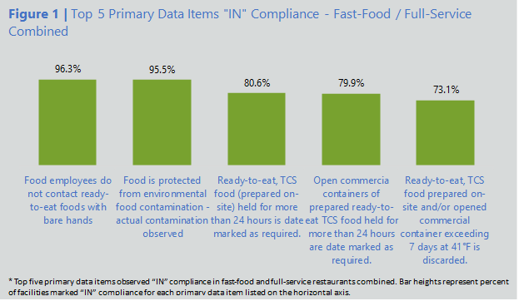

Top 5 Primary Data Items “OUT” of Compliance

“As with the data for the Top 5 items marked “IN,” primary data items (1-10) were used to determine the top five Risk Factor items marked “OUT” of compliance (Sample Table 6, Sample Figure 2 in this template); percent “OUT” was calculated using the total number of data collection findings (IN, OUT, NO, and NA). [SAMPLE DATA: please indicate your results here based on your risk factor study data]. Cold holding of TCS foods (5A) had the highest percentage “OUT” at ___%. As mentioned in the methodology above, the _______ (regulatory document) allow for cold storage of TCS foods at 41°F for up to 72 hours. The FDA model was followed during the data collection and all TCS foods measuring above 45˚F were marked “OUT.” Food protected from potential contamination (3D) was observed “OUT” in half of the facilities included in this study. In ___% of facilities included in this study, food contact surfaces and utensils cleaned and sanitized (4A) were observed “OUT” of compliance. Both when (1B) and how (1A) to wash hands rounded out the top 5 primary items observed “OUT” of compliance at ___% and ___%, respectively. ________ (risk factor identified in RFS) was determined to be a priority risk factor requiring attention during the ___ (year) Baseline study. Those results led to the creation of a hand washing intervention strategy.” (Southern Nevada HD)

Sample Table 6 (Southern Nevada HD) | Top 5 Primary Data Items “OUT” of Compliance – Fast-Food/Full-Service Combined
Sample Figure 2 (Southern Nevada HD) | Top 5 Primary Data Items “OUT” of Compliance – Fast-Food/Full-Service Combined
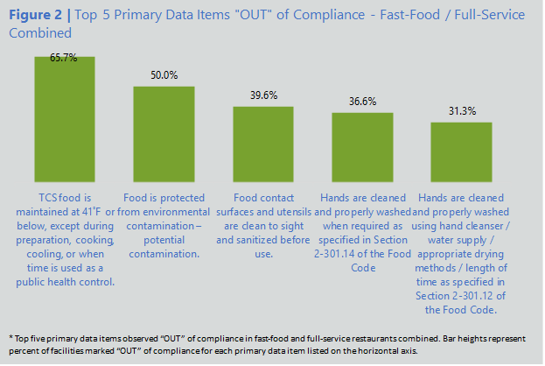

Result Tables and Charts
SAMPLE TABLES: Please use the following tables and charts as a reference for how to analyze and present the data collected during your jurisdiction’s Risk Factor Study. You are not required to use these tables; however, they are intended to provide ideas about how to display the data collected during your risk factor study. These tables and charts can be used in your results/discussion section to graphically demonstrate and support your findings. Please note that the charts in this document are static and cannot be edited. These sample charts and figures have been recreated to the best of NACCHO’s ability.

Sample Figure 3 (Riverstone HD) | Percent of Observations OUT-of-Compliance by Risk Factor Category
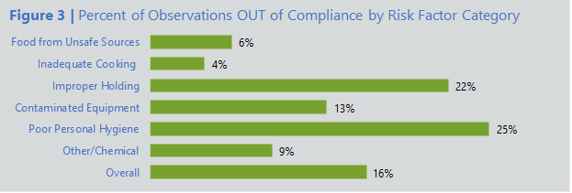

Sample Table 7 (Riverstone HD) | CFPM prevalence by Facility Type

Sample Figure 4 (CDPHE) | Poor Personal Hygiene - % of Observations In-Compliance and Out-of-Compliance
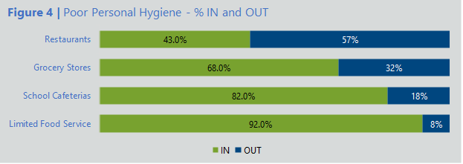

Sample Figure 5 (CDPHE) | Poor Personal Hygiene – Violation Items Marked OUT By Facility Type
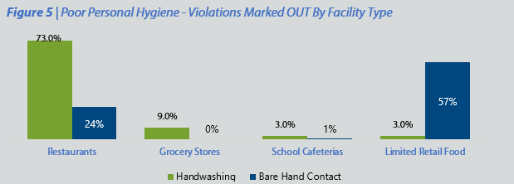

Sample Figure 6 (CDPHE) | Improper Holding Times/Temperatures – Violation Items Marked OUT By Facility Type
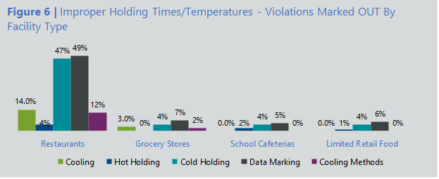

Sample Table 8 (Richmond HD) | Summary of Compliance Percentage of the Observations Per Facility

Sample Figure 7 (Richmond HD) | Risk Factor % Out-of-Compliance for All Facility Types
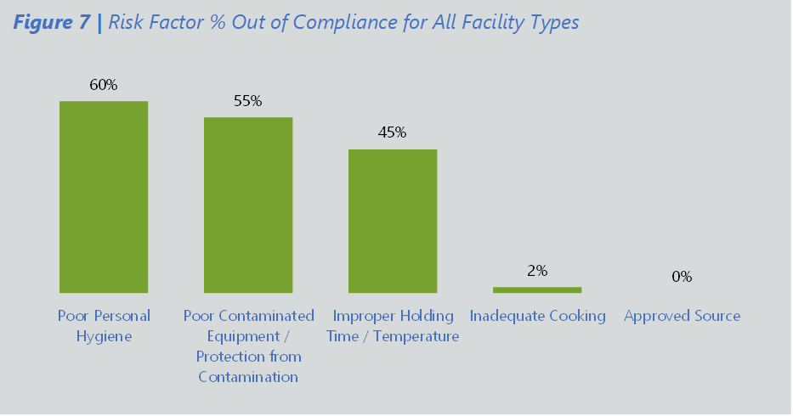

Sample Figure 8 (Riverstone HD) | Percent (%) of Observations OUT-of-Compliance By Risk Factor Category
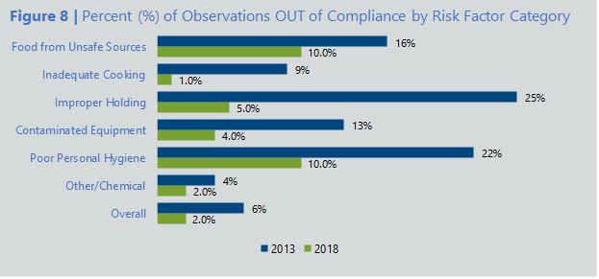

Sample Figure 9 (Rockingham HD) | Summary Chart of Out-of-Compliance Observations (2016 vs. 2021)
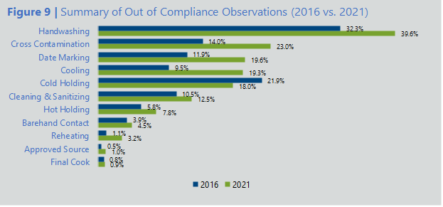

Sample Table 9 (Rockingham HD) | 2021 Summary of Compliance Percentages Per Facility Type for All Data Types (FoodSHIELD Report 6b)
Sample Figure 10 (Rockingham HD) | Chart Comparing Percentage of Observations Found to be Out-of-Compliance Per Facility Type for All Data Items (2016 Study to 2021 study)
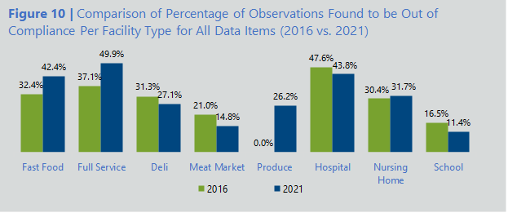

Sample Figure 11 (Rockingham HD) | 2021 Cross Contamination – Percentage of Out-of-Compliance Observations
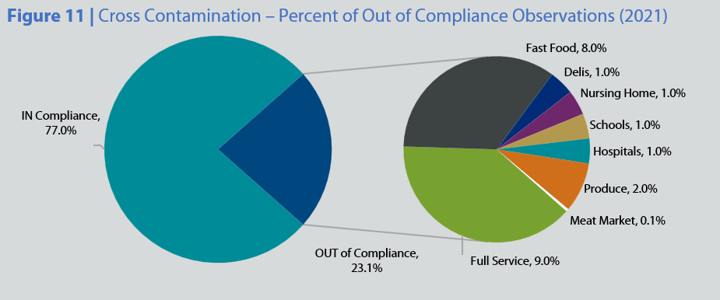

Sample Figure 12 (Rockingham HD) | Meat Markets Percent of Out-of-Compliance Observations – Comparison (2016 vs. 2021)
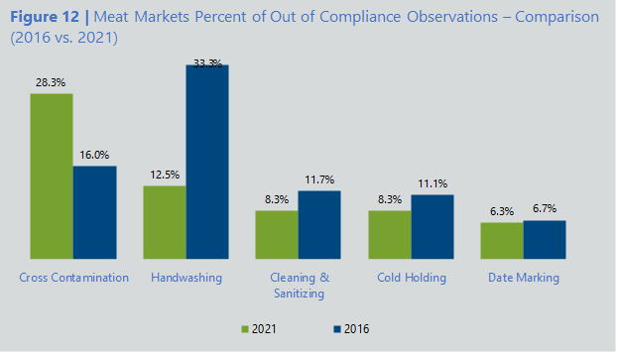

Sample Table 10 (Rockingham HD) | Handwashing Frequency Observations

Sample Table 11 (Southern Nevada HD) | Personal Hygiene Percentage Composition – Fast Food/Full-Service Combined
Sample Table 12 (Southern Nevada HD) | Rank Comparison of the Top 5 Primary Data Items Marked “IN” (2016 vs. 2021)

Sample Figure 13 (Southern Nevada HD) | Personal Hygiene Percent Composition – Fast-Food and Full-Service Facilities Combined
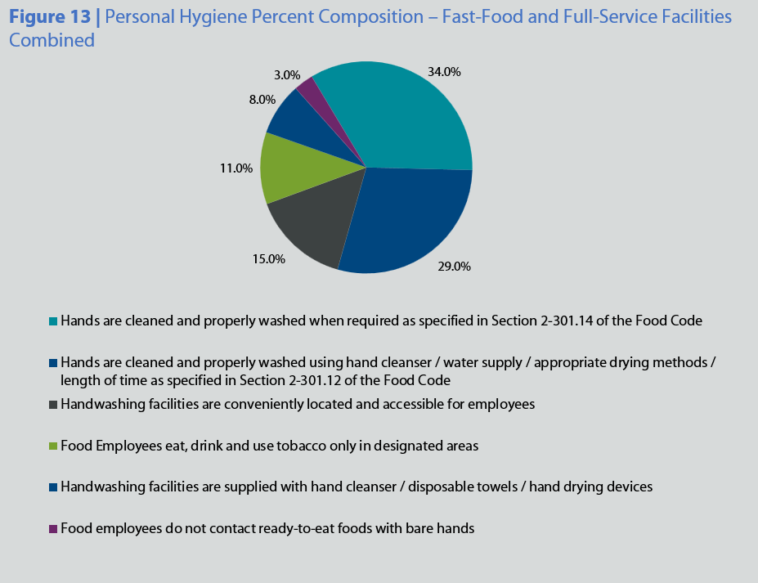

Sample Table 13 (Southern Nevada HD) | Handwashing Amount and % Marked “OUT” for Fast-Food, Full-Service, and Fast-Food/Full-Service Combined (2016 vs. 2021)
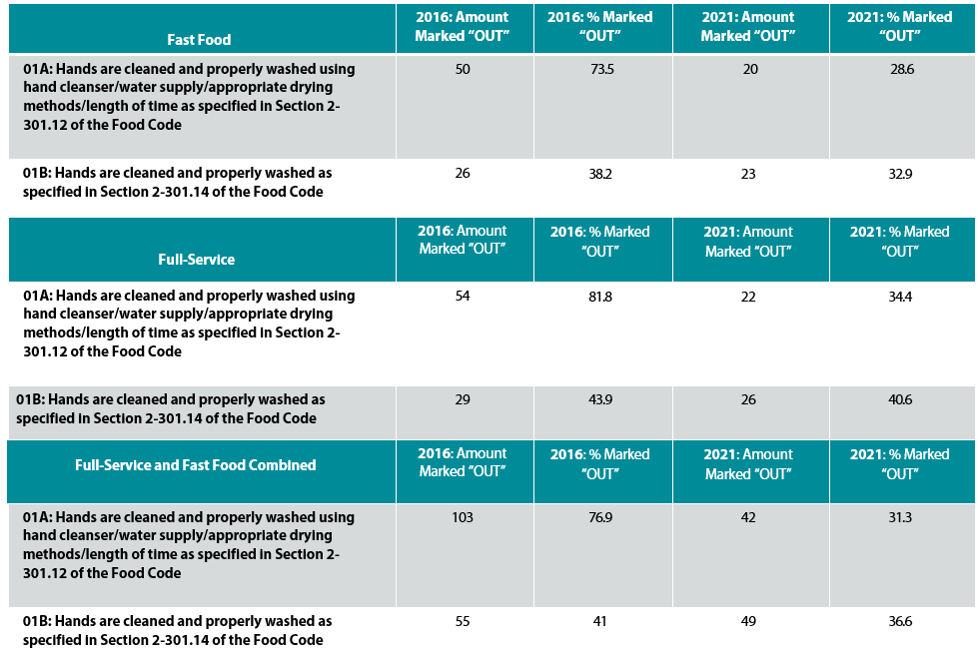

Sample Figure 14 (Southern Nevada HD) | Handwashing % “OUT”: Pre- and Post-Handwashing Intervention
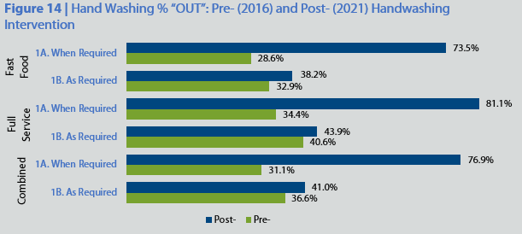

Sample Figure 15 (Vineland HD) | Full-Service Restaurants “OUT” of Compliance Observations
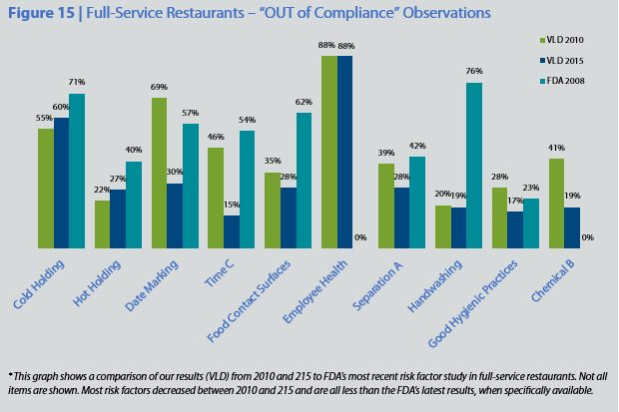

Sample Table 14 (Wake Co HD) | Risk Factors IN-Compliance Comparison by RFS Year

*Employee Health Policy compliance improved from 2010 to 2015 (10% to 64%) based on the 2009 Code; however, when compared with the 2017 Code, there was only 17% compliance (non-typhoidal Salmonella)

Sample Table 15 (Wake Co HD) | Hospital Cafeteria Risk Factors IN-Compliance Comparison by RFS Year
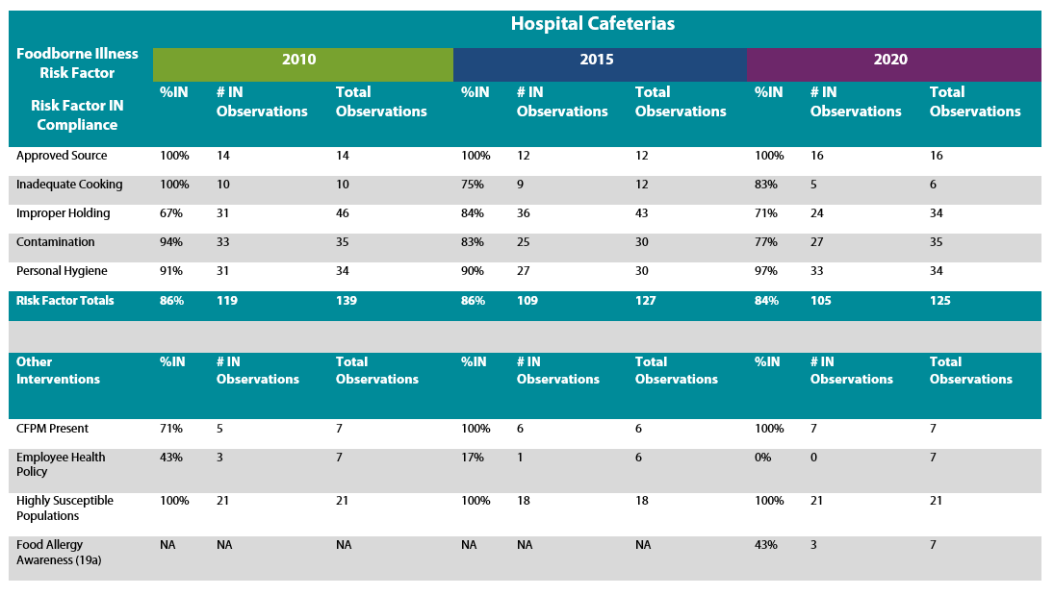
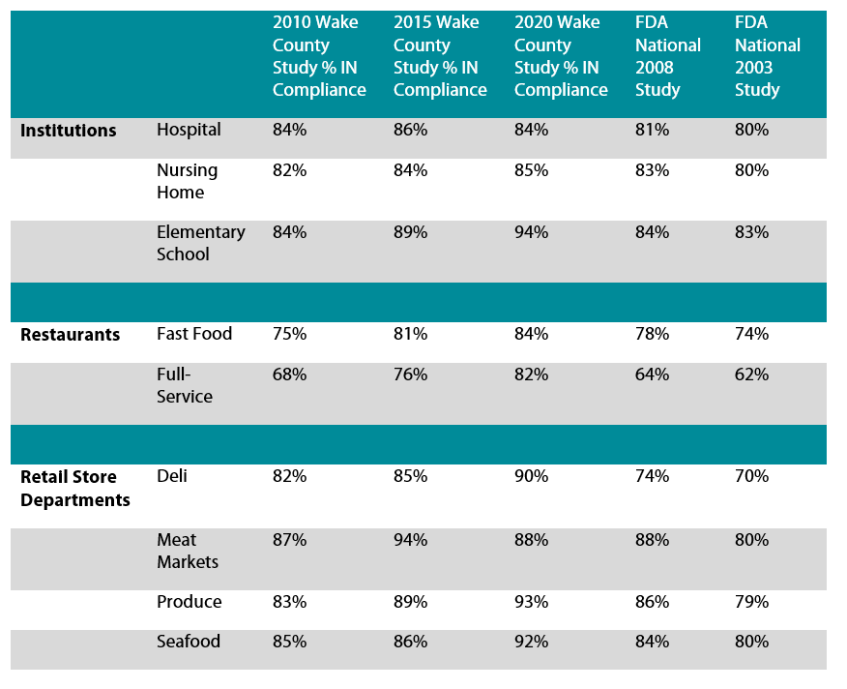
Sample Table 16 (Wake Co HD) | Overall percent (%) of Observable and Applicable Data Items Found IN-Compliance by Facility Type

Sample Table 17 (Washington Co HHS) | Summary of Compliance Per Risk Factor
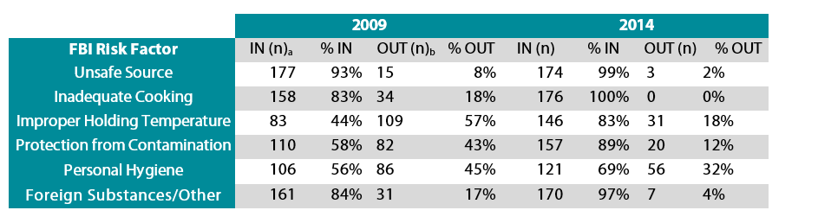
Sample Table 18 (Washington Co HHS) | FBI Risk Factor Study 2009 and 2014 Results

Sample Figure 16 (Washington Co HHS) | FBI Risk Factor Baseline Study – Facilities (Fast Food and Full-Service) IN-Compliance by Year
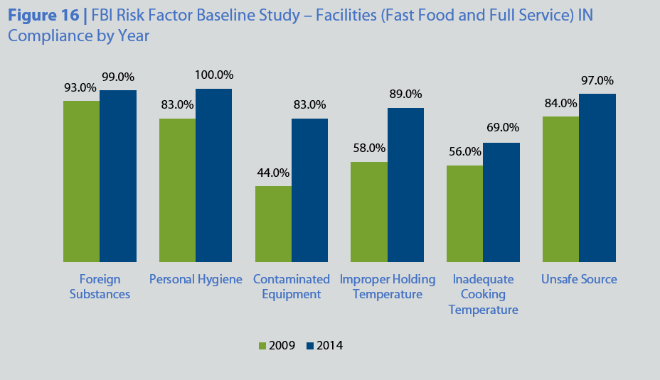

Sample Figure 17 (Washington Co HHS) | Citation of Hot/Cold Holding Violations (2007-2012)
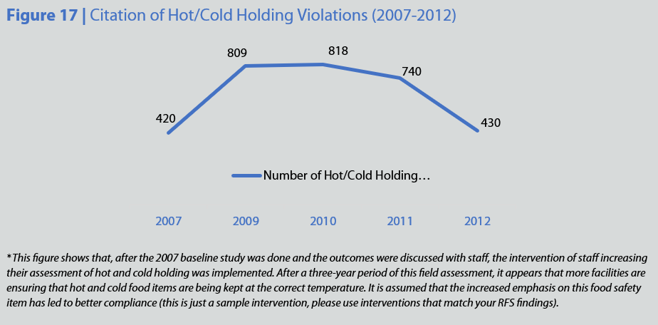

Recommendations, Priorities & Interventions

Continuous Program Improvement
“The recommendations described are captured in more detail in the Voluntary National Retail Food Regulatory Program Standards (Retail Program Standards). The Retail Program Standards apply to the operation and management of a retail food regulatory program that is focused on the reduction of foodborne illness risk factors and the promotion of active managerial control of these risk factors. Through a process of self-assessment, agencies can use the Retail Program Standards to evaluate the effectiveness of their food safety program.
While the nine Retail Program Standards viewed together represent a highly effective and developed retail food safety program, any regulatory program can use the Retail Program Standards as a foundation to build upon through a continuous improvement process. Managers of regulatory inspection programs are encouraged to review existing practices and procedures against the criteria in the Retail Program Standards to ensure that current program activities target reducing the occurrence of those risk factors identified in the results section.
The Voluntary National Retail Food Regulatory Program Standards can be accessed and downloaded from FDA’s website at: fda.gov/food/retail-food-protection/voluntary-national-retail-food-regulatory-program-standards.
Retail Program Standard 9 encourages state and local jurisdictions to establish studies on the occurrence of foodborne illness risk factors that are specific to their geographic area of responsibility. To assist agencies interested in conducting risk factor studies of their own, FDA has prepared a manual and an accompanying software program designed to assist with the management of the data collected. Information about the data collection manual and software package can be obtained from an FDA Regional Retail Food Specialist.” (GNR Public Health)

Recommendations for Foodservice and Retail Food

Intervention Strategies
“A goal of the ____ (year) Risk Factor Survey in __________ (jurisdiction) is to develop intervention strategies aimed at reducing the occurrence of foodborne illness risk factors. Strategies will be implemented according to the data items prioritized for greatest need of attention in each facility type.” (Washington Co HHS)
“Ultimate responsibility for the development and maintenance of effective food safety management systems lies with the management of institutional food service, restaurant, and retail food store operations. Individual operators that are responsible for the day-to-day management of these facilities play a key role in preventing foodborne illness. The establishment manager’s role in preventing foodborne illness should be raised to a new level of awareness.
Food safety management systems can take many forms. Every establishment has some set pattern of procedures, even if it is simply described as “the way we do things.” Some establishments have implemented effective food safety management systems by establishing controls for food preparation methods and monitoring processes common to their operation. Many others, however, continue to rely on vague, unmonitored procedures. At a minimum, an operator’s food safety management system should be based on achieving the same level of safety established by the critical limits in the Food Code. (if applicable you can include the following: “During this study, data has been collected on food safety management systems and employee health. However, those items will be analyzed in a subsequent report”).

Here are some recommendations for industry managers based on the results of this study:
- Intervention 1
- Intervention 2
- Intervention 3
- Etc.…
To assist industry in the development of management systems designed to control foodborne illness risk factors, FDA has developed a document, Managing Food Safety: A Manual for the Voluntary Use of HACCP Principles for Operators of Food Service and Retail Establishments. The direct FDA web site link to this document is: www.fda.gov/Food/FoodSafety/RetailFoodProtection/ManagingFoodSafetyHACCPPrinciples/Operators/default.htm.” (GNR Public Health)

Recommendation for Regulatory Retail Food Protection programs

Recommendations for Future Study
“The percentage of observations found to be OUT-of-Compliance with many of the data items covered in this study indicates that regulatory agencies need to do more to affect change in food safety practices and behaviors in food service establishments. The data collected in this study will be used at a later date to recognize and evaluate areas of improvement for the inspection staff.
Annex 5 of the 2013 FDA Food Code provides regulatory professionals with approaches for conducting risk-based inspections within retail food store and food service establishments. Additional guidance for assisting the industry assess the effectiveness of their food safety management systems is contained in FDA’s Managing Food Safety: A Regulator’s Manual for Applying HACCP Principles to Risk-Based Retail and Food Service Inspections and Evaluating Voluntary Food Safety Management Systems. The FDA website link to this document is fda.gov/food/hazard-analysis-critical-control-point-haccp/managing-food-safety-manual-voluntary-use-haccp-principles-operators-food-service-and-retail.” (GNR Public Health)
- Intervention 1
- Intervention 2
- Intervention 3
- Etc.…

Disclaimer
This resource was completed with active support from the National Association of County and City Health Officials staff as well as input from members of the Retail Food Safety Advisory Group. This document was supported by the U.S. Food and Drug Administration (Grant Agreement # 5U18FD007736-03).

References
- Aron J. Hall, D. M. (2014, June 6). Vital Signs: Foodborne Norovirus Outbreaks — United States, 2009–2012. Morbidity and Mortality Weekly Report, 63(22), 491-495. Retrieved June 6, 2025, from https://www.cdc.gov/mmwr/preview/mmwrhtml/mm6322a3.htm?s_cid=mm6322a3_w
- Centers for Disease Control and Prevention. (2011). Burden of Foodborne Illness: Findings. Retrieved from CDC Archive: https://archive.cdc.gov/www_cdc_gov/foodborneburden/2011-foodborne-estimates.html

For more information, contact:
NACCHO’s Food Safety Program at foodsafetyinfo@naccho.org
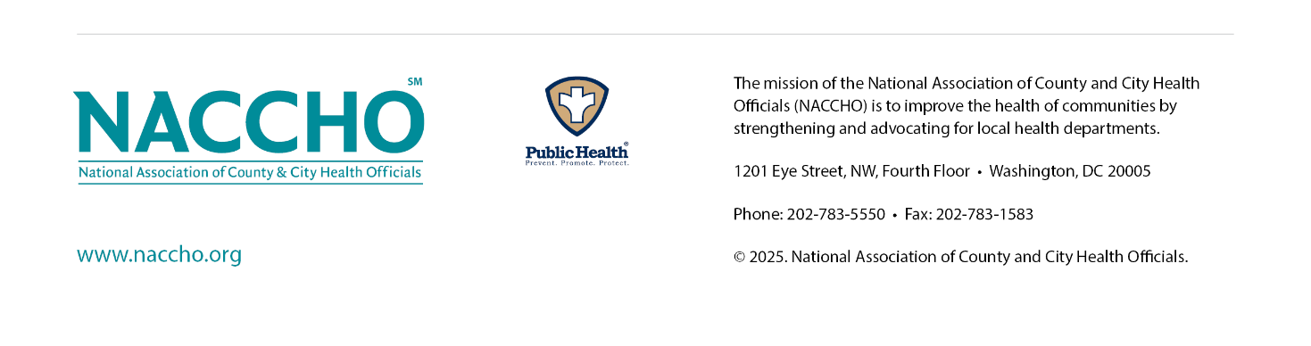

FDA Data Collection Manual, “Developing a Baseline on the Occurrence of Foodborne Illness Risk Factors,” page 12.

