Social Media Templates

About
NACCHO developed a set of editable social media graphics to help local health departments quickly alert community members during a chemical emergency. These ready-to-use messages cover key actions such as sheltering in place, evacuation, and the all-clear to return home.

Included are sample social media graphics which are available as templates for updating in Canva. Several graphics also include captions as examples to be customized to meet local needs.

Instructions for Use
- Click here to access social media graphics as customizable templates in Canva.
- Click each graphic within this document for high resolution generic graphics.
- Replace all bracketed placeholders ([like this]) with relevant information.

Additional Resources
This resource is among a suite of materials designed to help local health departments strengthen their chemical preparedness, response, and recovery efforts. For additional resources, visit https://www.naccho.org/chemprep.

Sample Graphics
- Click each image to download a high resolution graphic.
- Click here for customizable templates on Canva.
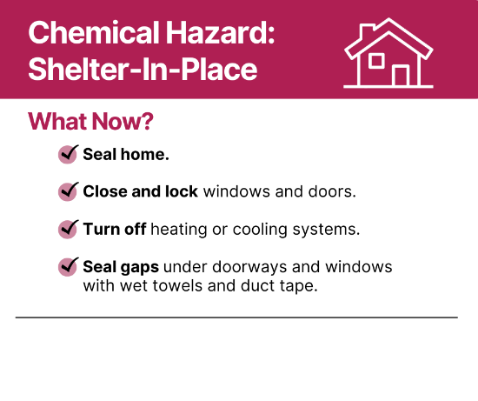 | 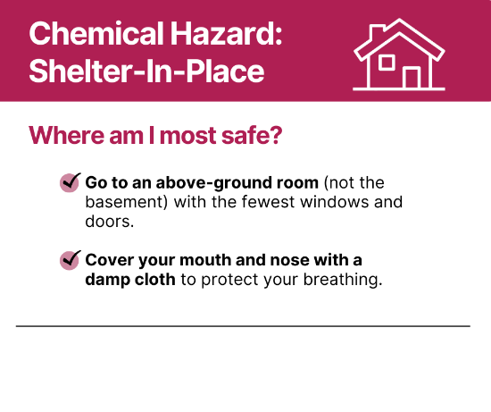 | 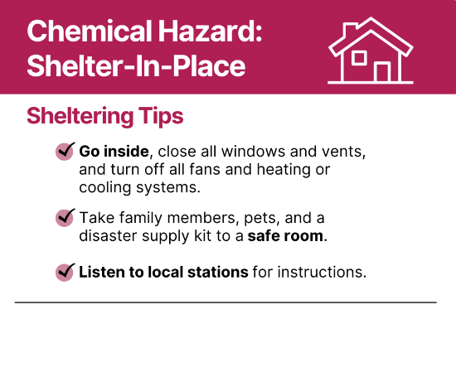
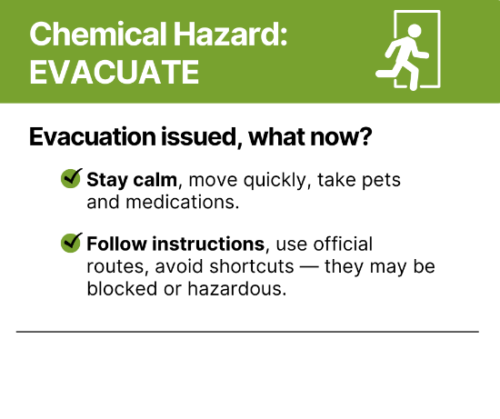 | 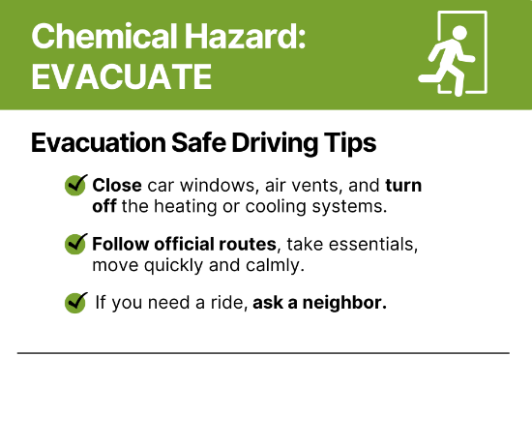 | 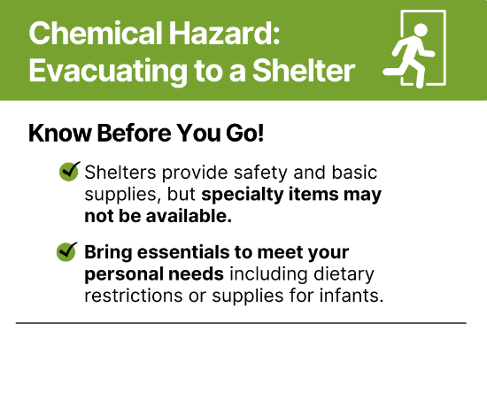
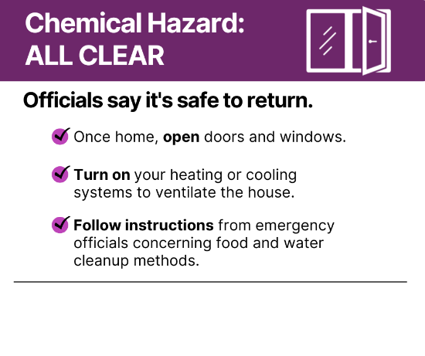 | `

Sample Captions
- Replace all bracketed placeholders ([like this]) with relevant information.
BREAKING: Shelter-in-Place

A chemical incident occurred [location] on [day] at [time].

Go inside, close all doors and windows, turn off AC/heating, use bottled water, bring pets inside, and seal gaps to outside air.

Visit [Health Department social media handle] for further instructions.

EVACUATE IMMEDIATELY
A chemical incident occurred [location] on [day] at [time].

✅ Pack essentials
🚗 Use 1 car per family
🧒 Bring kids, pets, meds, ID
🏠 Shut off vents, lock up
📻 Listen for updates at [LHD social media]
📍Follow the exact route given

Stay calm. Stay safe.

BREAKING: Shelters Opened

A chemical incident occurred [location] on [day] at [time].
[Agency name] has opened shelters [names/locations of these shelters].

Remember:
💊 Bring meds, ID, important documents
🐶 Only some shelters allow pets—check first

BREAKING: Safe to Return Home

On [Day] at [time], [Agency name] gave the official notice that it is now safe to return home.

What now:
🌬️ Ventilate: Open windows and turn on HVAC
🧼 Clean carefully and dispose of residue
📻 Follow local instructions on food & water safety

